Final Year Project (2024 – 2025)
CPEG Final Report

Computer Vision-based Path Planning for Robot Manipulator Using Bézier Curves

Project ID: WKT06
Supervisor: Professor Kam Tim Woo
Author (Student ID): CHEUNG Dick Ho (20857899)
Date: 20 March 2025

Main Objective

This project aims to design and build a robot manipulator system that integrates a 3D Bézier-curve-based path planning algorithm with a computer vision machine learning model. The system will be demonstrated through its application in writing Chinese calligraphy, highlighting the algorithm's improved smoothness, speed, and accuracy compared to traditional methods. Additionally, the computer vision model will ensure optimal distance between the Chinese writing brush and the paper, maintaining consistent contact and preventing overly thick, indistinguishable strokes. Ultimately, this project seeks to enhance the traditional calligraphy process while showcasing the potential of robotics in preserving and advancing cultural artistry.

Objective Statements
- To develop and simulate a 3D Bézier curves path planning algorithm that generates smooth trajectories for the robot manipulator system.
- To implement the Bézier curves path planning algorithm within the robot manipulator system for writing Chinese calligraphy, demonstrating the algorithm's precise and fluid movements.
- To utilize machine learning model on computer vision system to identify whether the Chinese writing brush (毛筆) touches the paper with an accuracy of 90% or above.
- To demonstrate the advantages of using Bézier curves in robotic path planning compared to traditional methods, focusing on improvements in smoothness, speed, and accuracy.
Contents
ABSTRACT vi
SECTION 1—INTRODUCTION 7
1.1 Background and Engineering Problem 7
1.2 Objectives 7
1.2.1 Objective Statements 7
1.3 Literature Review of Existing Solutions 8
SECTION 2—METHODOLOGY 9
2.1 Overview of the Robot Manipulator System 9
2.1.1 System Description 9
2.1.2 System Block Diagram 11
2.1.3 Components List 12
2.1.4 CPEG Knowledge 12
2.2 Objective Statement Execution 13
2.2.1 Path Planning Algorithm using Bézier Curves 13
2.2.2 Applying Bézier Curves Path Planning on Chinese Calligraphy 20
2.2.3 Computer Vision System 39
2.2.4 Comparing Bézier Curves Path Planning Algorithm with Traditional Methods 47
2.3 Main Objective Evaluation & Discussion 55
SECTION 3—CONCLUSION 56
REFERENCES 57
APPENDICES 58
Appendix A – Final Project Schedule 58
Appendix B — Budget 60
Appendix C — Deviation(s) from the Proposal and Progress Report and Supporting Reason(s) 61
Appendix D — Monthly Reports 62

List of Illustrations
List of Figures
Figure 1. Experiment Setup of the Robot Manipulator System 9
Figure 2. An Example Image Captured by the USB Camera 10
Figure 3. The User Interface of the Chinese Calligraphy Robot Manipulator System 10
Figure 4. Data Flow of the Robot Manipulator System 11
Figure 5. UI of Robocon 2D Bézier-Curve-Based Omnidirectional-Wheelbase Trajectory Planner 14
Figure 6. A 2D Bézier Curve-Based Trajectory Plotted Using Part of the Trajectory Planner's Code 14
Figure 7. Screenshot of RoArm-M2-S MoveIt Simulation 15
Figure 8. A 3D Plot of a Simulated Robotic Arm Trajectory 15
Figure 9. A 3D Hermite Curve Plot with Simulated Robotic Arm 16
Figure 10. A 3D Hermite Spline Trajectory 18
Figure 11. A 3D Hermite Spline Trajectory with its Curvature and Derivative Graphs 19
Figure 12. The Graphics Data of the Chinese Character 大 in graphics.txt 22
Figure 13. A Catmull-Rom Spline in HKUST COMP4411 Lecture Notes 22
Figure 14. Hermite Spline of the Chinese Character 大 with Different Tension Control 23
Figure 15. Hermite Spline of the Chinese Character 大 with the Modified Formula 24
Figure 16. Trajectory of Writing the Chinese Character 大 with 2D Spline Algorithm 25
Figure 17. Different gripper_writing_height Values for Different Positions of the Chinese Writing Brush 26
Figure 18. The Chinese Character 大 Written with Different gripper_writing_height Values 26
Figure 19. The Graphics Data of the Chinese Character 一 in graphics.txt 27
Figure 20. Largest Fitting Circles of Medians Points of the Chinese Character 大 Stroke by Stroke 28
Figure 21. Largest Fitting Circles of Medians Point of the Chinese Character 我 28
Figure 22. Trajectory of Writing the Chinese Character 大 with 3D Spline Algorithm 30
Figure 23. Some Chinese Characters Written Using the 3D Spline Algorithm 30
Figure 24. Explanation of the Change of Thickness of Some Resulting Chinese Characters 31
Figure 25. An Online Image of Multiple Fai Chun 31
Figure 26. Collisions Between the Links of the Robotic Arm Restricting the Writable Area on the Paper 32
Figure 27. Trajectory Plot of the Chinese Characters 大吉大利 Using the 2D Spline Algorithm 33
Figure 28. Result of the Fai Chun 大吉大利 Written by the Robotic Arm Using the 2D Spline Algorithm 33
Figure 29. Trajectory Plot of the Chinese Characters 大吉大利 Using the 3D Spline Algorithm 34
Figure 30. Result of the Fai Chun 大吉大利 Written by the Robotic Arm Using the 3D Spline Algorithm 35
Figure 31. The User Interface of the Chinese Calligraphy Robot Manipulator System 35
Figure 32. The Robotic Arm Holding Different Positions of the Chinese Writing Brush 36
Figure 33. Auto Writing Height Calibration Part of UI 36
Figure 34. Manual Writing Height Calibration Part of UI 37
Figure 35. 2D Character Graph of UI 37
Figure 36. Fai Chun Selection Part of UI 37
Figure 37. 3D Trajectory Graph of UI 38
Figure 38. Main Control Part of UI 38
Figure 39. Example Image of “maobi_on_paper” 40
Figure 40. Example Image of “maobi_off_paper” 40
Figure 41. Example Image of “no_maobi” 40
Figure 42. Some Random Images for the Class “no_maobi” 40
Figure 43. Horizontal Flip of Images 42
Figure 44. Image of the Robotic Arm Holding a Tilted Chinese Writing Brush 42
Figure 45. Image of Highly Exposed Test Environment 42
Figure 46. Image of Motion Blurred Chinese Writing Brush 43
Figure 47. Dataset Split after Preprocessing and Augmentation 43
Figure 48. Structure of the CNN Model 44
Figure 49. Model Accuracy and Loss of the Computer Vision Model After 700 Epochs 44
Figure 50. The Brush Touching Paper with a Slight Bend and Writes a Black Ink Dot 45
Figure 51. The Brush Hovering Over a Patch of Shadow 46
Figure 52. The Brush Hovering Over a Patch of Ink 46
Figure 53. The Brush Going Too Low and Splitting Like a Mop 46
Figure 54. Result of Straight-Line Algorithm on the Chinese Character 大 47
Figure 55. Trajectory of Writing the Chinese Character 大 with the Straight-Line Algorithm 48
Figure 56. Trajectory of Writing the Chinese Characters 大吉大利 with Straight-Line Algorithm 48
Figure 57. Result of the Fai Chun 大吉大利 Written by the Robotic Arm Using the Straight-Line Algorithm 49
Figure 58. Result of the Chinese Character 大 Using Straight-Line Algorithm 50
Figure 59. Result of the Chinese Character 大 Using 2D Spline Algorithm 50
Figure 60. Result of the Chinese Character 大 Using 3D Spline Algorithm 50
Figure 61. Result of the Chinese Character 我 Using Straight-Line Algorithm 50
Figure 62. Result of the Chinese Character 我 Using 2D Spline Algorithm 50
Figure 63. Result of the Chinese Character 我 Using 3D Spline Algorithm 50
Figure 64. Result of the Chinese Character 春 Using Straight-Line Algorithm 50
Figure 65. Result of the Chinese Character 春 Using 2D Spline Algorithm 50
Figure 66. Result of the Chinese Character 春 Using Spline Algorithm 50
Figure 67. Result of the Chinese Characters大吉大利Using Straight-Line Algorithm 52
Figure 68. Result of the Chinese Characters大吉大利Using 2D Spline Algorithm 52
Figure 69. Result of the Chinese Characters大吉大利Using 3D Spline Algorithm 52
Figure 70. Result of the Chinese Characters心想事成 Using Straight-Line Algorithm 52
Figure 71. Result of the Chinese Characters心想事成 Using 2D Spline Algorithm 52
Figure 72. Result of the Chinese Characters心想事成 Using 3D Spline Algorithm 52
Figure 73. Result of the Chinese Characters恭喜發財Using Straight-Line Algorithm 53
Figure 74. Result of the Chinese Characters恭喜發財Using 2D Spline Algorithm 53
Figure 75. Result of the Chinese Characters恭喜發財Using 3D Spline Algorithm 53

List of Tables
Table 1. List of Specifications 12
Table 2. Description of Different Components of the User Interface 36
Table 3. The 3 Classes of the Object Classification Model 40
Table 4. Train, Validate, Test Split of the Dataset 41
Table 5. Comparison Between Different Algorithms Writing a Single Character 50
Table 6. Comparison Between Different Algorithms Writing a Fai Chun 52
Table 7. Project Schedule 58
Table 8. Budget 60

ABSTRACT
The project aims to develop an algorithm that generates a smooth, 3D curved path for robotic arm. A mathematical tool known as a Hermite curve or Hermite spline—an adaptation of Bézier curves or Bézier splines—is utilized to implement this path planning algorithm. This algorithm is applied to Chinese calligraphy to write Fai Chun (揮春) in Cantonese or chunlian (春聯) in Mandarin, demonstrating its enhanced performance. The written characters illustrate the 2D trajectory, while the thickness of the brush strokes represents the third dimension of the path. Maintaining an optimal distance between the Chinese writing brush (毛筆) and the paper is crucial, as this distance influences stroke thickness. To achieve this, a computer vision (CV) object classification convolutional neural network (CNN) model will calibrate the distance, ensuring consistent contact with the paper and preventing overly thick, indistinguishable strokes. The system is evaluated by comparing its performance with a simple straight-line implementation, showcasing improvements in smoothness, speed, and accuracy.

SECTION 1—INTRODUCTION

Background and Engineering Problem
Recent advancements in robotics and robot manipulators have significantly transformed various industries, enhancing automation, precision, and efficiency. With the integration of sophisticated sensors and advanced control algorithms, modern robotic systems can perform complex tasks that were once considered impossible. These developments have paved the way for more versatile and intelligent robot manipulators capable of operating in dynamic and unpredictable environments.
Concurrently, the field of computer vision has experienced remarkable growth, particularly in object detection and recognition using machine learning models. Techniques such as convolutional neural networks (CNNs) have revolutionized the ability of machines to interpret visual data, enabling robots to identify and interact with objects in real time. This capability is essential for applications requiring robots to navigate and manipulate their surroundings effectively.
A critical aspect of robot manipulation is the need for smooth and efficient trajectory planning. Smooth trajectories ensure that robotic movements are not only precise but also safe, minimizing the risk of collisions and mechanical wear. Bézier curves, a widely used mathematical tool in computer graphics and motion planning, provides an excellent solution for generating smooth paths. These curves allow for intuitive control over the shape of the trajectory, enabling robotic systems to adapt their movements to complex environments while maintaining stability and accuracy.
Despite existing research on robot manipulators, Bézier curves, computer vision, and path planning individually, there remains a notable gap in the literature regarding the integration of these elements into a single cohesive project. While many studies have explored the use of Bézier curves for path planning or the application of computer vision for object detection in robotic systems, few have attempted to merge these approaches to create a comprehensive solution. This project aims to address this gap by developing a robot manipulator system that leverages computer vision for real-time object detection, utilizes Bézier curves for smooth trajectory planning, and applies this integration to a practical application of writing Fai Chun (揮春) in Chinese calligraphy.

Objectives

Objective Statements
This project aims to design and build a robot manipulator system that integrates a 3D Bézier-curve-based path planning algorithm with a computer vision machine learning model. The system will be demonstrated through its application in writing Chinese calligraphy, highlighting the algorithm's improved smoothness, speed, and accuracy compared to traditional methods. Additionally, the computer vision model will ensure optimal distance between the Chinese writing brush and the paper, maintaining consistent contact and preventing overly thick, indistinguishable strokes. Ultimately, this project seeks to enhance the traditional calligraphy process while showcasing the potential of robotics in preserving and advancing cultural artistry.
- To develop and simulate a 3D Bézier curves path planning algorithm that generates smooth trajectories for the robot manipulator system.
- To implement the Bézier curves path planning algorithm within the robot manipulator system for writing Chinese calligraphy, demonstrating the algorithm's precise and fluid movements.
- To utilize machine learning model on computer vision system to identify whether the Chinese writing brush(毛筆) touches the paper with an accuracy of 90% or above.
- To demonstrate the advantages of using Bézier curves in robotic path planning compared to traditional methods, focusing on improvements in smoothness, speed, and accuracy.

Literature Review of Existing Solutions
The HKUST Robotics Team Robocon Sub-team utilized a private 2D Bézier-curved path planner developed by Anshuman Medhi to design paths for various robot wheelbases. This path planner can pre-compute velocities at different points along a sub-optimal path while adhering to physical constraints such as maximum velocity, acceleration, and path curvature [1].
Inspired by this wheelbase path planner, the current project aims to enhance its functionalities by upgrading it to a 3D Bézier-curved path planner for robotic arms. This advancement will leverage advanced computational techniques to facilitate real-time path optimization, thereby improving the overall performance and adaptability of robotic arms in diverse environments.

Obstacle Avoidance Robot Manipulator Path Planning Using Bézier curves
The application of Bézier curves for path planning in robot manipulators has garnered significant attention due to their ability to generate smooth, collision-free trajectories. Al-Qassara and Abdulnabib (2018) demonstrate a robust method for optimal path planning of a 5-DOF robot manipulator using Bézier curves, highlighting their effectiveness in navigating environments with predefined obstacles. Their study employs a Particle Swarm Optimization (PSO) algorithm to minimize both the distance and time required for the robotic arm to reach its target while avoiding collisions with spherical obstacles defined by user input. This approach underscores the importance of precise obstacle representation for successful path planning, yet it relies heavily on human intervention for obstacle definition, which limits the system's autonomy [2].
In contrast, my project will utilize a camera as a sensory input, automating the process of path planning and removing the need for human input. By employing advanced image processing techniques, the robotic arm will be able to dynamically adapt its trajectory based on the environment it perceives. This enhancement will not only improve operational efficiency and versatility but also align with the growing trend of autonomous technologies in industrial applications, paving the way for smarter and more efficient robotic systems.
Application of Stroke Extraction and Trajectory Planning in Robotic Calligraphy
The study of stroke extraction and trajectory planning in robotic calligraphy has provided valuable insights into creating smooth and accurate writing motions. Wu et al. (2025) introduce a robotic calligraphy system that integrates stroke processing and dynamic trajectory planning, using a Convolutional Neural Network (CNN) for stroke recognition. This system allows for the precise reproduction of Chinese characters by dynamically adjusting the writing path based on recognized strokes, showcasing the capabilities of modern robotics in preserving cultural artistry.
This project will apply Bézier curves to optimize the trajectory of the robotic arm, ensuring that the writing motions are smooth and fluid. By leveraging Bézier curves, the system can create elegant transitions between strokes, minimizing abrupt changes in direction. This optimization is crucial for achieving high-quality calligraphy, as it maintains the integrity of the brush movements and enhances the overall aesthetic appeal of the written characters. The integration of these techniques not only improves the quality of the calligraphy produced but also illustrates the potential for robotic systems to engage in traditional artistic practices, bridging the gap between technology and cultural heritage [3].
Real-time Quintic Hermite Interpolation for Robot Trajectory Execution
In the realm of robotic trajectory control, the choice of interpolation method significantly impacts performance. Lind's work introduces quintic Hermite splines, highlighting their advantages over traditional Bézier curves. One primary benefit of Hermite splines is their ability to provide smooth transitions with continuous derivatives, specifically in position, velocity, and acceleration, which is crucial for applications requiring precise motion control. Unlike Bézier curves, which are parameterized by control points that can lead to abrupt changes in trajectory, Hermite splines are defined by endpoint values and their derivatives, ensuring a more predictable and controllable motion path. This characteristic is particularly advantageous in real-time robotic applications, where maintaining smooth motion is essential for avoiding potential collisions and ensuring safety during operation [4].
Hermite splines also allow for greater control over the shape of the trajectory, as users can directly specify the tangents at the endpoints, enabling the creation of more customized and adaptive motion profiles. This flexibility makes Hermite splines suitable for various applications, including those that require intricate movement patterns. By utilizing robust programming techniques for trajectory execution, my project can leverage the advantages of Hermite splines to ensure that the robot manipulator performs writing tasks with high precision and fluidity. Understanding these dynamics will enhance my project's performance and provide a framework for optimizing trajectory planning and execution in robotic applications [4].

SECTION 2—METHODOLOGY

Overview of the Robot Manipulator System

System Description
The robot manipulator system comprises several key components: a robotic arm, a computer, a USB camera, a Chinese writing brush, a reusable water drawing cloth, and an ink/water dish. These elements are arranged on a flat table as illustrated in the Figure 1 below.
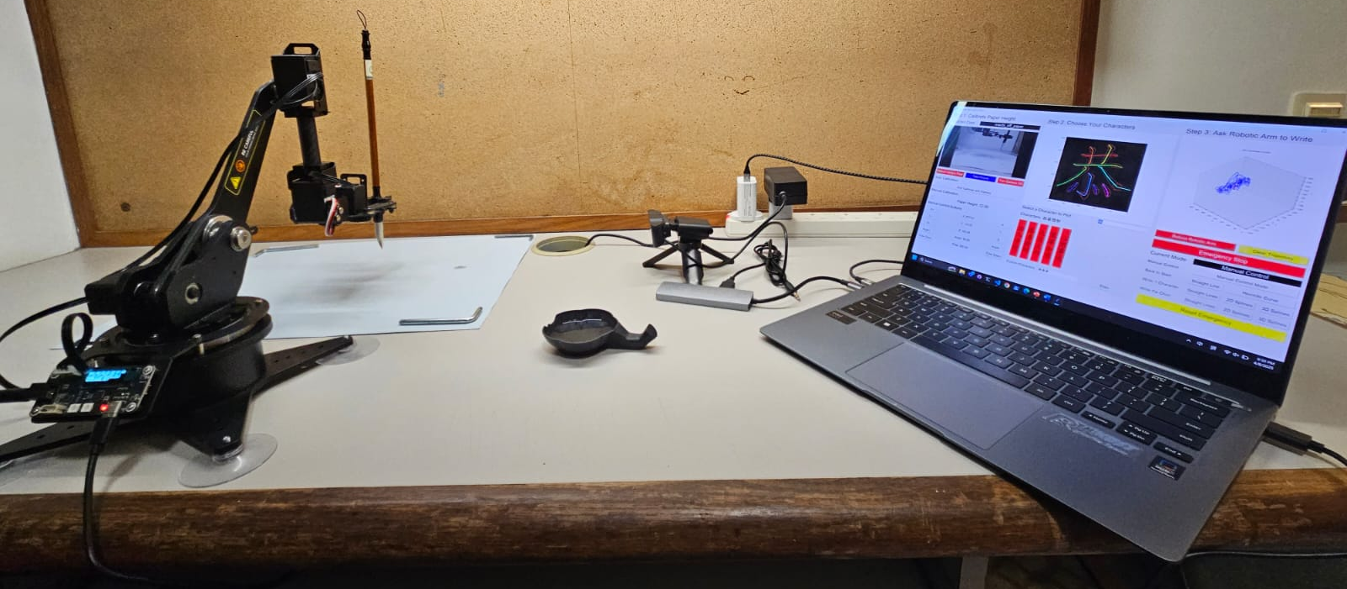
Figure 1. Experiment Setup of the Robot Manipulator System
The system features a 5-DOF (Degree of Freedom) robotic arm, specifically the Waveshare RoArm-M1, positioned at the bottom left corner of the table. This robotic arm is controlled by an integrated ESP-32 driver board. A 12V, 5A power supply is connected to the 12V DC port on the driver board to power the servo motors, while a USB cable links the driver board's serial port to the computer, facilitating the transmission of control signals from the main program.
At the top left of the table, the robotic arm's gripper holds a Chinese writing brush above a reusable water writing cloth. This cloth is designed to change color; it appears white when dry and turns black when wet, allowing for clean testing of the system without wasting paper or ink. A small black ink dish filled with water is positioned next to the drawing cloth to enable the robotic system to refill the brush as needed.
A 480p USB camera is mounted on the right side of the drawing cloth, oriented toward it. The camera has the following view as shown in the Figure 2 below. The white drawing cloth is located at the bottom of the image, potentially with some characters written on the drawing cloth. The gripper of the robotic arm is shown on the center left of the image, holding a Chinese writing brush on the right of the image.
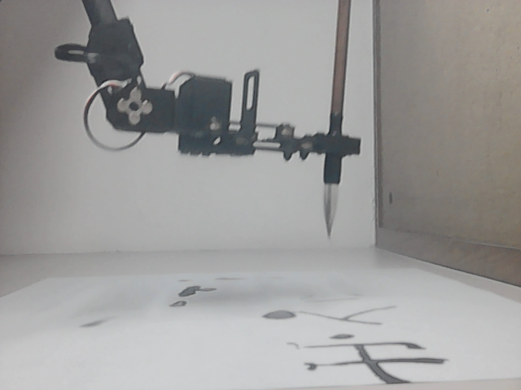
Figure 2. An Example Image Captured by the USB Camera
The images captured by the camera are transmitted to the computer via a USB cable. These images undergo preprocessing—including conversion to grayscale, resizing, and histogram equalization for contrast enhancement—before being fed into a Convolutional Neural Network (CNN) for object classification, which determines the position of the Chinese writing brush.
The computer is located on the right side of the table with a user interface as shown in Figure 3 below. Users can specify the characters or words they wish the system to write on the user interface and the program on the computer will control the robot manipulator system to write the given characters or words. A detailed explanation of different parts of the user interface would be introduced in Section 2.2 below.
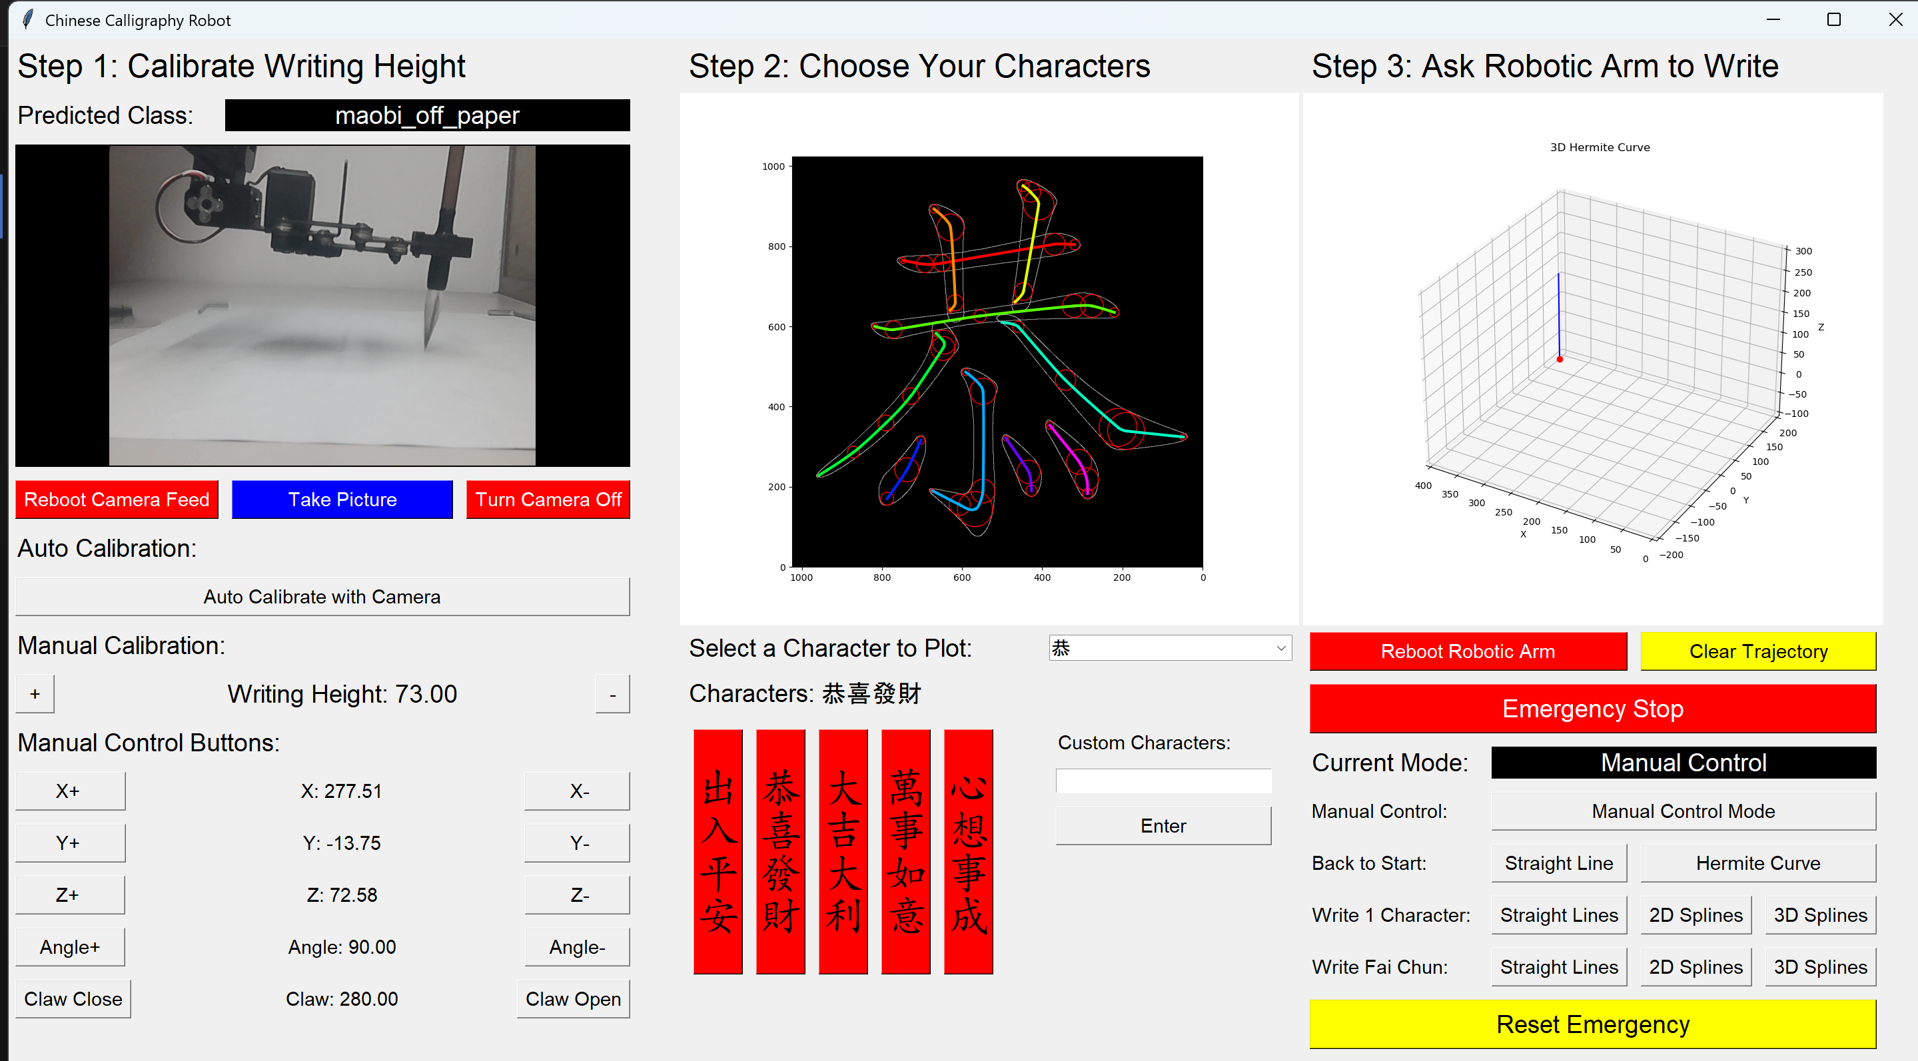
Figure 3. The User Interface of the Chinese Calligraphy Robot Manipulator System

System Block Diagram
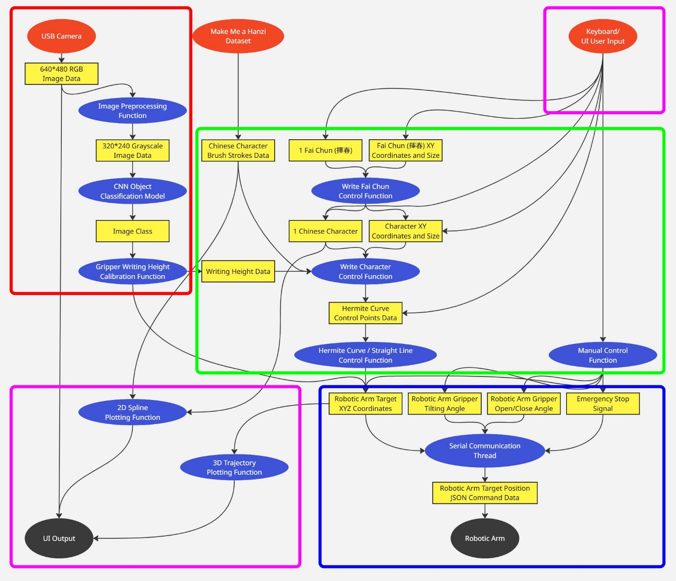
Figure 4. Data Flow of the Robot Manipulator System
Figure 4 illustrates the data flow within the robot manipulator system. The process begins with three input sources: the USB camera, the Make Me a Hanzi dataset [5], and keyboard/user interface (UI) inputs. The data then traverses through various processing threads, including the computer vision machine learning thread (red), the main control thread (green), the robotic arm control thread (blue), and the UI thread (purple). The data flow concludes with the output of target angles for all joints to the robotic arm, along with the display of the UI on the computer screen.
The computer vision thread (red) receives a stream of input images from the USB camera. The raw images are in 480p RGB format, with a resolution of 640x480 pixels. These images undergo preprocessing, which includes conversion to grayscale, resizing to 240p (320x240 pixels), and contrast enhancement through histogram equalization. The processed image is then fed into a pre-trained Convolutional Neural Network (CNN) object classification model, which categorizes the image into one of three classes: “no_maobi”, “maobi_off_paper”, or “maobi_on_paper”. Subsequently, a writing height calibration function utilizes these classifications to determine whether the Chinese writing brush (毛筆), referred to as “maobi” in pinyin, is in contact with the drawing paper or cloth.
The main control thread (green) employs a layered architecture. The bottom layer consists of a manual control function that directly outputs the target XYZ coordinates to the subsequent layer. Above this, the Hermite Curve control function takes Hermite curve control points—such as starting and ending positions, as well as velocities—and generates points along the curve based on the elapsed time since the command was initiated. The next layer, the Draw Character control function, processes a single character, decomposes it into smaller brush strokes using the Make Me a Hanzi dataset [5], and converts these into multiple Hermite splines for the Hermite Curve control function.
The robotic arm control thread (blue) receives target XYZ coordinates and additional commands, such as instructions to open or close the gripper and the gripper's tilting angle. These commands are combined into a single JSON message, which is transmitted to the robotic arm driver board via USB cable serial communication every 10 milliseconds to facilitate the movement of the robotic arm.
Finally, the user interface (UI) thread (purple) aggregates data from the various threads and presents it on a unified UI displayed on the computer screen. This interface contains multiple buttons to control different system functions and various labels to display information. Additionally, the raw images from the USB camera are shown, providing users with a visual of what the camera is capturing. The XYZ coordinates of the robotic arm's trajectory are saved and plotted on a 3D graph, clearly illustrating the robot's movement path.

Components List
Here is the list of the components used in the robot manipulator system. The table below shows the detailed specifications of the different components of the robot manipulator system that is used in this project.

Table 1. List of Specifications
Items | Specifications/Model
Robotic Arm | Waveshare RoArm-M1
Computer | Windows 11 laptop computer  Python 3.12.4 environment
USB camera | 480P Standard Computer Camera
Chinese Calligraphy Drawing Cloth | 45cm * 34.5cm water writing cloth
Chinese Drawing Brush | Beginner brush pen  Brush tip diameter: 0.9cm  Brush tip length: 3.8cm  Handle length: 24.5cm

CPEG Knowledge
This FYP provides an opportunity to synthesize knowledge and practical techniques acquired from both ECE and CSE courses. The following specific courses from the CPEG curriculum will be applied in this FYP:
COMP4211 --- Machine Learning
This course introduces the fundamentals of different supervised and unsupervised machine learning models. In this project, Convolutional Neural Network (CNN) is used to process the images from the computer vision system to detect whether the Chinese writing brush is in contact with the paper or not.
COMP4411 --- Computer Graphics
This course introduces the definitions and mathematical formulas of many different Bézier curves and splines that are commonly used in computer graphics. As well as the continuity of different curves to form a smooth, continuous splines. The Bézier curve, Hermite curve, Catmull-Rom spline, and the curves continuity from this course are used to draw the smooth paths for the robotic arm to move.
COMP4421 --- Image Processing
This course introduces the fundamentals of different image processing techniques. The concepts of image histogram, contrast stretching and compressing, histogram equalization, grayscale image are used to preprocess the images of the computer vision dataset before training the machine learning model in this project.
ELEC3210 --- Introduction to Mobile Robotics
This course introduces Robot Operating System (ROS), Kinematics, Sensors, Trajectory Planning for robotics applications. In this project, most of the concepts from this course will be used to control the robotic arm.
ELEC3300 --- Introduction to Embedded Systems
This course introduces many protocols that are commonly used in different embedded systems applications. Some of the knowledge in this course will be used in this project as Pulse Width Modulation (PWM) might be utilized to control the servo motors of the robotic arm. The concept of Universal Asynchronous Receiver / Transmitter (UART) protocol makes me familiar with how to send signals from my computer to the robotic arm through a serial port of the ESP32 driver board of the robotic arm.

Objective Statement Execution
This subsection further describes the robot manipulator system and outlines the design, programming, testing, and evaluation processes employed to ensure the system meets the established objectives.

Path Planning Algorithm using Bézier Curves
Objective: To develop and simulate a 3D Bézier curves path planning algorithm that generates smooth trajectories for the robot manipulator system.
In this objective, we develop a path planning algorithm for the robotic arm that follows a curved path defined using 3D Bézier curve. It also supports longer and more complex paths by combining multiple 3D Bézier curves into a 3D Bézier spline. Multiple 3D Bézier curves are combined with C¹ continuity or above, meaning that the position, velocity, and acceleration of the last point of the previous Bézier curve are equal to the position, velocity, and acceleration of the first point of the next Bézier curve. This ensures the smoothness between the 2 curves for a smooth trajectory.

Task 1
Aim: Simulate the trajectory of the robot manipulator system in a 3D plot.
Expected Outcome: The trajectory of the robot manipulator system is plotted on a 3D graph in real time such that the movement of the robotic arm can be simulated on my computer without the need of testing it on the physical robotic arm.
Work Description:
Task 1.1: Analyze Robocon Trajectory Planner:
As noted in Section 1.3, this project draws inspiration from the 2D Bézier-curve omnidirectional-wheelbase trajectory planner developed by the HKUST Robotics team's Robocon sub-team. The trajectory planner features a user-friendly interface, as shown on the left side of Figure 5, which displays the 2D Bézier-curved trajectory over a background image of the room’s floor plan. This design allows for easy visualization of the trajectory and modification of control points to achieve the desired shape. A similar visualization will be created to enable real-time plotting of the robotic arm's trajectory, simulating its movement on a computer without needing to test it on a physical robotic arm.
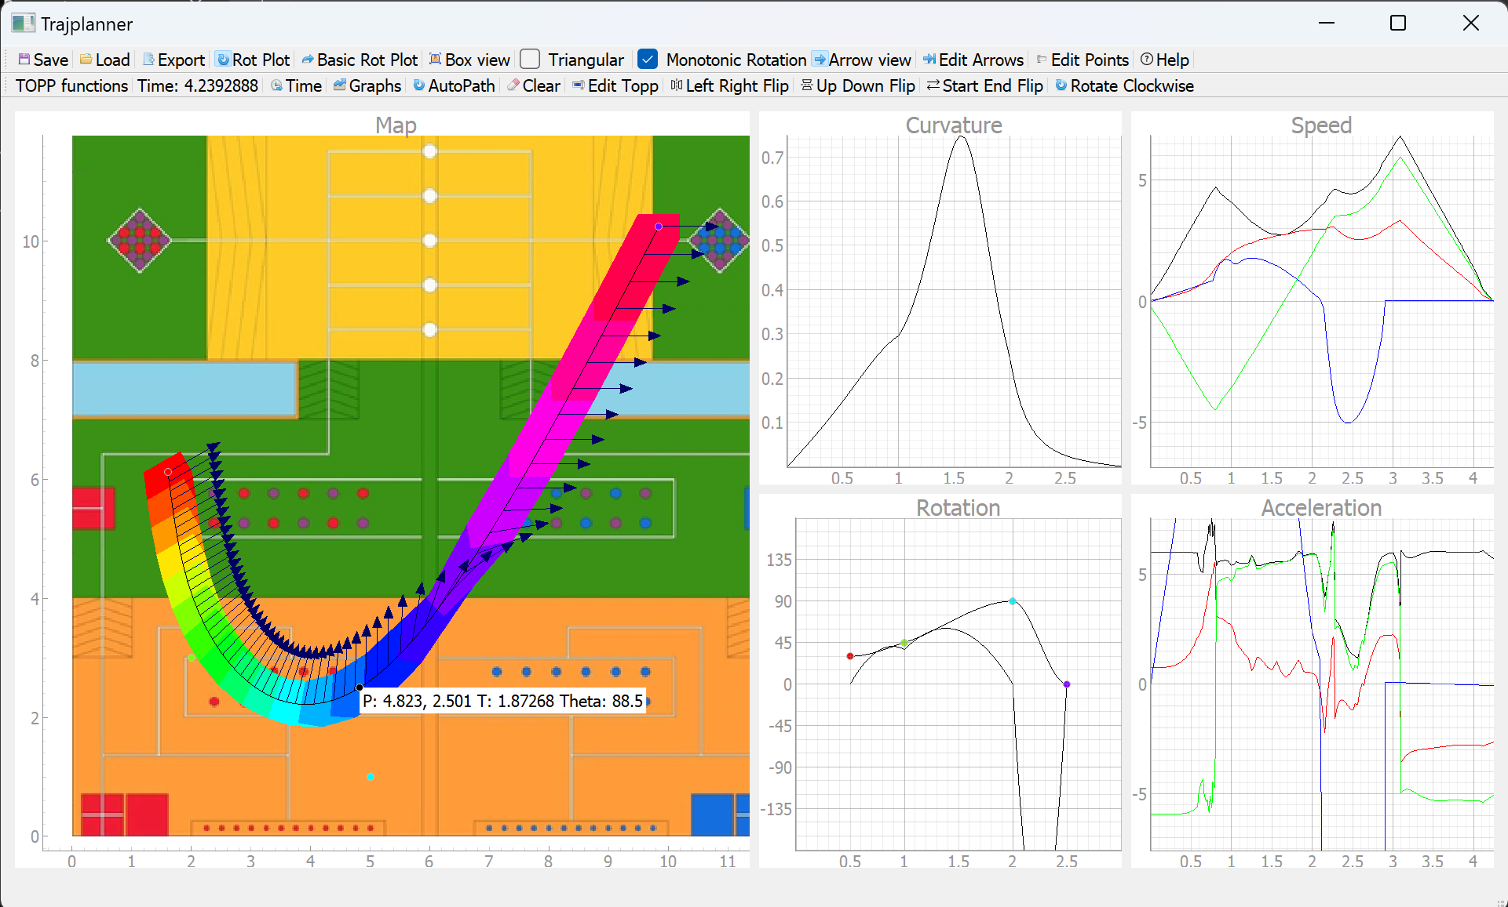
Figure 5. UI of Robocon 2D Bézier-Curve-Based Omnidirectional-Wheelbase Trajectory Planner
Inspired by this trajectory planner, time was dedicated to analyzing its underlying code to understand how the previous developers implemented the Bézier-curve-based approach. Although the code was somewhat disorganized, redundant components related to the UI and wheelbase control were eliminated, retaining only the sections focused on the Bézier-curve trajectory. The outcome is shown in Figure 6. The original design of applying a rainbow color scheme to the trajectory was followed, using red at the starting point and purple at the end to clearly illustrate the direction of the path.
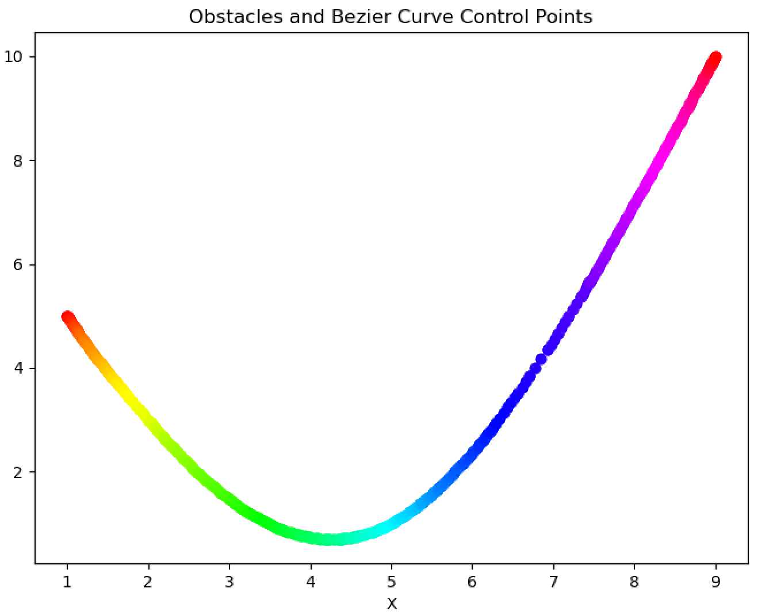
Figure 6. A 2D Bézier Curve-Based Trajectory Plotted Using Part of the Trajectory Planner's Code
Initially, the plan was to modify the trajectory planner's code to create a 3D Bézier-curve-based trajectory planner for this project. However, the code proved too complex due to a lack of comments and the use of unfamiliar abbreviated variable names. Additionally, adapting the original 2D plot into a 3D version was challenging because of the existing user interface functions for adding, dragging, and deleting control points. Consequently, a decision was made to develop everything from scratch.
Task 1.2: Waveshare RoArm-M2-S ROS2 MoveIt2 Simulation:
One supervisor suggested using the Waveshare RoArm-M2-S robotic arm, along with ROS2 and simulation software like Gazebo and MoveIt, to simulate the movement of the robotic arm. Following the instructions on the Waveshare RoArm-M2-S wiki, VirtualBox was set up on a Windows laptop to run Linux Ubuntu for ROS2. However, VirtualBox was laggy and took several minutes to boot. Therefore, WSL (Windows Subsystem for Linux) was chosen to run the Waveshare RoArm-M2-S MoveIt2 simulation instead. Despite encountering many missing libraries and errors during the WSL setup, the simulation was successfully executed. Figure 7 shows a screenshot of the RoArm-M2-S MoveIt simulation running on WSL.
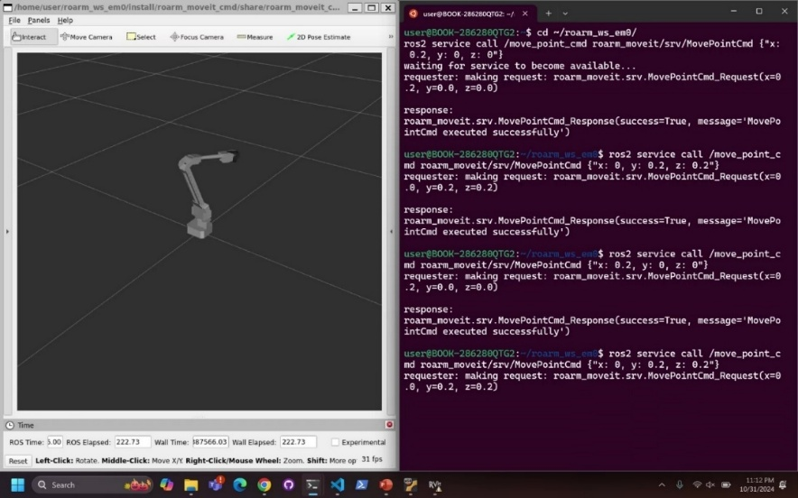
Figure 7. Screenshot of RoArm-M2-S MoveIt Simulation
However, the RoArm-M2-S only has 4 DOF (Degrees of Freedom), which is insufficient for this project. Consequently, another robotic arm from the same series was sought that has more DOF. The RoArm-M1, a 5 DOF robotic arm produced by the same company, was found. Since both robotic arms are from the same series, the code for the RoArm-M1 and RoArm-M2-S is highly similar, allowing for easy migration of work to the new robotic arm. However, the RoArm-M1 does not have a MoveIt simulation. Integrating other parts of the project into the WSL environment proved challenging, particularly in connecting USB serial ports, which are linked to the Windows environment, making it difficult to connect them to the Linux environment in WSL. As a result, connections to the robotic arm and the USB camera for the project were not possible.
Task 1.3: Python Matplotlib:
As an alternative, a simple Python program was written on the Windows computer using Matplotlib to plot the 3D trajectory. In Figure 8, the red dot represents the position of the robotic arm's tip. The x, y, and z coordinates of the red dot can be controlled by pressing the ‘w’, ‘a’, ‘s’, ‘d’, ‘r’, and ‘f’ keys. The trajectory of the red dot is plotted as a blue line, allowing for visualization of the robotic arm's trajectory without needing to test it with a physical robotic arm.
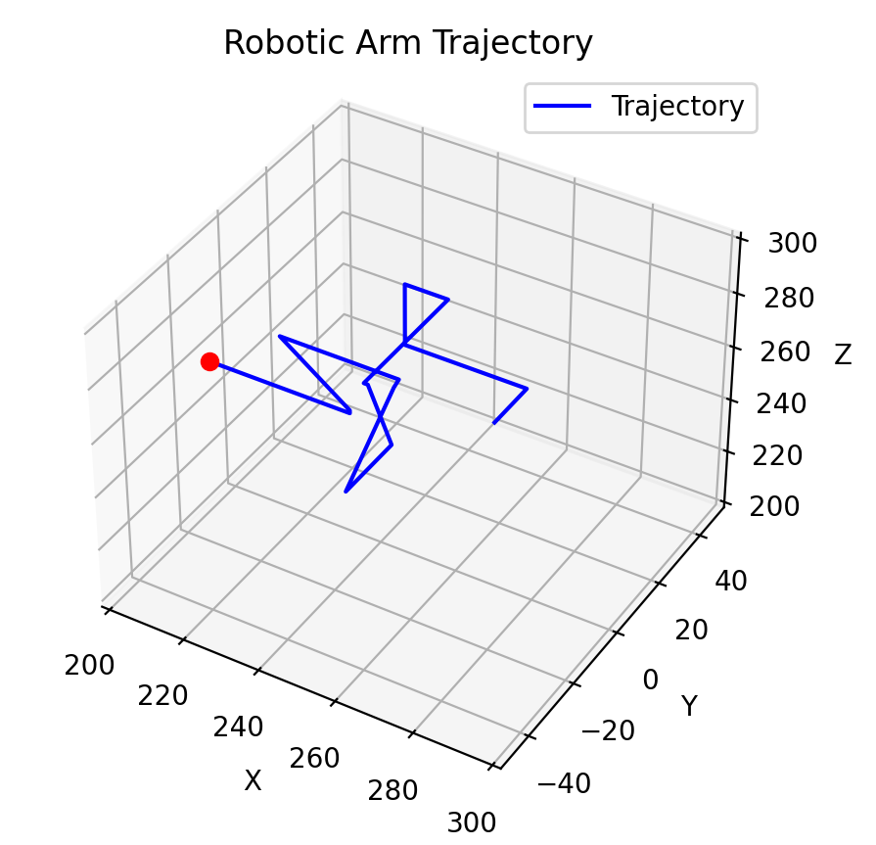
Figure 8. A 3D Plot of a Simulated Robotic Arm Trajectory
Task 2
Aim: Create a 3D Bézier curve algorithm that outputs target positions and velocities using specified control points.
Expected Outcome: Implement a Bézier curve algorithm that accepts a fixed number of 3D control points of the Bézier curve and plot the Bézier curve trajectory on by using Task 1’s simulator.
Work Description:
Since the original plan as stated in the proposal report is to shoot a basketball, the final position and velocity of the path is very important to the accuracy of shooting. So, a variant of Bézier curve called Hermite curve is chosen as it uses the start and end positions and velocities as control points.
The formula for Hermite curve is:
$$H\left(t\right)=\left[\begin{matrix}t^{3} & t^{2} & \begin{matrix}t & 1\end{matrix}\end{matrix}\right]\left[\begin{matrix}\begin{matrix}\begin{matrix}2 \\ -3 \\ \begin{matrix}0 \\ 1\end{matrix}\end{matrix} & \begin{matrix}-2 \\ 3 \\ \begin{matrix}0 \\ 0\end{matrix}\end{matrix}\end{matrix} & \begin{matrix}\begin{matrix}1 \\ -2 \\ \begin{matrix}1 \\ 0\end{matrix}\end{matrix} & \begin{matrix}1 \\ -1 \\ \begin{matrix}0 \\ 0\end{matrix}\end{matrix}\end{matrix}\end{matrix}\right]\left[\begin{matrix}\begin{matrix}\begin{matrix}P_{0x} & P_{0y} & P_{0z}\end{matrix} \\ \begin{matrix}P_{1x} & P_{1y} & P_{1z}\end{matrix}\end{matrix} \\ \begin{matrix}\begin{matrix}V_{0x} & V_{0y} & V_{0z}\end{matrix} \\ \begin{matrix}V_{1x} & V_{1y} & V_{1z}\end{matrix}\end{matrix}\end{matrix}\right]$$
, where
- Time t ranges from 0 ~ 1
- P₀ is the Starting Point 3D Position Vector
- P₁ is the Ending Point 3D Position Vector
- V₀ is the Starting Point 3D Velocity Vector
- V₁ is the Ending Point 3D Velocity Vector
We can plot the positions of the Hermite Curve by inputting various t values ranging from 0.00 to 1.00 in increments of 0.01. Figure 9 below illustrates a simple 3D plot of a Hermite curve represented by a blue line. Basic inverse kinematics is applied to the points along the curve to calculate the angles of the joints in a 4 DOF (Degree of Freedom) robotic arm, displayed in a rainbow color scheme. The robotic arm also indicates every 0.1 interval of t values.
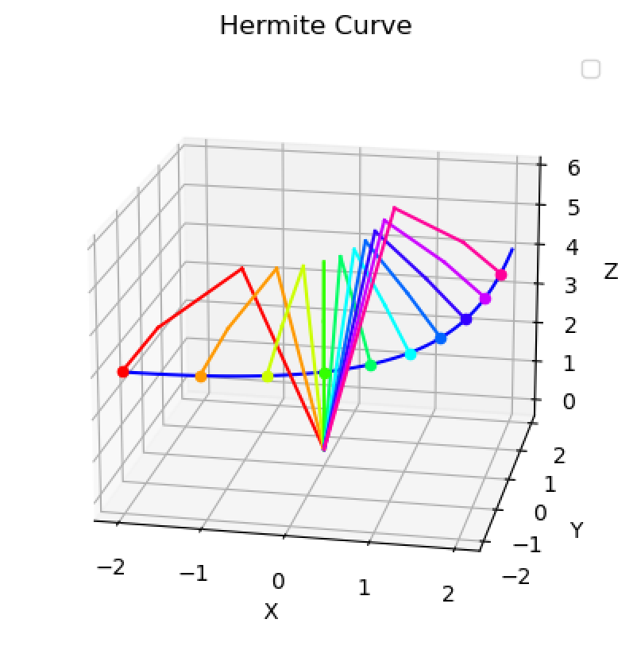
Figure 9. A 3D Hermite Curve Plot with Simulated Robotic Arm

Task 3
Aim: Develop a 3D Bézier spline algorithm that connects multiple Bézier curves with C¹ continuity.
Expected Outcome: Implement a Bézier spline algorithm that takes a variable number of 3D control points and plots the trajectory of the Bézier spline using the simulator from Task 1.
Work Description:
In Task 2, we work with two control points: the starting point P₀ and the ending point P₁. However, we often have more than two control points. To create a more complex path, we need to connect multiple Hermite curves. It is essential to ensure that these curves are joined with high continuity to preserve the overall smoothness. Otherwise, users may observe abrupt changes in position or speed as the robotic arm transitions between curves. Thus, we will maintain C¹ continuity.
Task 3.1: Continuity of curves:
Given two Hermite curves H₁(t) and H₂(t) with their corresponding control points, {P₀, V₀, P₁, V₁} and {P₂, V₂, P₃, V₃} respectively, where
- P₀, P₂ are the Starting Point 3D Position Vectors
- V₀, V₂ are the Starting Point 3D Velocity Vectors
- P₁, P₃ are the Ending Point 3D Position Vectors
- V₁, V₃ are the Ending Point 3D Velocity Vectors

C⁰ continuity:
The Hermite curves H₁(t) and H₂(t) have C⁰ continuity if the ending position of one curve equals to the starting position of the other curve. Mathematically, it can be represented as:
$$H_{1}\left(1\right)=H_{2}(0)$$
And if we further simplify it, it becomes
$$P_{1}=P_{2}$$
C⁰ continuity ensures that the two curves are continuous and are connected.

G¹ continuity:
The Hermite curves H₁(t) and H₂(t) have G¹ continuity if it has C⁰ continuity and the ending velocity of one curve has the same direction as the starting velocity of the other curve. Mathematically, it can be represented as:
$${H'}_{1}\left(1\right)=k {H^{'}}_{2}\left(0\right), where k>0$$
or
$$\frac{{H'}_{1}\left(1\right)}{|{H^{'}}_{1}\left(1\right)|}=\frac{{H'}_{2}\left(0\right)}{|{H^{'}}_{2}\left(0\right)|}$$
H’(t) is the first derivative of H(t). As Bézier curve is a simple parametric curve with the following formula below:
$$H\left(t\right)=\left[\begin{matrix}t^{3} & t^{2} & \begin{matrix}t & 1\end{matrix}\end{matrix}\right]\left[\begin{matrix}\begin{matrix}\begin{matrix}2 \\ -3 \\ \begin{matrix}0 \\ 1\end{matrix}\end{matrix} & \begin{matrix}-2 \\ 3 \\ \begin{matrix}0 \\ 0\end{matrix}\end{matrix}\end{matrix} & \begin{matrix}\begin{matrix}1 \\ -2 \\ \begin{matrix}1 \\ 0\end{matrix}\end{matrix} & \begin{matrix}1 \\ -1 \\ \begin{matrix}0 \\ 0\end{matrix}\end{matrix}\end{matrix}\end{matrix}\right]\left[\begin{matrix}\begin{matrix}\begin{matrix}P_{0x} & P_{0y} & P_{0z}\end{matrix} \\ \begin{matrix}P_{1x} & P_{1y} & P_{1z}\end{matrix}\end{matrix} \\ \begin{matrix}\begin{matrix}V_{0x} & V_{0y} & V_{0z}\end{matrix} \\ \begin{matrix}V_{1x} & V_{1y} & V_{1z}\end{matrix}\end{matrix}\end{matrix}\right]$$
It can be easily differentiated into:
$$H'\left(t\right)=\left[\begin{matrix}3t^{2} & 2t & \begin{matrix}1 & 0\end{matrix}\end{matrix}\right]\left[\begin{matrix}\begin{matrix}\begin{matrix}2 \\ -3 \\ \begin{matrix}0 \\ 1\end{matrix}\end{matrix} & \begin{matrix}-2 \\ 3 \\ \begin{matrix}0 \\ 0\end{matrix}\end{matrix}\end{matrix} & \begin{matrix}\begin{matrix}1 \\ -2 \\ \begin{matrix}1 \\ 0\end{matrix}\end{matrix} & \begin{matrix}1 \\ -1 \\ \begin{matrix}0 \\ 0\end{matrix}\end{matrix}\end{matrix}\end{matrix}\right]\left[\begin{matrix}\begin{matrix}\begin{matrix}P_{0x} & P_{0y} & P_{0z}\end{matrix} \\ \begin{matrix}P_{1x} & P_{1y} & P_{1z}\end{matrix}\end{matrix} \\ \begin{matrix}\begin{matrix}V_{0x} & V_{0y} & V_{0z}\end{matrix} \\ \begin{matrix}V_{1x} & V_{1y} & V_{1z}\end{matrix}\end{matrix}\end{matrix}\right]$$

And if we further simplify the G¹ continuity equations, it becomes
$$V_{1}=k V_{2}, where k>0$$
or
$$\frac{V_{1}}{|V_{1}|}=\frac{V_{2}}{|V_{2}|}$$
G¹ continuity ensures that the curves not only meet at a point but also have the same direction at the connection.
C¹ continuity:
The Hermite curves H₁(t) and H₂(t) have C¹ continuity if it has C⁰ continuity and the ending velocity of one curve is equal to the starting velocity of the other curve. Mathematically, it can be represented as:
$${H'}_{1}\left(1\right)={H^{'}}_{2}\left(0\right)$$
And if we further simplify it, it becomes
$$V_{1}=V_{2}$$
C¹ continuity ensures a smooth transition in both position and velocity, preventing any abrupt changes in motion.
Task 3.2: Plot Hermite Spline:
Although higher continuity, such as C² or even C³, where the second and third derivatives of the Hermite curves are also equal, could be achieved, this would impose too many constraints on the curve, reducing flexibility in controlling the spline's shape. Therefore, C¹ continuity was chosen, with the following constraints:
$$P_{1}=P_{2} and V_{1}=V_{2}$$

With these constraints, the Hermite spline can be plotted as shown in Figure 10:

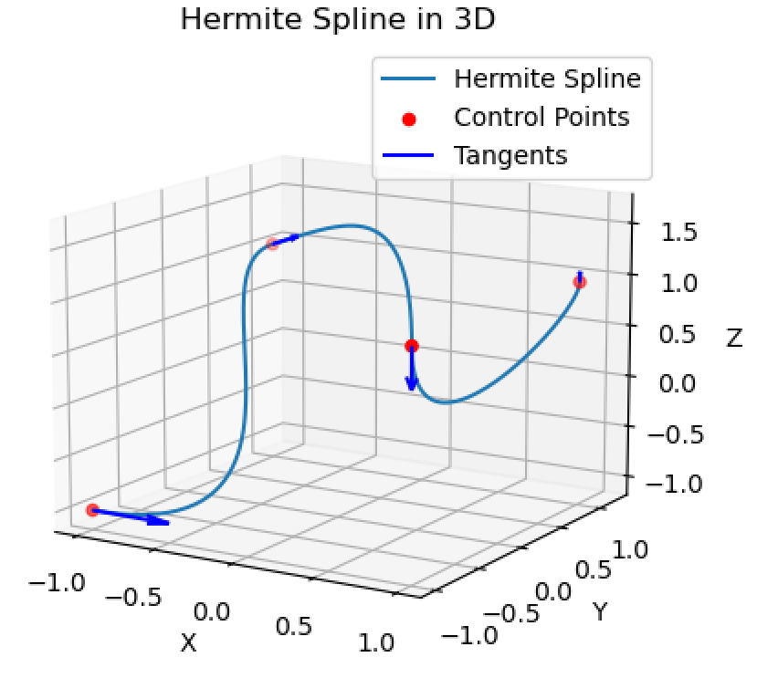
Figure 10. A 3D Hermite Spline Trajectory
Task 3.3: Showing the spline continuity:
To show its continuity, we can plot its first, second, third derivative graphs as well as the curvature graph of the Hermite spline to visualize it. The equations of the second and third derivatives can be calculated by
$$H''\left(t\right)=\left[\begin{matrix}6t & 2 & \begin{matrix}0 & 0\end{matrix}\end{matrix}\right]\left[\begin{matrix}\begin{matrix}\begin{matrix}2 \\ -3 \\ \begin{matrix}0 \\ 1\end{matrix}\end{matrix} & \begin{matrix}-2 \\ 3 \\ \begin{matrix}0 \\ 0\end{matrix}\end{matrix}\end{matrix} & \begin{matrix}\begin{matrix}1 \\ -2 \\ \begin{matrix}1 \\ 0\end{matrix}\end{matrix} & \begin{matrix}1 \\ -1 \\ \begin{matrix}0 \\ 0\end{matrix}\end{matrix}\end{matrix}\end{matrix}\right]\left[\begin{matrix}\begin{matrix}\begin{matrix}P_{0x} & P_{0y} & P_{0z}\end{matrix} \\ \begin{matrix}P_{1x} & P_{1y} & P_{1z}\end{matrix}\end{matrix} \\ \begin{matrix}\begin{matrix}V_{0x} & V_{0y} & V_{0z}\end{matrix} \\ \begin{matrix}V_{1x} & V_{1y} & V_{1z}\end{matrix}\end{matrix}\end{matrix}\right]$$
$$H'''\left(t\right)=\left[\begin{matrix}6 & 0 & \begin{matrix}0 & 0\end{matrix}\end{matrix}\right]\left[\begin{matrix}\begin{matrix}\begin{matrix}2 \\ -3 \\ \begin{matrix}0 \\ 1\end{matrix}\end{matrix} & \begin{matrix}-2 \\ 3 \\ \begin{matrix}0 \\ 0\end{matrix}\end{matrix}\end{matrix} & \begin{matrix}\begin{matrix}1 \\ -2 \\ \begin{matrix}1 \\ 0\end{matrix}\end{matrix} & \begin{matrix}1 \\ -1 \\ \begin{matrix}0 \\ 0\end{matrix}\end{matrix}\end{matrix}\end{matrix}\right]\left[\begin{matrix}\begin{matrix}\begin{matrix}P_{0x} & P_{0y} & P_{0z}\end{matrix} \\ \begin{matrix}P_{1x} & P_{1y} & P_{1z}\end{matrix}\end{matrix} \\ \begin{matrix}\begin{matrix}V_{0x} & V_{0y} & V_{0z}\end{matrix} \\ \begin{matrix}V_{1x} & V_{1y} & V_{1z}\end{matrix}\end{matrix}\end{matrix}\right]$$

And the curvature of the Hermite curve can be calculated using the formula below:
$$κ\left(t\right)=\frac{\left\|H^{'}\left(t\right)×H''(t)\right\|}{{\left\|H'(t)\right\|}^{3}}$$

A Hermite spline that consists of 3 Hermite curves are plotted below in Figure 11 with its curvature graph and its first, second, and third derivative graphs. The 3 Hermite curves are colored in red, green, and blue respectively for easier identification.

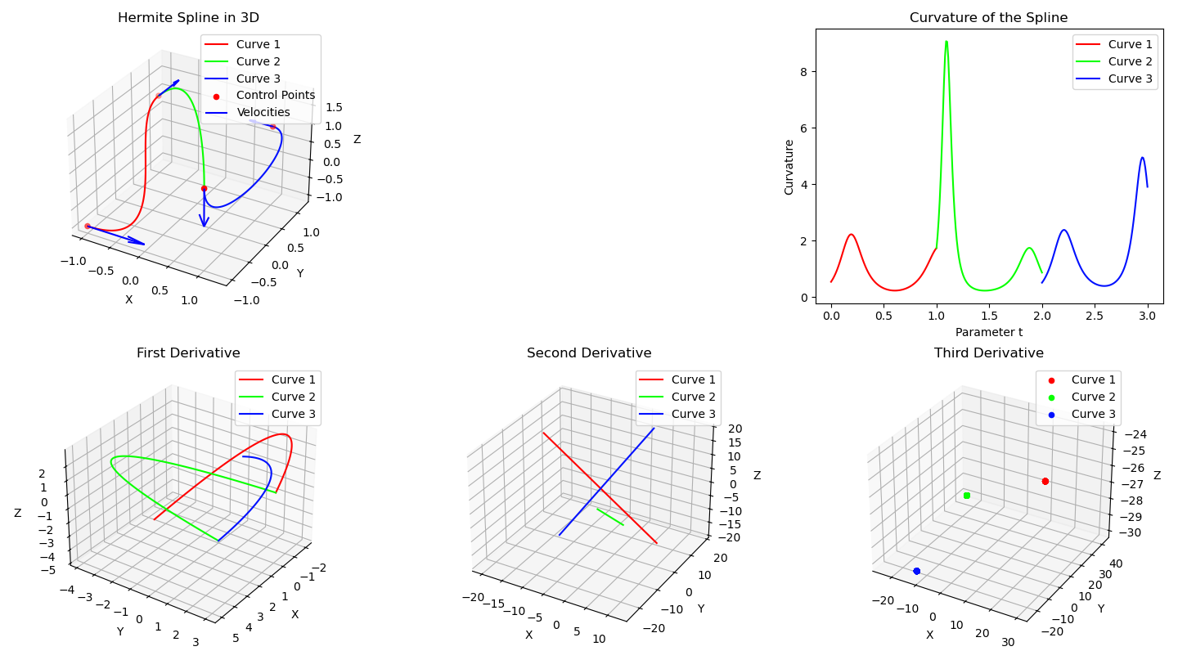
Figure 11. A 3D Hermite Spline Trajectory with its Curvature and Derivative Graphs
As shown in the graphs above, the Hermite curves in the Hermite Spline graph are connected, indicating C⁰ continuity. Similarly, the First Derivative graph also shows that the three curves are connected, confirming C¹ continuity. However, in the Second Derivative graph, the three curves appear as separate lines, indicating a lack of C² continuity. Likewise, the Third Derivative graph displays three separate points, indicating no C³ continuity. Since the curvature of the Hermite curve relies on the second derivative, the curvature graph is also disconnected. This discontinuity may lead to a non-smooth trajectory in later parts of the project, and improvements will be sought in the future.

Applying Bézier Curves Path Planning on Chinese Calligraphy
Objective: To implement the Bézier curves path planning algorithm on the robot manipulator system for writing Chinese calligraphy, demonstrating the algorithm's precise and fluid movements.
In this objective, we will implement the Bézier curves path planning algorithm developed in Task 1 on the robotic arm to test its real-world performance. Chinese calligraphy has been selected as the application because the characters produced by the robotic arm effectively illustrate the algorithm's trajectory. Although the writing surface is 2D, Chinese calligraphy can convey a sense of three-dimensionality due to the unique nature of the writing brush. When the brush is slightly lifted, the stroke becomes thinner, and the opposite occurs when it is pressed down. Thus, the characters created in Chinese calligraphy can showcase the precise and fluid movements of the 3D Bézier spline path planning algorithm.
Task 1
Aim: Acquire the robotic arm and Chinese calligraphy tools for this project.
Expected Outcome: Successfully purchase all necessary materials through Taobao for use in this project
Work Description:
For this task, the required materials were acquired to test the developed code. Given a lack of prior online shopping experience, challenges arose in searching for items, completing online payments, and managing delivery logistics.
In November, the Waveshare RoArm-M1 robotic arm was purchased. Due to unfamiliarity with Taobao, prices across different shops were not compared, resulting in a payment that was 10% higher than the lowest available price.
Additionally, a beginner Chinese calligraphy set was acquired, which includes a writing brush, several water writing cloths, and an ink dish. The water writing cloth is particularly useful for repeated testing, as it turns black when wet and returns to white when dry. This allows for multiple tests without wasting paper or creating a mess with ink, as only water is needed for writing.
Traditional Chinese calligraphy ink and red Fai Chun papers were also obtained for final demonstrations, though testing to determine any performance differences between water and ink is still pending.
Unfortunately, one of the servo motors on the robotic arm stalled during testing in early March, necessitating the purchase of a replacement motor. This delay resulted in an additional two weeks added to the project timeline due to shipping.
shipping.
Task 2
Aim: Control the robotic arm to move to some 3D coordinates using my own code
Expected Outcome: The robotic arm can move to the desired 3D position with the desired gripper tilting angle and gripper open/close angle with my own program.
Work Description:
Task 2.1: Move to 3D Coordinates:
Initially, the plan was to perform inverse kinematics on the target 3D coordinates and gripper angles to derive the joint angles needed to control the robotic arm. However, after reviewing the RoArm-M1 wiki provided by the manufacturer, it is discovered that the inverse kinematics algorithm has already been integrated into the ESP32 driver board by the manufacturer. This allows me to send data in JSON format via the USB serial port to control the arm's movement to specific target 3D coordinates and gripper angles.
Here is the JSON commands used in the project:
EMERGENCY_STOP: {"T":0}
COORD_CTRL:
T: cmdType, P1-3: coordInput, P4: thetaAngle, P5: grabberAngle, S1: stepDelay, S5: grabberSpeed
{"T": 2, "P1": 253.53437236026596, "P2": -173.010771951539216, "P3": 261.72576730676815, "P4": 88.20000000000002, "P5": 251.0, "S1": 10, "S5": 200}
The baud rate of the USB serial port is set at 115200. Given that the JSON message can exceed 150 bytes due to the number of decimal places in values P1 to P5, the estimated number of messages that can be sent each second is calculated as follows:
$$\frac{baud rate}{message size}=\frac{115200 bit/s}{150 bytes}=\frac{115200 bit/s}{150*8 bit}=96 messages/s$$
When a delay of 0.01s was implemented in the code, the program occasionally crashed, unable to send 100 messages per second. To resolve this, the delay is increased to 0.02s, limiting the rate to 50 messages per second to prevent the robotic arm from becoming uncontrollable due to backlogged commands. Although the rounding of the floating-point numbers to two decimal places is attempted to reduce message size, the robotic arm would stop moving midway and display warning lights if the delay was set to 0.01s. Therefore, the delay of 0.02s is used in the end for stability.
Task 2.2: Emergency Stop:
The importance of the emergency stop function was recognized due to experience gained in the HKUST Robotics Team. This led to the implementation of the emergency stop command from the very beginning of the project during the initial tests of the robotic arm. When the space bar is pressed or the emergency button on the UI is activated, the program immediately sends the EMERGENCY_STOP command to halt operation.
However, in early March, the program encountered an unknown error and crashed, preventing the emergency stop signal from being sent as the program was no longer running. This resulted in one of the servo motors on the robotic arm stalling, necessitating the purchase of a replacement motor and causing a delay of one week in the project timeline.
Task 3
Aim: Apply the 3D Bézier spline algorithm on the robotic arm to write a Chinese character.
Expected Outcome: The robotic arm can write a Chinese character using the 3D Bézier spline algorithm
Work Description:
Task 3.1 Find Control Points for writing Chinese character:
In Section 2.2.1 task 3, the implementation of a 3D Bézier spline algorithm was discussed. The next step involves inputting control points into the algorithm to allow the robotic arm to follow the generated trajectory. For writing Chinese characters, these control points correspond to the brush strokes of the characters.
A search was conducted for a dataset of Chinese character brush strokes, specifically targeting traditional Chinese characters used in Hong Kong, rather than the simplified characters used in mainland China. A suitable dataset called “Make Me a Hanzi” was found. This free, open-source dataset includes over 9,000 of the most common simplified and traditional Chinese characters.
The “Make Me a Hanzi” dataset is divided into two parts: dictionary.txt, which provides dictionary data, and graphics.txt, which contains stroke-order vector graphics. For the purpose of writing characters, only the graphics.txt file is utilized for its stroke order and graphics data.
The graphics.txt file is further divided into two sections: the "strokes" in SVG path format, which store the outlines of the character strokes (represented by the white lines in Figure 12), and the "medians" in list format, which store the points used to produce a rough stroke-order animation (represented by the red points in Figure 12). The characters are drawn on a 1024x1024 canvas, which must be scaled down to 100mm x 100mm for this project to ensure they fit within the paper and remain within the robotic arm's movable range. The scaled coordinates are then translated in both the x and y directions to center the character on the paper.
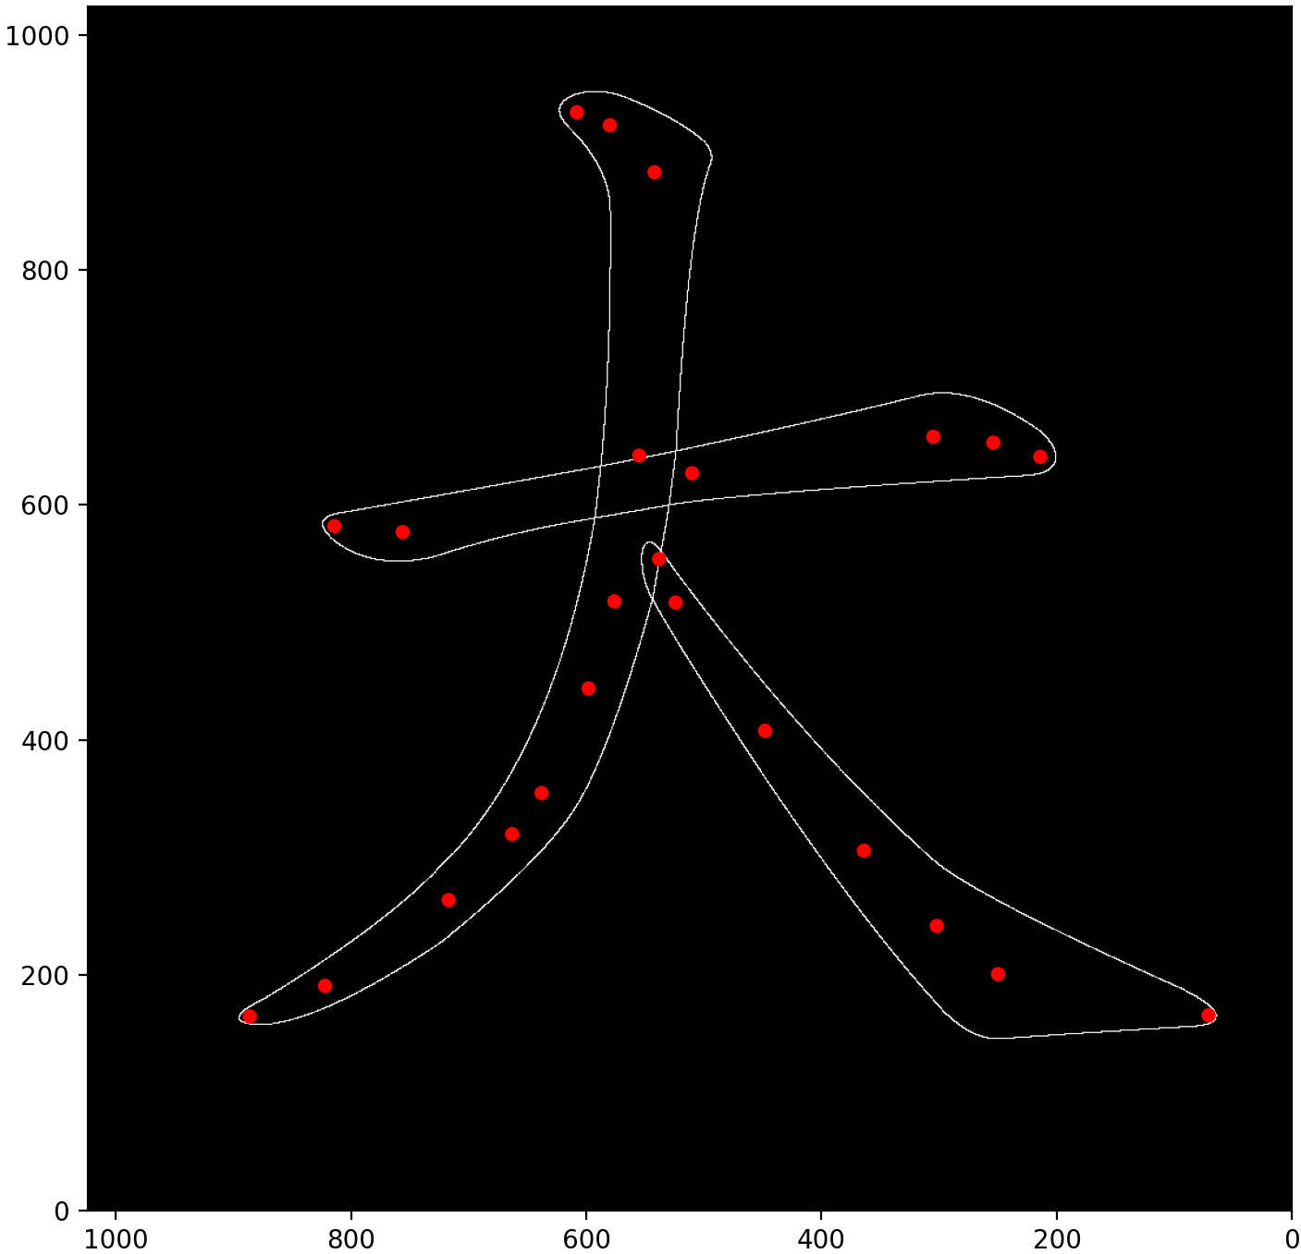
Figure 12. The Graphics Data of the Chinese Character 大 in graphics.txt
The "medians" data from graphics.txt is used as the control points for the 3D Bézier spline algorithm. As these points are 2D coordinates, a hard-coded Z coordinate, referred to as gripper_writing_height, is added. This height represents the optimal distance between the robotic arm and the paper, ensuring that the writing brush maintains contact with the paper without excessive bending.
With control points P₀​ and P₁​ established, the next step is to calculate the control velocities V₀​ and V₁​ to ensure the spline is smooth and accurately follows the strokes of the Chinese character.
Task 3.2 Calculate control velocities for the Bézier spline:
Inspired by the Catmull-Rom Splines algorithm discussed in the COMP 4411 lecture, control velocities were defined based on the previous and next control points. For a Bézier spline with n control points, the control velocity V_{i}​ is defined as follows:
$$V_{i}=\left\{\begin{aligned}k\left(P_{1}-P_{0}\right) if i=0 \\ k\left(P_{i+1}-P_{i-1}\right) if 1≤i≤n-2 \\ k\left(P_{n-1}-P_{n-2}\right) if i=n-1 \end{aligned}\right.$$
, where
- n is the total number of control point in the spline
- k is the tension control parameter (in the Figure 13 below, k = ½)
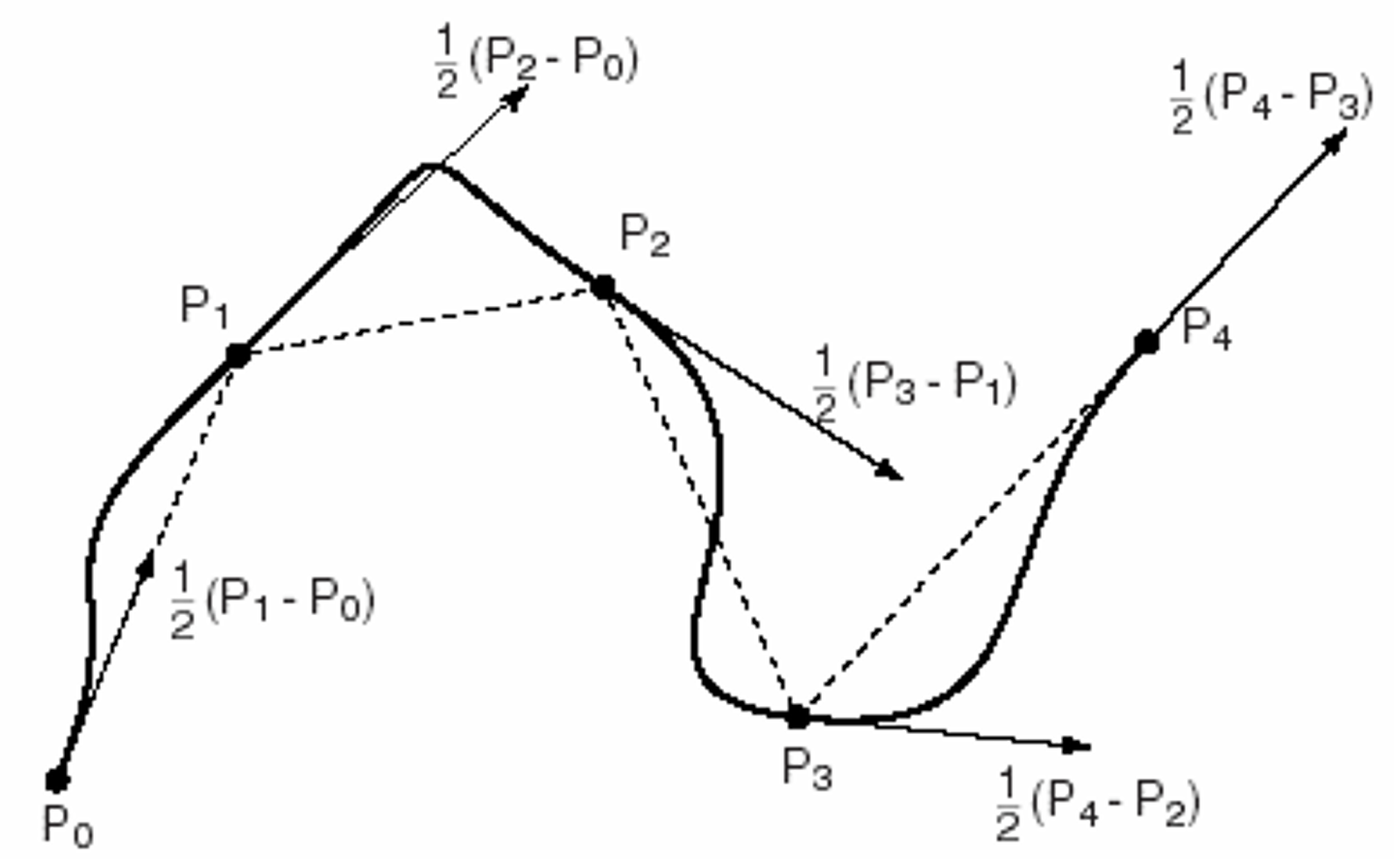
Figure 13. A Catmull-Rom Spline in HKUST COMP4411 Lecture Notes
Image Source: C. K. Tang, Class Lecture, Topic: "Lecture 16b Curve details." COMP4411, CSE, HKUST, Hong Kong, May, 2, 2024.
The tension control parameter k is experimented with different values. if k is too small, the spline would appear as if the points are simply connected by straight lines. An example is shown in the left graph in Figure 14 below. If k is too large, there will be some twists and backward movement in the middle of the spline as shown in the right graph of Figure 14 below. Various values of k were tested, but they either resulted in overly straight lines or undesirable twists in more complex characters.

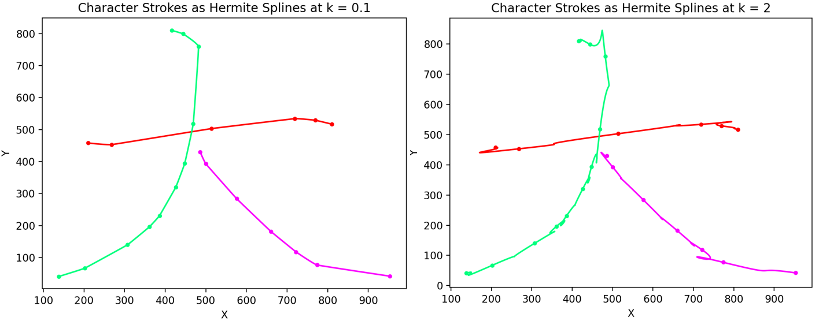
Figure 14. Hermite Spline of the Chinese Character 大 with Different Tension Control
As the medians point are not distributed evenly, when the distance to the previous point and the distance to the next point has a large difference, the control velocity would be unreasonably large for the shorter curve. This would result in overshooting and the strange twist and backward movement in the middle of the spline.
Therefore, the formula of the control velocities V_{i} is modified to make it depends on the distance to the closer control points：
$$V_{i}=\left\{\begin{aligned}k\left(P_{1}-P_{0}\right) if i=0 \\ k ∙min\left({|P}_{i+1}-P_{i}|, { |P}_{i}-P_{i-1}|\right) \frac{P_{i+1}-P_{i-1}}{|P_{i+1}-P_{i-1}|} if 1≤i≤n-2 \\ k\left(P_{n-1}-P_{n-2}\right) if i=n-1 \end{aligned}\right.$$
, where
- n is the total number of control point in the spline
- k is the tension control parameter
$\frac{P_{i+1}-P_{i-1}}{|P_{i+1}-P_{i-1}|}$is the unit vector of the direction from previous control point to the next control point.
${|P}_{i+1}-P_{i}|$ calculates the magnitude between the current point and the next control point.
${|P}_{i}-P_{i-1}|$ calculates the magnitude between the current point and the previous control point.
$min\left({|P}_{i+1}-P_{i}|, { |P}_{i}-P_{i-1}|\right)$ outputs the minimum between the two magnitudes. This limits the control velocity such that it will not become unreasonably large and overshoots. If it does not overshoot, there will be no strange twists and backward movements in the middle of the spline.
After further experimentation with the tension control parameter, k=1 was selected. If k > 1, The shorter curve might need to move backwards to achieve the target control velocity. On the other hand, if k < 1, the curve would not be that obvious and would tends to be a straight line. Figure 15 below shows the result of the spline using this modified formula:

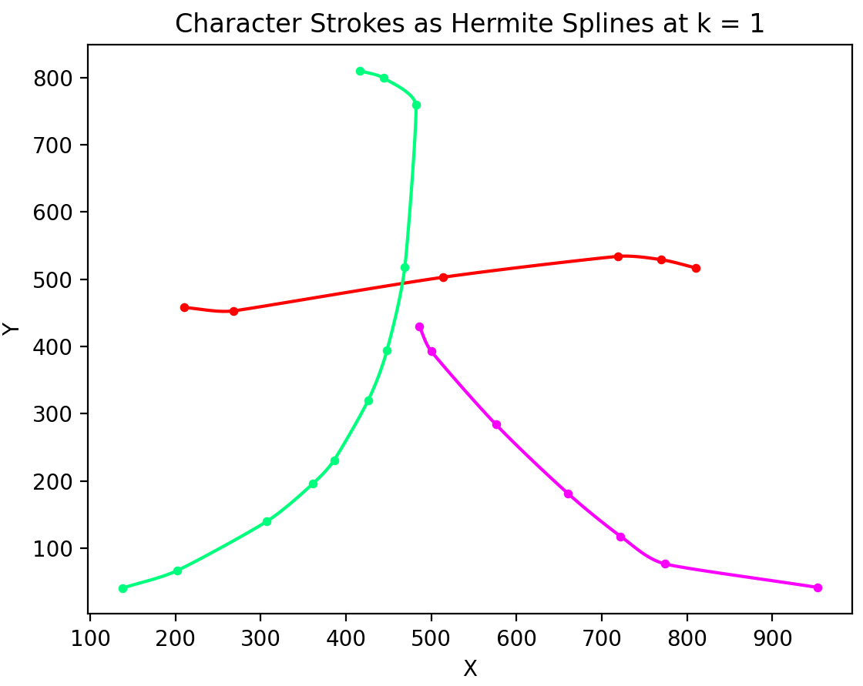
Figure 15. Hermite Spline of the Chinese Character 大 with the Modified Formula

Task 3.3 Equalizing Hermite curves’ speed along the spline:
During the simulation of drawing the splines, it was observed that the robotic arm moved slowly on short curves while moving quickly on longer curves. This discrepancy was due to the uniform incrementation of the time variable t by adding 0.01 every 20ms. Since all Hermite curves start at t=0 and end at t=1, regardless of their control points, both short and long curves took 2 seconds to complete their travel. To address this, it was decided to increment t based on the length of the curve, ensuring all curves travel at the same speed.
The formula for calculating the curve length LLL is given by:
$$L=\int_{0}^{1}{\left|\left|H\left(t\right)\right|\right| dt}$$
Since this integral may not have a closed form, numerical approximation is used to estimate its value. The curve is subdivided into 100 segments by substituting t=0, 0.01, 0.02, …, 0.99, into H(t). Each segment is defined as follows: segment 1 is between t=0 and t=0.01, segment 2 is between t=0.01 and t=0.02, and so on. The Euclidean distance between the starting and ending points of each segment is calculated and summed to obtain the total estimated length of the entire curve.
The mathematical formula for this numerical approximation is:
$$L=\left\|H\left(0\right)-H(0.01)\right\|+\left\|H\left(0.01\right)-H(0.02)\right\|+\left\|H\left(0.02\right)-H(0.03)\right\|+…+\left\|H\left(0.99\right)-H(1.00)\right\|$$

With the approximated curve lengths calculated for each Hermite curve in the spline, t can be incremented based on the length of the current Hermite curve. For every 20ms, the update for t is defined as:
$$t+=\frac{PEN_SPEED}{curve_length}$$
, where
PEN_SPEED is a constant parameter used to control the overall speed of the spline, and
curve_length is the length of the current traveling Hermite curve.
This method ensures that each curve of the spline takes $\frac{curve_length}{PEN_SPEED}$​ time to move from t=0 to t=1. Consequently, shorter Hermite curves complete their travel in less time, while longer curves take more time, allowing all curves to maintain a consistent speed throughout the entire spline and across different curves and splines.
Task 3.4 Connecting different brush stroke splines together:
With the Bézier spline of each brush stroke calculated, the next step is to connect different brush strokes together. After writing one stroke, the robotic arm needs to lift up the Chinese writing brush such that the brush does not touch the paper. Then move to the beginning of the next stroke and put down the writing brush such that it touches the paper again.
I decided to add a simple Hermite curve with the following control points to connect two strokes together.
- P₀ is the Starting Point 3D Position Vector: The last control point of the current stroke
- P₁ is the Ending Point 3D Position Vector: The first control point of the next stroke
- V₀ is the Starting Point 3D Velocity Vector: Directly upwards in +Z direction
- V₁ is the Ending Point 3D Velocity Vector: Directly downwards in -Z direction with the same magnitude as V₀
Since V₀ and V₁ are equal in magnitude but in opposite direction, the Hermite curve is symmetrical and very smooth to see. With these connecting curves (red trajectories in Figure 16 below), We can connect the splines of the different brush stroke (black trajectories in Figure 16 below) into one long path.
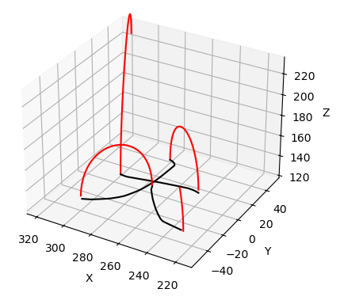
Figure 16. Trajectory of Writing the Chinese Character 大 with 2D Spline Algorithm
The robotic arm starts at the top initial position. Then, it moves through a red connecting Hermite curve into the first control point of the first stroke of character. It then moves through the black spline of the first stroke of the character, which is the same spline as the red spline plotted in Figure 15 above on previous page. When it reaches the end of the first spline, it can then go through the connecting red Hermite curve to go to the beginning of the second brush stroke. This process repeats until it finishes writing all brush strokes of the given character.
The connecting Hermite curves and the splines are only connected with C⁰ continuity as only the positions of their control points are connected while their velocities are almost perpendicular. This sudden change in velocity at the control points often leads to the robotic arm skipping the initial parts of the spline and only in contact with the spline moments later. That is why a slight delay is added after every connecting curve such that it stays in the starting point of the spline for a short period of time before proceeding to draw the spline. Although this slightly lowers its writing speed, it significantly improves the writing accuracy of the character.
Task 3.5 Testing the algorithm on robotic arm with different hardcoded Z values:
As stated in Task 3.1, the Z coordinates of the control points are hardcoded to a value called gripper_writing_height. It determines the distance between the gripper and the paper when the robotic arm is writing the Chinese characters. The red arrows in the Figure 17 below illustrates the different gripper_writing_height values when the robotic arm hold the Chinese writing brush in different positions:
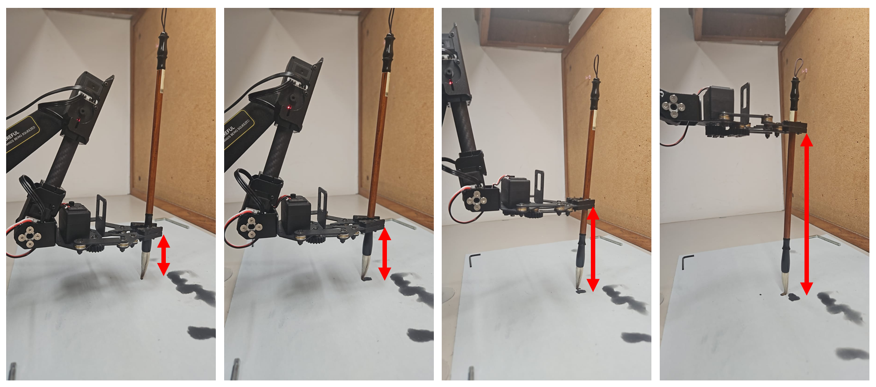
Figure 17. Different gripper_writing_height Values for Different Positions of the Chinese Writing Brush
Different values of gripper_writing_height would affect the thickness of the brush strokes drawn on the paper. Here are some resulting characters drawn by the robotic arm with different gripper_writing_height values:
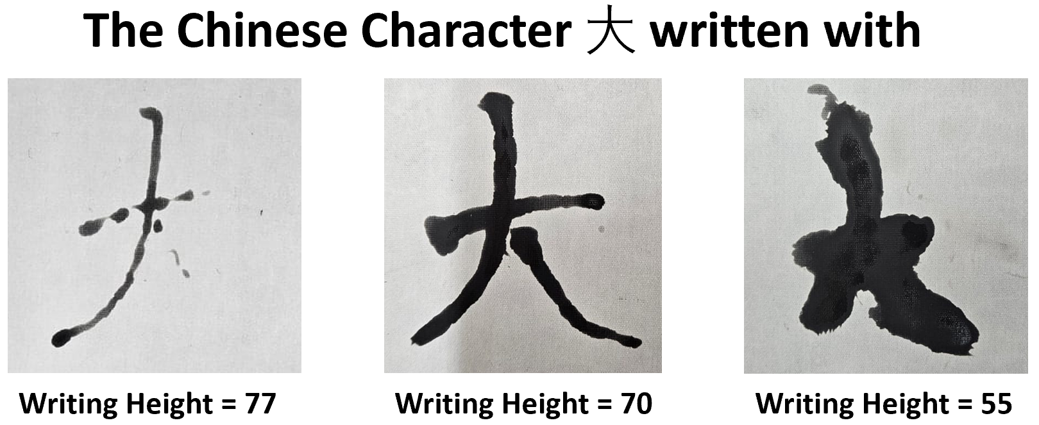
Figure 18. The Chinese Character 大 Written with Different gripper_writing_height Values
As illustrated in the character on the left of Figure 18, if the gripper_writing_height is set too high, the strokes appear thin. Additionally, the brush may lift off the paper, causing strokes to vanish, as seen in the bottom right part of the character on the left. Conversely, if the gripper_writing_height is too low, the strokes become overly thick, like the character on the right. While this character remains identifiable due to its three strokes, characters with more than ten strokes may become indistinguishable as the thick strokes blur together. Thus, it is essential to determine an optimal gripper_writing_height value that yields thin strokes like the character in the middle while ensuring all strokes maintain contact with the paper.

Task 3.6 Calculate different Z coordinates for different control points:
While the robotic arm can write normally using hard-coded Z values, the thickness of all brush strokes remains uniformly sized, limiting the demonstration of the full capabilities of the 3D Bézier spline algorithm. In Chinese calligraphy, the thickness of strokes can vary even within the same stroke. For example, the simplest Chinese character 一 features a single horizontal brush stroke that starts thick on the left, becomes thinner in the middle, and thickens again on the right, as illustrated in Figure 19. This variation in thickness contributes to a more natural appearance and reduces the robotic feel of the Chinese calligraphy.
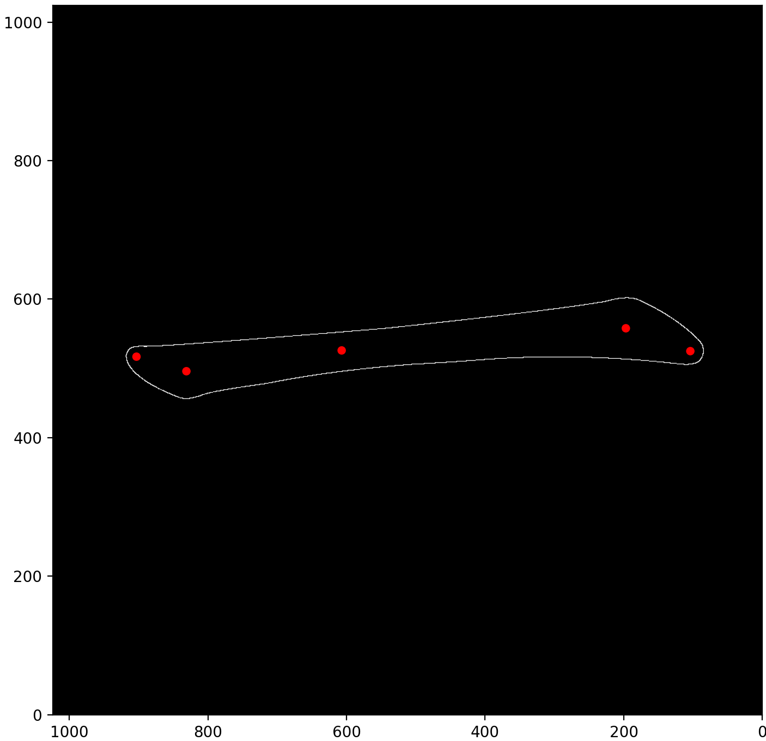
Figure 19. The Graphics Data of the Chinese Character 一 in graphics.txt
To calculate the thickness of the brush stroke, data from graphics.txt must be utilized. Currently, only the "medians" points (the red points in Figure 19) are being used as spline control points. To determine the thickness of the brush stroke, the "strokes" data (the white lines in Figure 19) is also needed. The "strokes" data is in SVG path format, necessitating parsing and plotting on a 1024x1024 binary array.
The strokes are processed individually to avoid complications from overlapping strokes. Each stroke's path data is parsed and plotted on an empty binary array. The corresponding red "medians" points for each stroke are then read. For each control point of the spline, the largest fitting circle that does not touch the white line of the "strokes" data is identified.
If the radius of the largest fitting circle is larger, it indicates greater thickness at that point, suggesting that the robotic arm should move the brush closer to the paper, resulting in a lower Z coordinate. Conversely, a smaller radius indicates a thinner brush stroke, requiring the robotic arm to lift the brush away from the paper, leading to a higher Z coordinate.
Figures 20 and 21 present resulting plots of the largest fitting circles for the Chinese character 大, processed stroke by stroke, and for the more complex character 我, respectively.

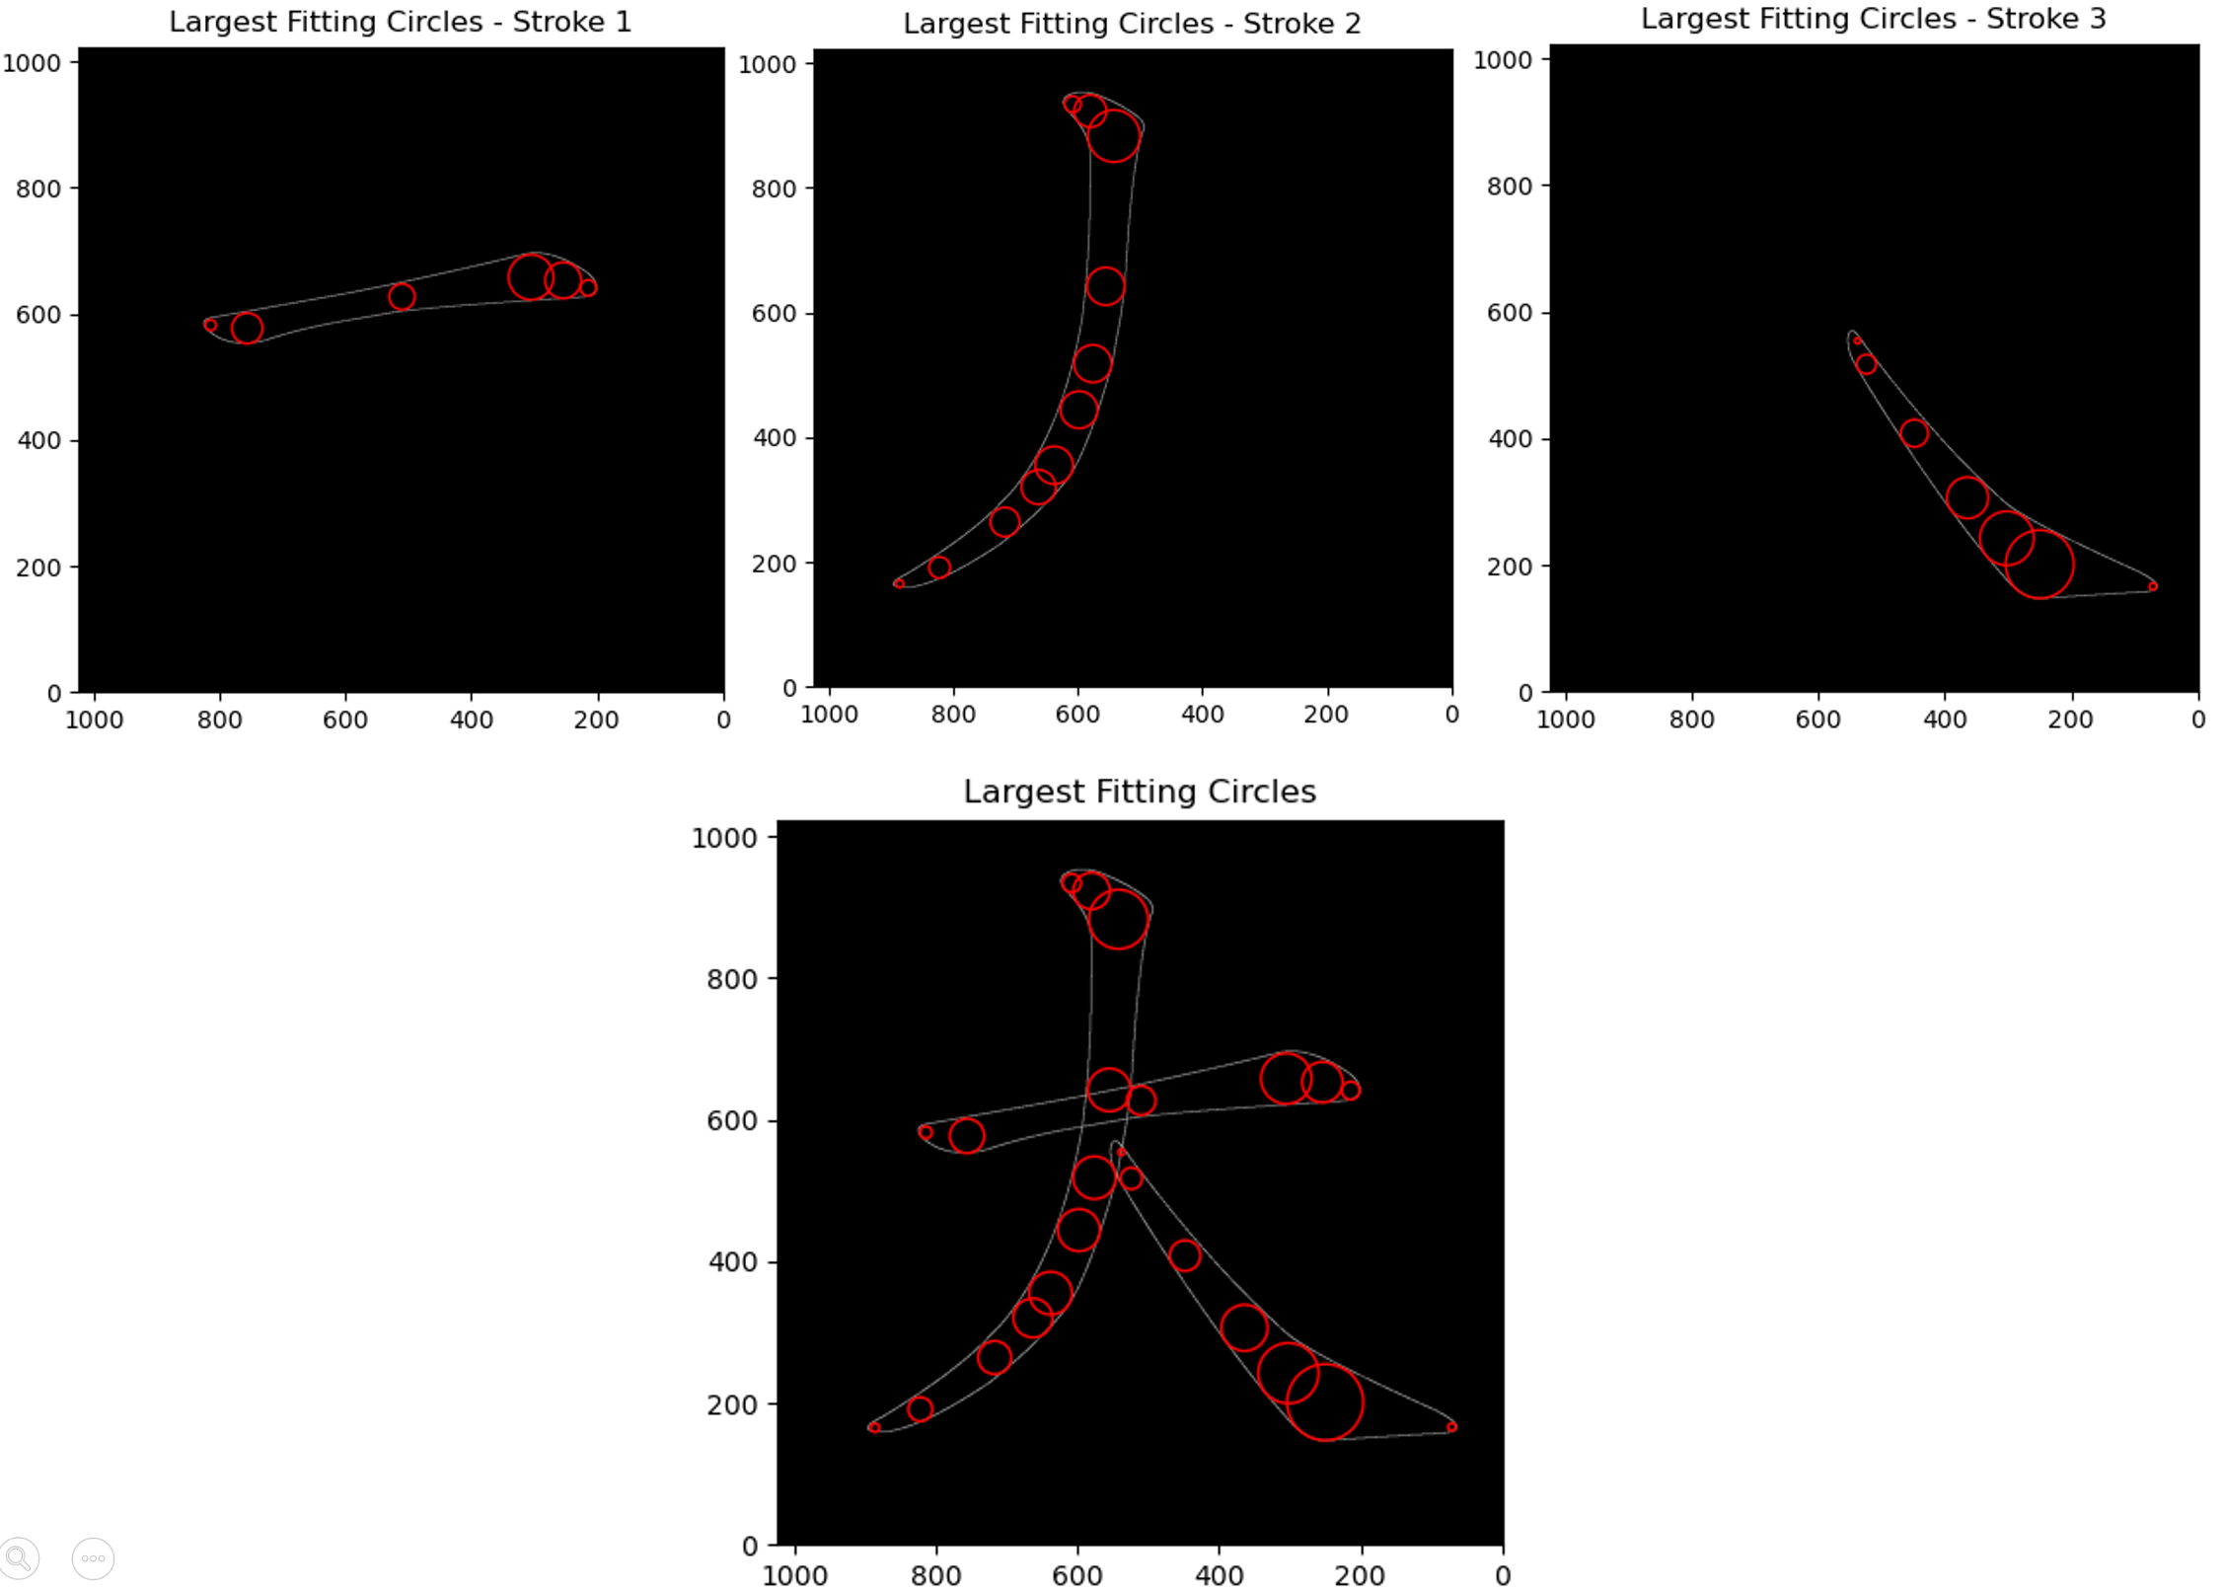
Figure 20. Largest Fitting Circles of Medians Points of the Chinese Character 大 Stroke by Stroke
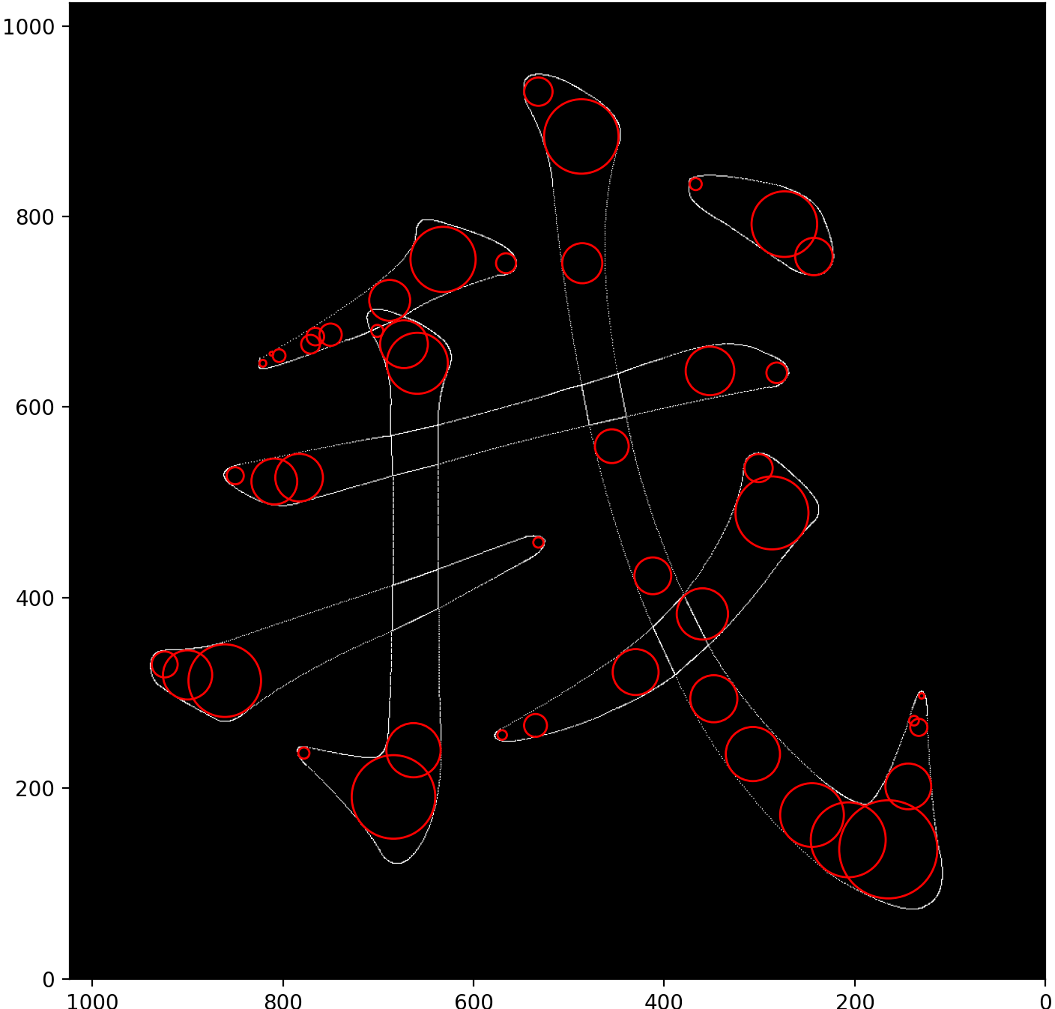
Figure 21. Largest Fitting Circles of Medians Point of the Chinese Character 我
The minimum, maximum, and average radii of all largest fitting circles across the dataset were calculated. The minimum radius was found to be 0.0, the maximum radius approximately 59.68, and the average radius around 20. Consequently, the following equation was established to calculate the Z coordinates for all control points:
Z coordinate = gripper_writing_height + (20 – largest fitting circle radii) / 4
, where
- gripper_writing_height represents the hard-coded Z coordinate established in Task 3.5, enabling the robotic arm to write with average thickness brush strokes,
- 20 serves as an estimate of the average radius of all largest fitting circles,
- “/4” is a scaling factor used to prevent the brush from lifting completely off the paper or from going down too far, risking damage to the brush or paper.
With these calculations, the 3D control points P₀​ and P₁​ for the Hermite curves and the 3D spline are established, allowing for the application of the methodologies from Tasks 3.2 and 3.3 to calculate the splines of the brush strokes.
Task 3.7 Connecting the brush strokes with a more fluid path:
The approach in Task 3.4 of adding a simple Hermite curve with C⁰ continuity to the splines does not feel very smooth when the robotic arm is writing the words. As the robotic arm suddenly changes its direction from writing a brush stroke horizontally on the paper 2D plane to lifting the brush vertically away from the paper 2D plane, this sudden change of velocity would give the user an unpleasant feeling.
Therefore, the connecting Hermite curve is modified to have a G¹ continuity with the previous stroke/spline. The reason why only the G¹ continuity with the previous stroke/spline is maintained, instead of maintaining the G¹ continuity with both the previous and the next spline, is because Chinese calligraphers tend to care about how to lift the brush after writing a stroke, but they usually pause and rest for a while before writing the next stroke. So, adding a pause/delay between the connecting curve and the start of the next stroke is a natural movement. So, the C⁰ continuity and the slight delay at the start of the next stroke is kept while the continuity when it tries to lift up the brush after writing a stroke is enhanced.
Therefore, the connecting Hermite curve is modified into the following control points:
- P₀ is the Starting Point 3D Position Vector: The last control point of the current stroke
- P₁ is the Ending Point 3D Position Vector: The first control point of the next stroke
- V₀ is the Starting Point 3D Velocity Vector: $\frac{P_{last}-P_{last-1}}{\left|P_{last}-P_{last-1}\right|}×PEN_LIFT_VELOCITY$
- V₁ is the Ending Point 3D Velocity Vector: Directly downwards in -Z direction with a magnitude of PEN_LIFT_VELOCITY
PEN_LIFT_VELOCITY is a constant used to define the magnitudes of the control velocities of all connecting Hermite curves. The Starting Point 3D Velocity Vector V₀ is normalized and PEN_LIFT_VELOCITY is used as the magnitude to avoid V₀ to have some unreasonably small or big magnitudes. The fact that V₁ is directly downwards would force the connecting curve to lift up eventually no matter what V₀ is. This makes sure that the brush is indeed lifted up and off the paper.
Here is a plot of the trajectory of writing the Chinese character 大 with this new connecting curves. The connecting curves are shown in red while the stroke/spline of the character is shown in black.
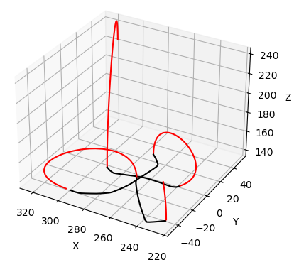
Figure 22. Trajectory of Writing the Chinese Character 大 with 3D Spline Algorithm
With this new 3D control points in Task 3.6 and new connecting curves in Task 3.7, we apply this final 3D Bézier spline algorithm onto the robotic arm to write the Chinese characters. Here are some results of robot manipulator system writing different characters using this final algorithm:
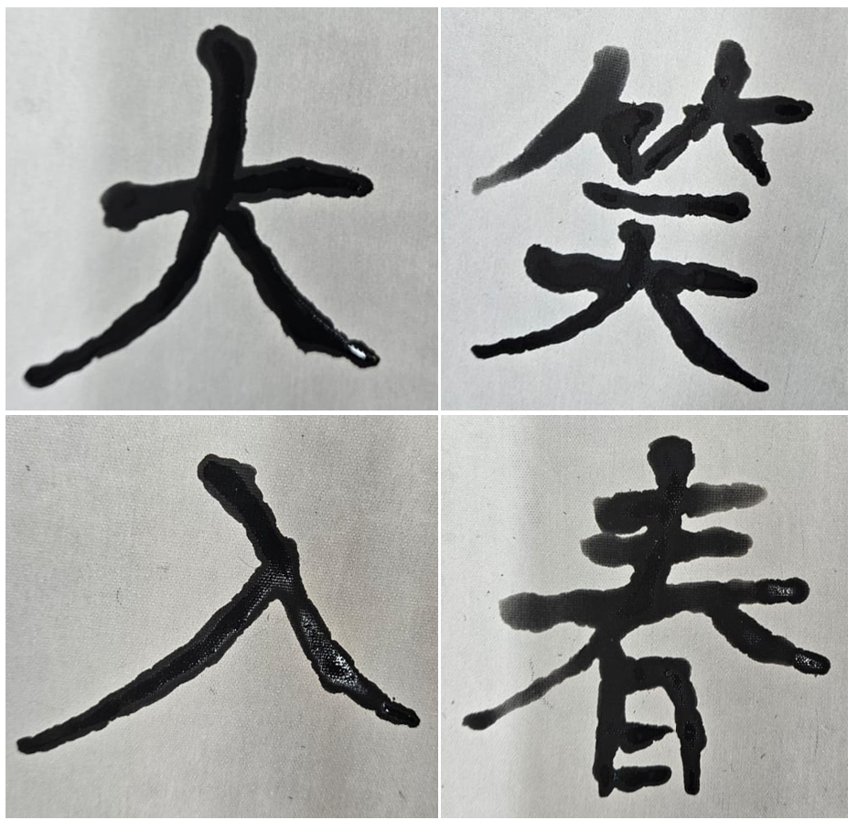
Figure 23. Some Chinese Characters Written Using the 3D Spline Algorithm
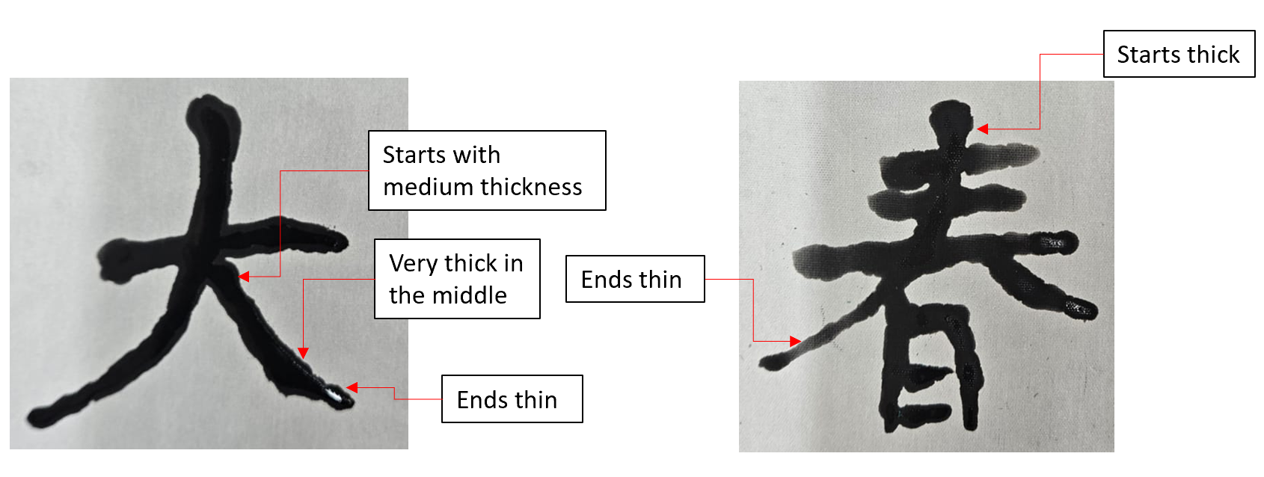
Figure 24. Explanation of the Change of Thickness of Some Resulting Chinese Characters
As illustrated in Figures 23 and 24, although it may not be immediately apparent, the thickness of the characters' brush strokes varies in the middle. The stroke can start with a very thick line and taper off to a thin finish. Alternatively, it might begin with medium thickness, press down in the middle to create a thicker segment, and then end with a thin finish.
This variation indicates that the robot manipulator system is moving along a dynamic 3D trajectory rather than a simple 2D path, showcasing its capability to write a Chinese character along a 3D curved trajectory.

Task 4
Aim: Develop a user interface to control the robot manipulator system for writing a Fai Chun(揮春) of the user's choice.
Expected Outcome: Users can choose which Fai Chun(揮春) he/she wants the robot manipulator system to write through a user interface and the robot manipulator system will write it using the 3D Bézier spline algorithm
Work Description:
Task 4.1: Fitting the characters within the paper:
Fai Chun(揮春) or chunlian(春聯) usually contains 4 Chinese characters, aligned vertically on a red, vertical rectangular paper as shown on the Figure 25 below:
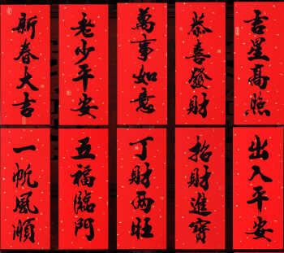
Figure 25. An Online Image of Multiple Fai Chun
Image Source: [Hok Ming], 從風水說2021牛年貼揮春秘法, [Online]. Available: https://www.hokming.com/fengshui-2021fengshui-faichunmethod-fengshui.htm. [Accessed: Apr. 8, 2025].
As mentioned in Task 3.1, a Chinese character measures 100mm by 100mm. Therefore, a Fai Chun featuring four Chinese characters would require an area of 100mm by 400mm. Since my water writing cloth/paper is only 345mm by 450mm (and is slightly smaller than the manufacturer's specifications), the four characters of the Fai Chun need to be positioned carefully to ensure they all fit within the paper.
Although 345mm of paper seems significantly larger than the 100mm needed for the Fai Chun, the actual writable area is limited due to the constraints of the robotic arm. During a test to write on the left side of the paper, the first arm/link of the robotic arm collides with the second arm/link, and the second arm/link interferes with the servo motor of the gripper, as shown in the Figure 26 below. This prevents me from writing on the left half of the paper, restricting my writing to only the right half and further reducing the system's writable space.
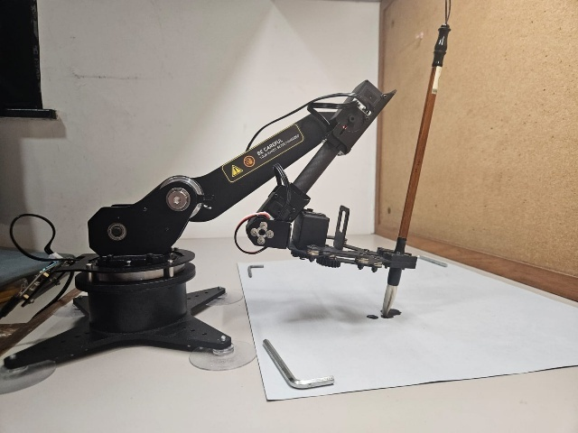
Figure 26. Collisions Between the Links of the Robotic Arm Restricting the Writable Area on the Paper
So, we start writing the Fai Chun by writing the first character at the top of the paper, near the margin of the paper. Then, after we finish writing the first character, we translate 100mm downwards and start writing the second character. We repeat this process until we finish writing all characters in the Fai Chun.
After testing and some experiments, the value of translating 100mm downwards is modified to 90mm. As most Chinese characters do not occupy the whole 100mm * 100mm and has some empty padding space near the margins, this padding space can be used such that the Fai Chun can be smaller, making it fit the drawing paper more easily.
Task 4.2: Connecting multiple Chinese characters together into a Fai Chun:
Similar to how we connect different strokes/splines together in Task 3.4 and Task 3.7, we can apply the same method to connect different characters together.
For the 2D Spline algorithm in Task 3.4, we can use a simple Hermite curve with the following control points to connect the two characters together.
- P₀ is the Starting Point 3D Position Vector: The last control point of the last stroke of the previous character
- P₁ is the Ending Point 3D Position Vector: The first control point of the first stroke of the next character
- V₀ is the Starting Point 3D Velocity Vector: Directly upwards in +Z direction
- V₁ is the Ending Point 3D Velocity Vector: Directly downwards in -Z direction with the same magnitude as V₀
Here is a resulting plot of the 2D Spline algorithm writing a Fai Chun:
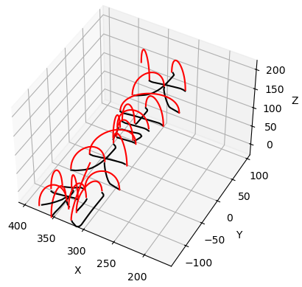
Figure 27. Trajectory Plot of the Chinese Characters 大吉大利 Using the 2D Spline Algorithm
Here is the result of the robot manipulator system writing a Fai Chun with this 2D Spline Algorithm:
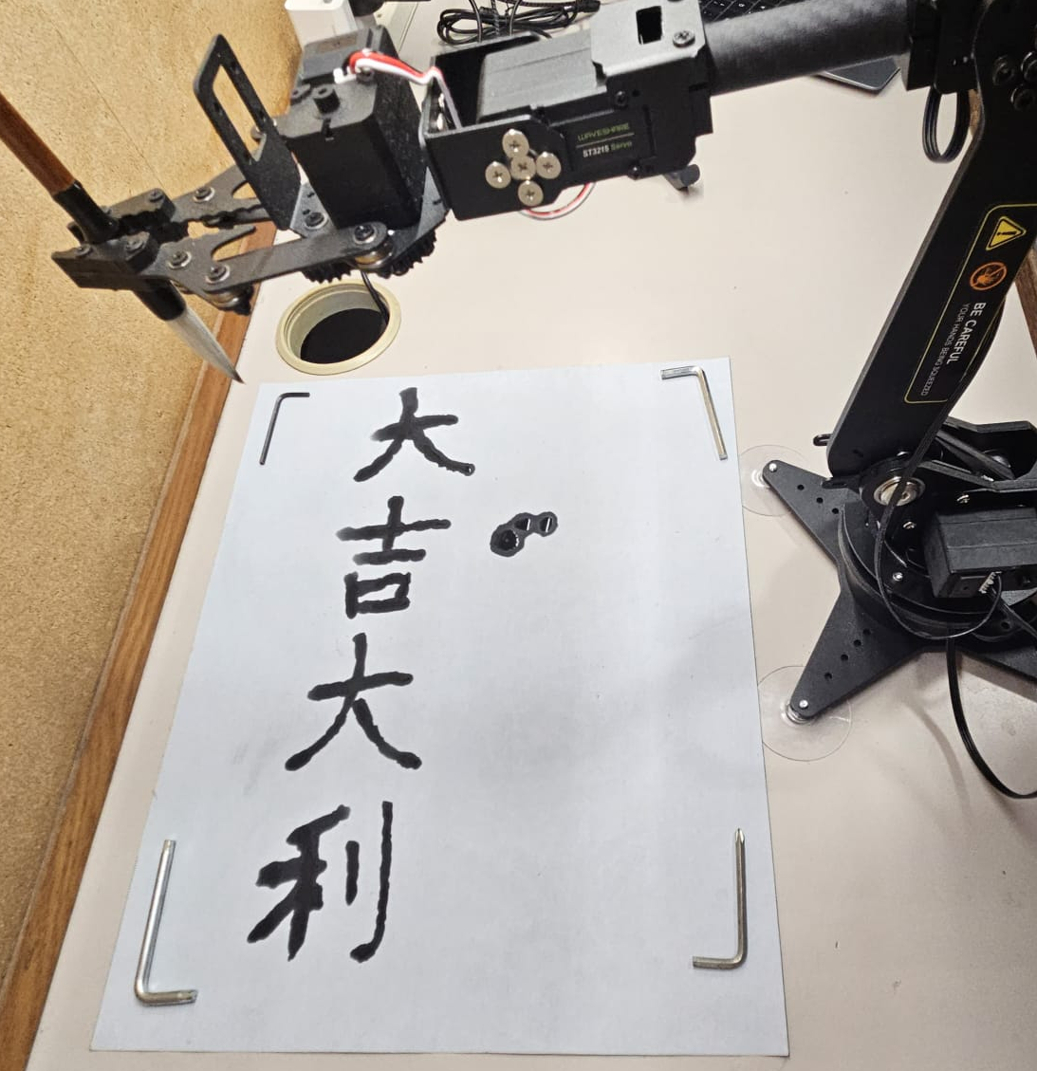
Figure 28. Result of the Fai Chun 大吉大利 Written by the Robotic Arm Using the 2D Spline Algorithm
For the 3D Spline algorithm in Task 3.6 and the more fluid connecting curve in Task 3.7, we use the following more fluid connecting Hermite curve with the following control points to connect the two characters together:
- P₀ is the Starting Point 3D Position Vector: The last control point of the last stroke of the previous character
- P₁ is the Ending Point 3D Position Vector: The first control point of the first stroke of the next character
- V₀ is the Starting Point 3D Velocity Vector: $\frac{P_{last}-P_{last-1}}{\left|P_{last}-P_{last-1}\right|}×PEN_LIFT_VELOCITY$
- V₁ is the Ending Point 3D Velocity Vector: Directly downwards in -Z direction with a magnitude of PEN_LIFT_VELOCITY
, where
- P_{last} is the 3D Position Vector of the last control point of the last stroke of the previous character
- P_{last-1} is the 3D Position Vector of the second last control point of the last stroke of the previous character
Here is a resulting plot of the 3D Spline algorithm writing a Fai Chun:
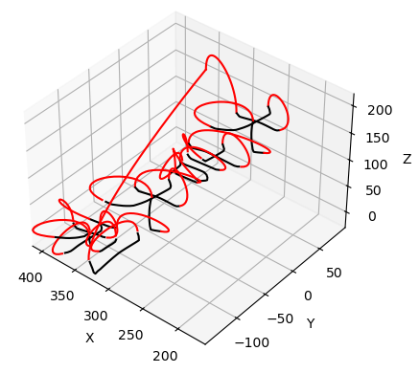
Figure 29. Trajectory Plot of the Chinese Characters 大吉大利 Using the 3D Spline Algorithm
Here is the result of the robot manipulator system writing a Fai Chun with this 3D Spline Algorithm:
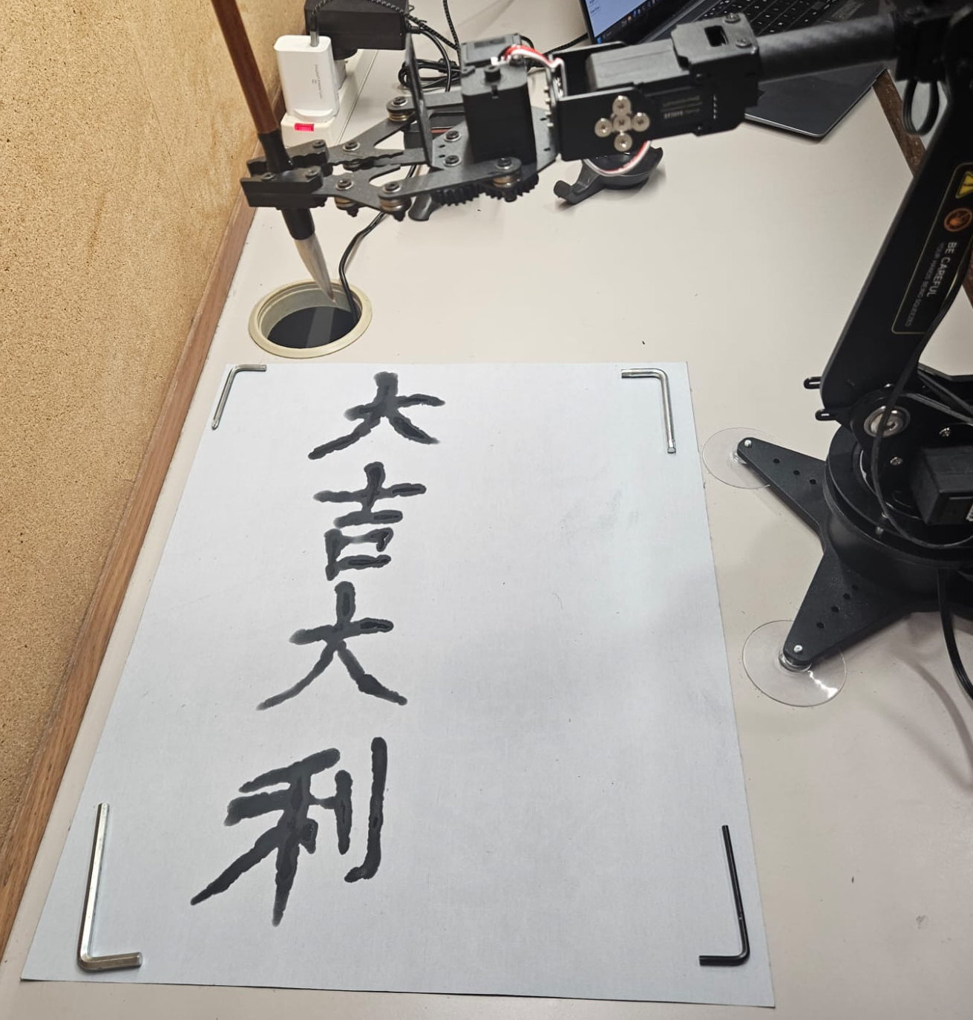
Figure 30. Result of the Fai Chun 大吉大利 Written by the Robotic Arm Using the 3D Spline Algorithm
Task 4.3: User Interface:
In order to let the user to choose which Fai Chun(揮春) he/she wants the robot manipulator system to write easily, a simple user interface is implemented using Python tkinter library. The user interface is shown in the Figure 31 below:
Figure 31. The User Interface of the Chinese Calligraphy Robot Manipulator System
As shown in the Figure 31 above, the user interface is separated into 3 columns or 3 steps.
- Step 1. Calibrate Writing Height
- Step 2. Choose Your Characters
- Step 3: Ask Robotic Arm to Write
For Step 1 Calibrate Writing Height, as mentioned in Task 3.5, gripper_writing_height is a variable that stores the optimal Z coordinate of the robotic arm such that the Chinese writing brush is in contact with the paper without the brush tip bending too much and creating overly thick strokes. The value of gripper_writing_height might change because the gripper of the robotic arm might hold on different parts of the handle of the Chinese writing brush as shown in the Figure 32 below. Therefore, the first step of the program is to calibrate this value.
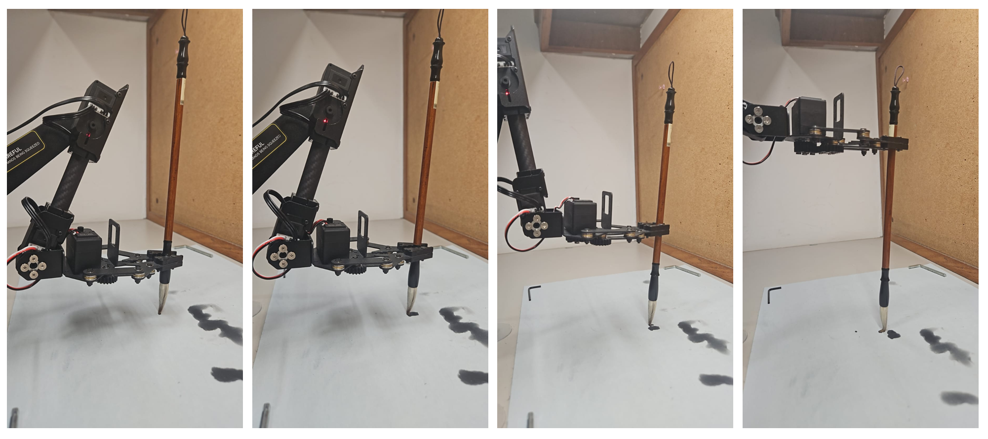
Figure 32. The Robotic Arm Holding Different Positions of the Chinese Writing Brush

Table 2. Description of Different Components of the User Interface
UI Components | Description
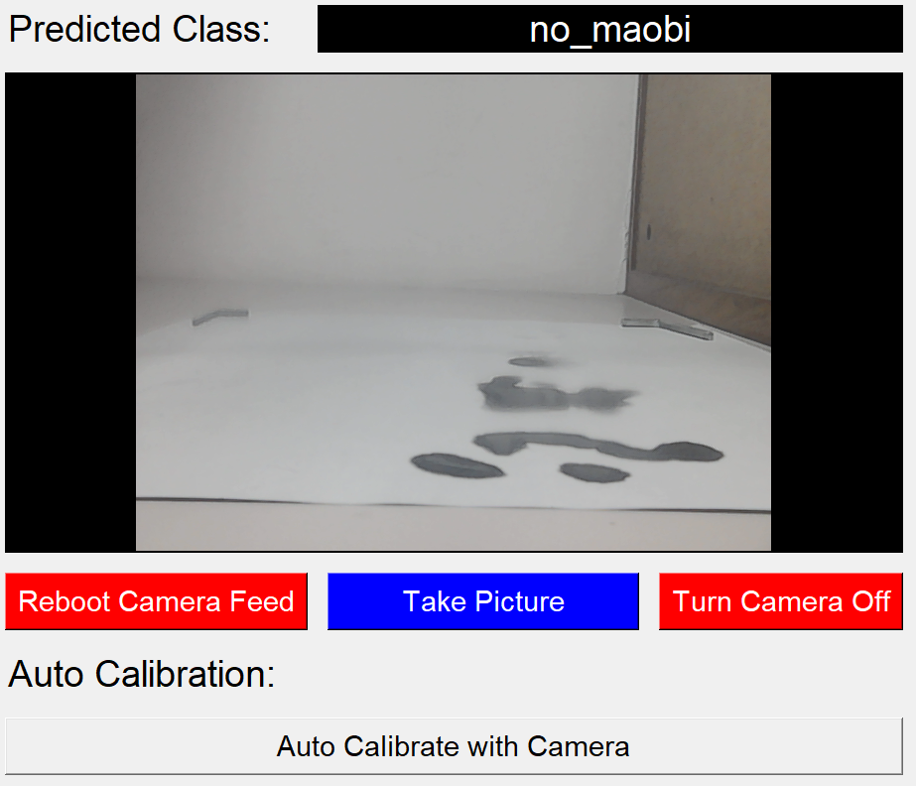  Figure 33. Auto Writing Height Calibration Part of UI | The upper half of step 1 is used for the auto calibration using the computer vision system that will be discussed in Section 2.2.3 below. It consists of a predicted class of the current camera video feed from the object classification model, the USB camera’s video feed, some buttons related to the USB camera, and a button to initiate the gripper_writing_height auto calibration program. Details will be introduced in Section 2.2.3 below.

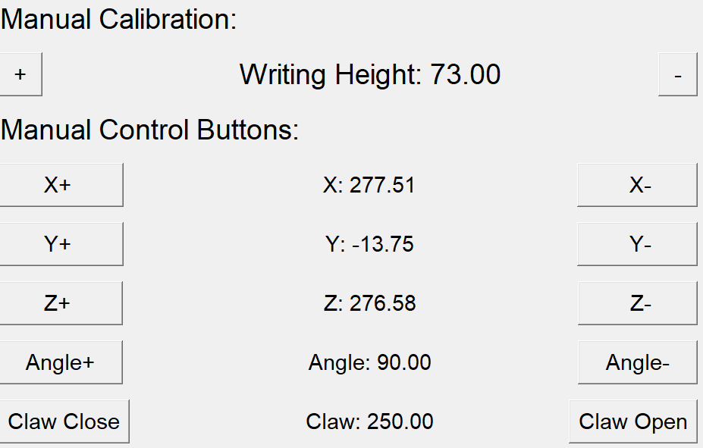  Figure 34. Manual Writing Height Calibration Part of UI | The lower half of step 1 is used for manual calibration. We can modify the value of gripper_writing_height manually using the plus and minus buttons. We can use the manual control buttons below to move the robotic arm to our desired position for testing out the optimal distance between the brush and the paper.
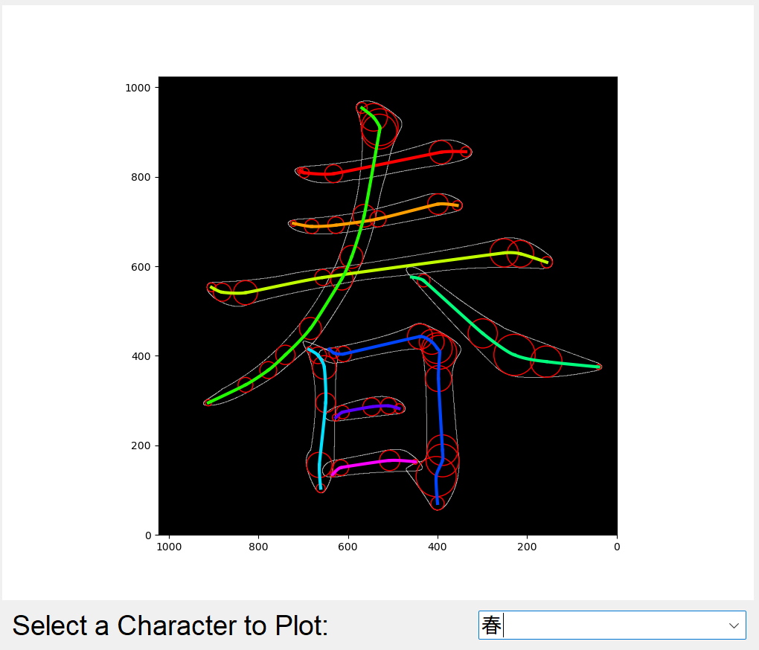  Figure 35. 2D Character Graph of UI | For Step 2 Choose Your Characters, In the upper half, the first character on the selected Fai Chun would be plotted on a 2D graph at the top half of Step 2. Users can choose to plot the other characters of the selected Fai Chun by selecting the other characters in a drop-down menu beneath the plot. The plot contains the outer frame of the character fetched from graphics.txt as stated in Task 3.1, the red largest fitting circles of the “medians” control points as in Task 3.6, and the rainbow-colored splines of the strokes of this character as stated in Task 3.2.
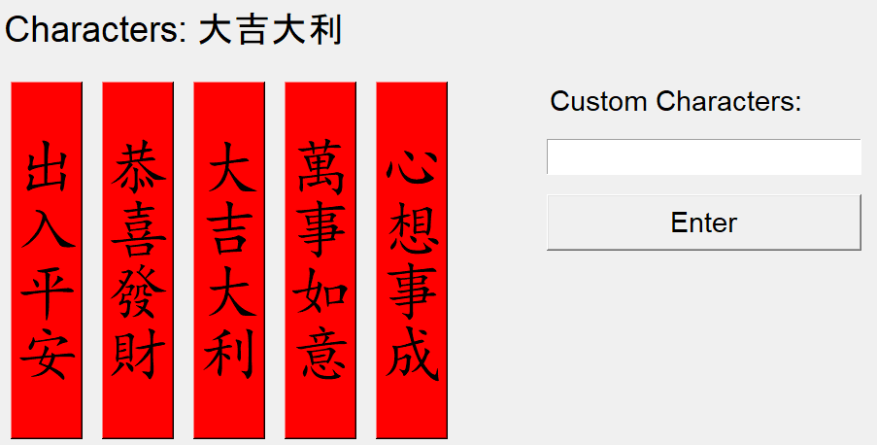  Figure 36. Fai Chun Selection Part of UI | In the lower half of Step 2 Choose Your Characters, the user can choose which Fai Chun he/she wants to write by clicking the corresponding red Fai Chun buttons. If the Fai Chun that the user wants to write is not an option, he/she can input their own custom Fai Chun in the text box on the right and press the “Enter” button to input it to the program. The chosen Fai Chun characters are then shown above the red Fai Chun buttons.
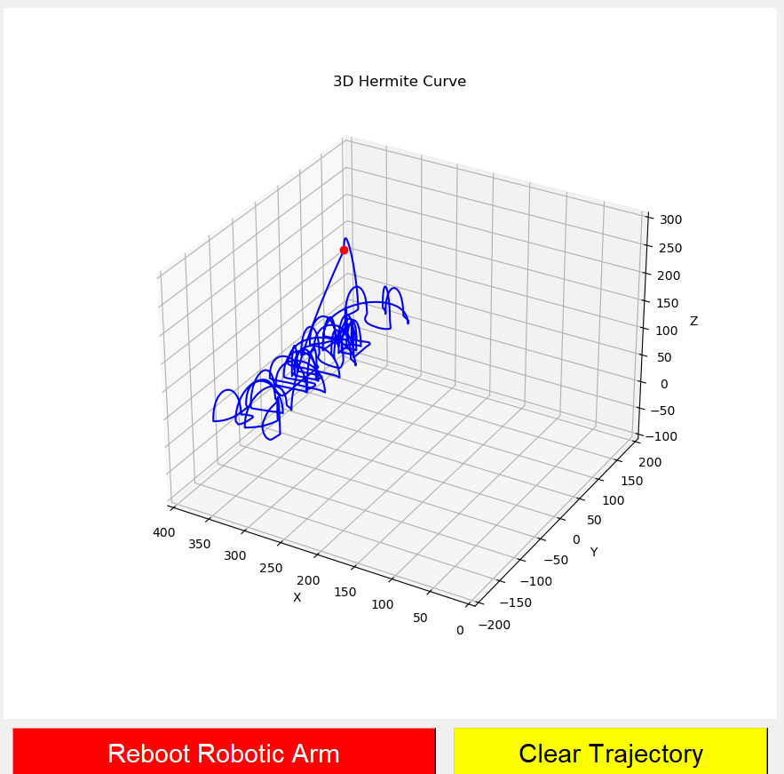  Figure 37. 3D Trajectory Graph of UI | For Step 3 Ask Robotic Arm to Write, on the upper half, there is a 3D plot of the trajectory the robotic arm has moved. If the robotic arm is not connected to the computer, this acts as a simulator for the program to simulate the trajectory of the robotic arm. A yellow “clear trajectory” button is added to the bottom of the plot as the plot can become messy very quickly like the Figure 37 on the left.
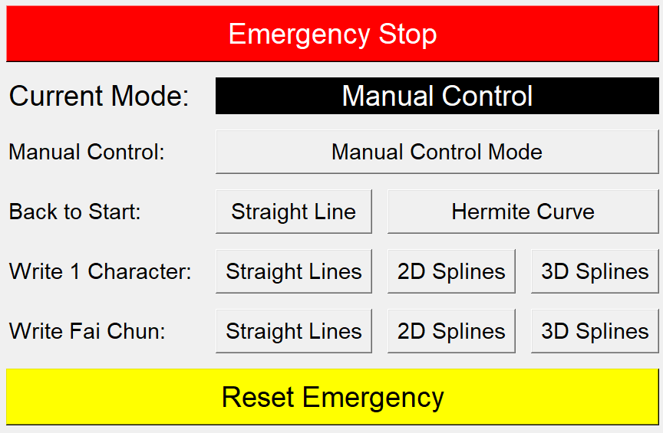  Figure 38. Main Control Part of UI | In the lower half of Step 3 Ask Robotic Arm to Write, there is a big red “Emergency Stop” button as stated in Task 2.2 in case the robotic arm goes out of control. A separate yellow “Reset Emergency” button is placed at the bottom as far away from the emergency stop button as possible to prevent misclicking the reset button when we are trying to stop the robotic arm.  In the middle, the user can choose which mode the robotic arm should move. There are 4 different actions, as aligned in 4 different rows. They are manual control, move the robotic arm back to its initial start position, write 1 Chinese character, and write a Fai Chun. There are also 3 different algorithms to execute the actions, as aligned as the 3 different columns. They are the Straight-Line benchmark algorithm that will be discussed in Section 2.2.4, the 2D Spline algorithm as stated in Task 3.4, and the 3D Spline algorithm as stated in Task 3.7. The current mode that the robotic arm is running is shown beneath the “Emergency Stop” button.

With this user interface, the user can easily follow the step to control the robotic arm. First, they can calibrate the gripper_writing_height variable through automatic or manual methods. Then, the user can select their desired Fai Chun characters by simply clicking the buttons or inputting custom Fai Chun. Finally, the user can choose the algorithm that the robotic arm will use and the action that he/she wants the robotic arm to do. This 3 steps approach provides a user-friendly interface for the user to control the robotic arm to write their desired Fai Chun.

Computer Vision System
Objective: To utilize machine learning model on computer vision system to identify whether the Chinese writing brush(毛筆) touches the paper with an accuracy of 90% or above.
In this objective, we will train a supervised object detection convolutional neural network model. The goal is to develop a machine learning model capable of determining whether a Chinese writing brush (毛筆) is in contact with the paper. Ideally, the model will be able to process the image stream from a USB camera in real time, accurately detecting the brush's contact with the paper at a high frames per second (fps). This will enable the model to identify the boundary height for the robotic arm, distinguishing between when the brush touches the paper and when it does not.
Task 1
Aim: Acquire a camera and implement code to capture images.
Expected Outcome: Buy a camera that can see the whole drawing area that is also easy to connect to the computer and easy to program to capture images
Work Description:
Based on the experience of acquiring the robotic arm and Chinese calligraphy tools in Section 2.2.2 Task 1, a cost-effective USB camera with a small tripod was identified. This camera can be used directly when plugged into the USB port of the laptop computer. Using simple OpenCV code, hundreds of images were captured with the USB camera while the robot manipulator system wrote a Fai Chun. These images will be utilized for the machine learning dataset.
Task 2
Aim: Annotate, preprocess, and augment the images to create a dataset.
Expected Outcome: Prepare a high-quality dataset for the machine learning model to train from.
Work Description:
Task 2.1: Determine the machine learning model type:
Before preparing the dataset, the type of machine learning model has to be decided. As stated in the progress report, the original plan is to sort different colored markers. So, a YOLO (You Ony Look Once) object detection model was trained to identify the multiple markers on the table. YOLO is suitable for identifying multiple markers as it can output multiple bounding boxes with the pixel location of each and every marker in the image.
However, for the current topic, we only need to identify whether the Chinese writing brush is in contact with the paper. There is only one Chinese writing brush in the setup so a model like YOLO that outputs multiple bounding boxes is not needed. The exact position of the Chinese writing brush does not matter as we only need a Boolean state of whether it is touching the paper or not. On a deeper thought, the brush can only go out of the camera’s viewing frustrum and not shown in the image. So, an object classification model is chosen instead as it only need to identify these 3 different states of the Chinese writing brush without the need of outputting the position of the brush.
As there is only 1 Chinese writing brush in the system, there can only be the following cases:
- The brush is touching the paper
- The brush is not touching the paper
- The brush is lifted above the camera's viewing frustum (or too far left or right) so that it is not visible in the scene.

From this, we can easily identify the 3 classes of the model:
Table 3. The 3 Classes of the Object Classification Model
Class name | maobi_on_paper | maobi_off_paper | no_maobi
Description | The Chinese writing brush (毛筆 maobi) is touching/on the paper such that the brush is bent | The Chinese writing brush (毛筆 maobi) is NOT touching/off the paper so the brush is NOT bent | It cannot identify any Chinese writing brush (毛筆 maobi) in the image
Example images | 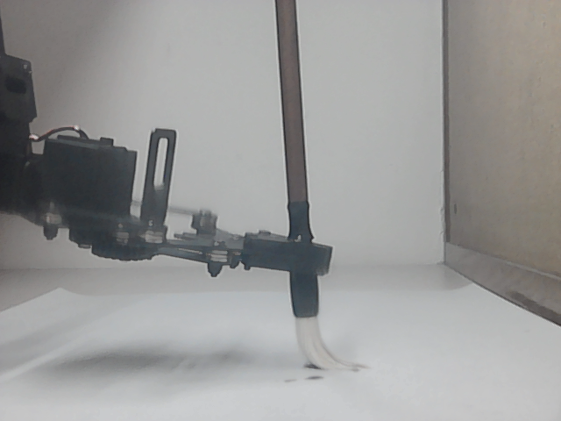  Figure 39. Example Image of “maobi_on_paper” | 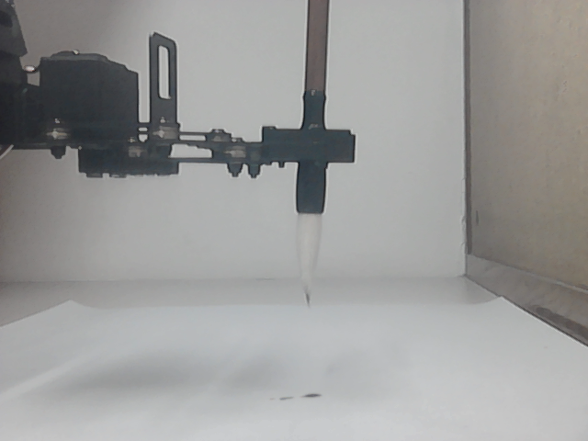  Figure 40. Example Image of “maobi_off_paper” | 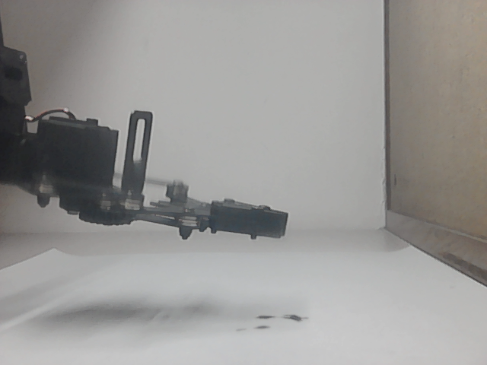  Figure 41. Example Image of “no_maobi”
Task 2.2: Annotate the images to form a dataset:
Hundreds of different images in different lighting conditions are taken with the positions of both the camera and the robotic arm changed in different scenario. In the end, a total of 794 images is taken with 463 images annotated with class “maobi_off_paper”, 268 images with class “maobi_on_paper”, and 63 images with class “no_maobi”.
For the class "no_maobi," the concept of "there is no Chinese writing brush" is too abstract for the CNN model to learn, as it essentially equates to learning the idea of "none" or "void." To prevent the model from overfitting to the small dataset of 63 images, which features a consistent white background (as shown in Figure 41 inside Table 3 above), a solution is needed to help the model understand the concept of "none" or "void". So, some random images are added in the dataset and are labeled as "no_maobi". This way, the model can learn that the concept of "none" or "void" corresponds to the idea of "there is no Chinese writing brush in the scene", allowing it to accurately label such instances even when the background of the system changes.
Roboflow [8], a computer vision platform that simplifies the process of building and deploying computer vision applications, is utilized to search for some random images and a dataset called Final Database by Essam Haider is chosen. This dataset contains various images of different objects and scenes suitable for training models [9]. 200 random images are extracted from this dataset and labelled them as "no_maobi" such that my CNN model can learn the concept of "none” or “void” more easily. Here are some examples of the random images:
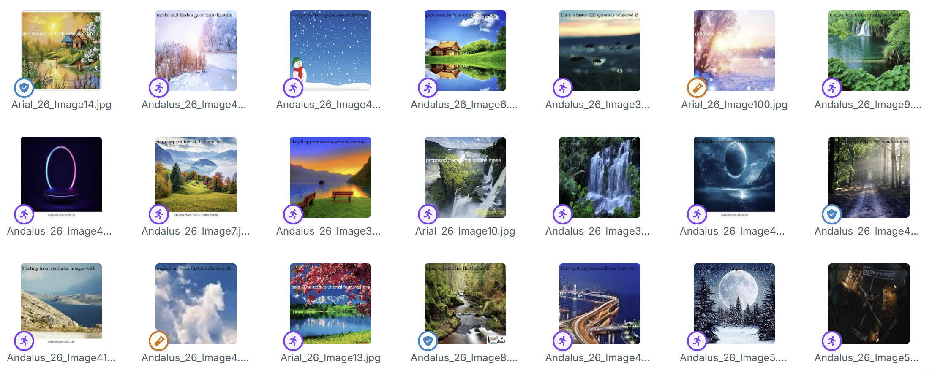
Figure 42. Some Random Images for the Class “no_maobi”
With the help of Roboflow [8] annotate function, a total of 994 images has been annotated and be divided into training, validation, and test sets following a 70%:20%:10% ratio. The table below outlines the distribution of images across different classes within each of these sets:
Table 4. Train, Validate, Test Split of the Dataset
Class Name | Total Count | Training Count | Validation Count | Test Count
maobi-off-paper | 463 | 315 | 95 | 53
maobi-off-paper | 46.58% of dataset | 68.03% of class | 20.52% of class | 11.45% of class
maobi-on-paper | 268 | 193 | 53 | 22
maobi-on-paper | 26.96% of dataset | 72.01% of class | 19.78% of class | 8.21% of class
no-maobi | 263 | 188 | 51 | 24
no-maobi | 26.46% of dataset | 71.48% of class | 19.39% of class | 9.13% of class
Total | 994 | 696 | 199 | 99
Total | 100% of dataset | 70.02% of dataset | 20.02% of dataset | 9.96% of dataset
This structured approach ensures that the model is trained effectively while also being validated and tested on separate datasets to evaluate its performance accurately. Proper splitting of datasets is crucial for preventing overfitting and ensuring that the model generalizes well to unseen data.

Task 2.3: Preprocess and Augment the Dataset:
Following the initial dataset preparation, with the help of Roboflow [8], a series of augmentation and preprocessing steps are implemented to enhance the quality and diversity of the images.
Preprocessing Steps:
Each image underwent the following preprocessing procedures:
Auto-orientation: The pixel data was automatically oriented, with EXIF orientation information stripped to ensure consistency.
Resizing: All images were resized to a standard dimension of 320x240 pixels, which helps maintain uniformity across the dataset as the random images from Final Database by Essam Haider are mostly 400x400 pixels while my images are 640x480 pixels.
Grayscale Conversion: Images were converted to grayscale to simplify the data as it should not be affected by the color of the paper and should focus on the shape of the brush.
Auto-contrast: Contrast stretching was applied to enhance the visibility of features within the images.

Augmentation Process:
To further enrich the dataset, we applied various augmentation techniques, generating three distinct versions of each source image. We have annotated a total of 994 images, and through the augmentation process, this number is increased to 2,386 images.
The augmentation methods included:
Horizontal Flip: Each image had a 50% chance of being flipped horizontally, which helps the model learn to recognize the Chinese writing brush even though the robotic arm is on the right side of the image instead of the left side as shown in Table 2 above.
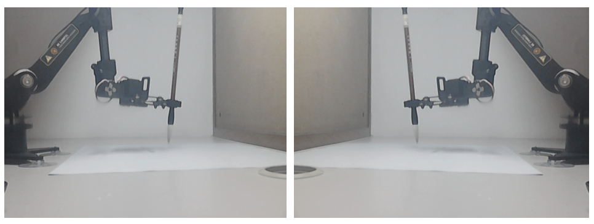
Figure 43. Horizontal Flip of Images
Random Rotation: Images were randomly rotated within a range of -15 to +15 degrees, introducing variability in the angle of view as the Chinese writing brush might be tilted with a small angle as in the Figure 44 below:
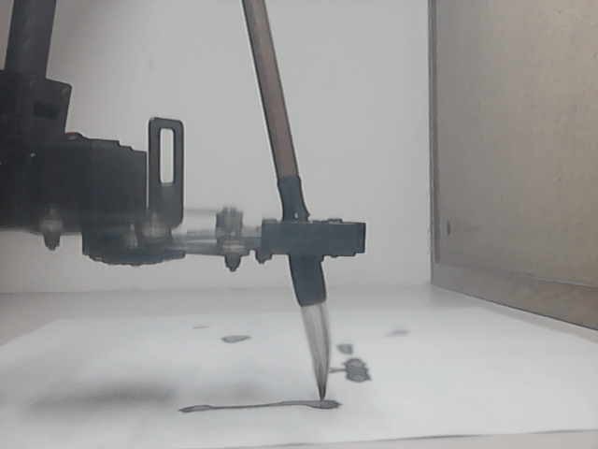
Figure 44. Image of the Robotic Arm Holding a Tilted Chinese Writing Brush
Random Shear: A random shear transformation was applied, varying between -10° to +10° both horizontally and vertically, which helps simulate perspective changes as the position of the camera is not fixed
Brightness Adjustment: Random adjustments to brightness were made, varying between -25% and +25%, to account for different lighting conditions.
Exposure Adjustment: Similar to brightness, exposure was randomly adjusted within a range of -15% to +15%.
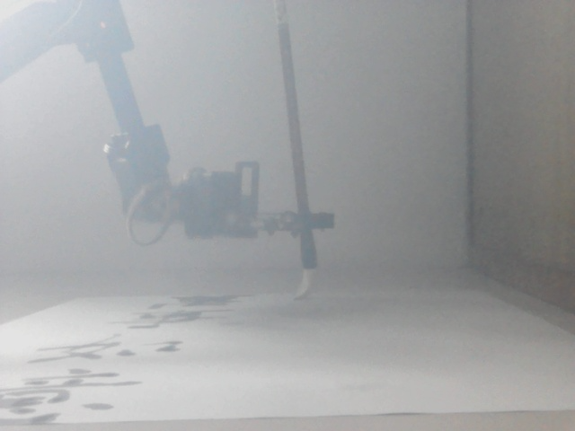
Figure 45. Image of Highly Exposed Test Environment
Gaussian Blur: A random Gaussian blur effect was applied, with a range of 0 to 2.5 pixels, to simulate out-of-focus images as the brush might be blurred when the robotic arm moves at a high speed.
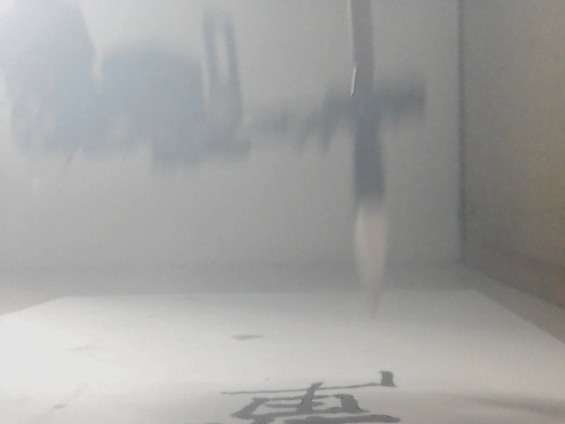
Figure 46. Image of Motion Blurred Chinese Writing Brush
Salt and Pepper Noise: Noise was introduced to 1% of the pixels in the images, which helps the model become robust against noisy data.
These preprocessing and augmentation techniques are crucial for improving the model's performance by providing a more diverse and representative dataset, ultimately enhancing its ability to generalize to new, unseen images. After the Preprocessing and augmentation stages, our dataset has a total of 2386 image with the following train, validate, test split:
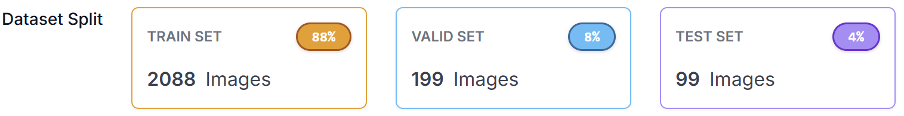
Figure 47. Dataset Split after Preprocessing and Augmentation
Task 3
Aim: Train the computer vision machine learning model.
Expected Outcome: The model can identify whether the Chinese writing brush is touching the paper with an accuracy of 90% or above in different lighting and background situation
Work Description:
Task 3.1: Model Architecture:
With the dataset in Task 2 exported to the laptop computer using Roboflow, the training of the Convolutional Neural Network (CNN) machine learning model is started. My CNN model has the following structure:
The model begins with an input layer that accepts grayscale images of size 320x240 pixels. It includes three convolutional layers; each followed by max pooling layers to reduce spatial dimensions and extract important features. The first convolutional layer uses 32 filters of size 3x3 with ReLU activation, followed by a max pooling layer to summarize the features. The second and third convolutional layers increase the number of filters to 64 and 128, respectively, each also using ReLU activation and max pooling.
After flattening the output from the convolutional layers, the model contains a dense layer with 128 units and another ReLU activation function. A dropout layer with a rate of 50% is applied to prevent overfitting. Finally, the output layer comprises three units with a softmax activation function, suitable for multi-class classification.
The Figure 48 below shows a visual representation of the model structure:
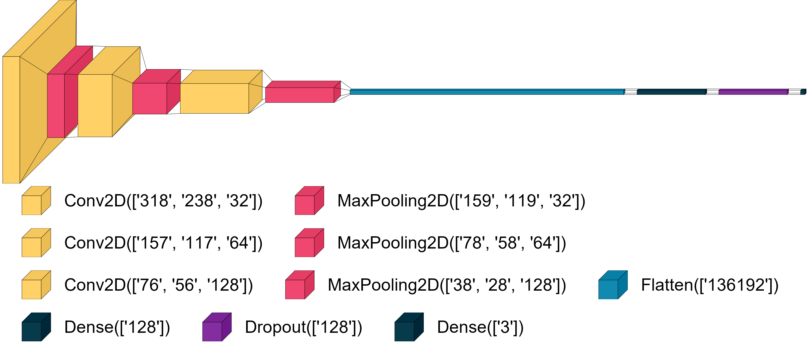
Figure 48. Structure of the CNN Model

Task 3.2: Model Training Result:
The training process involved multiple epochs, during which the model's performance was evaluated in terms of accuracy and loss.
During the training, the accuracy and loss metrics were recorded at different epochs. At epoch 30, the training accuracy reached 76.81%, with a corresponding loss of 0.4907. The validation accuracy was 83.42%, indicating that the model was starting to generalize well. By epoch 200, the validation accuracy plateaued, indicating that the model's performance had stabilized at around 91.96%.
By epoch 500, the training accuracy met the validation accuracy, both becoming horizontal, indicating that the model had reached a state of convergence. The final epoch, epoch 700, showcased a best validation accuracy of 94.47% and a training accuracy of 93.16%. This indicates that the model effectively learned to identify whether the writing brush was touching the paper, achieving the expected outcome of over 90% accuracy.
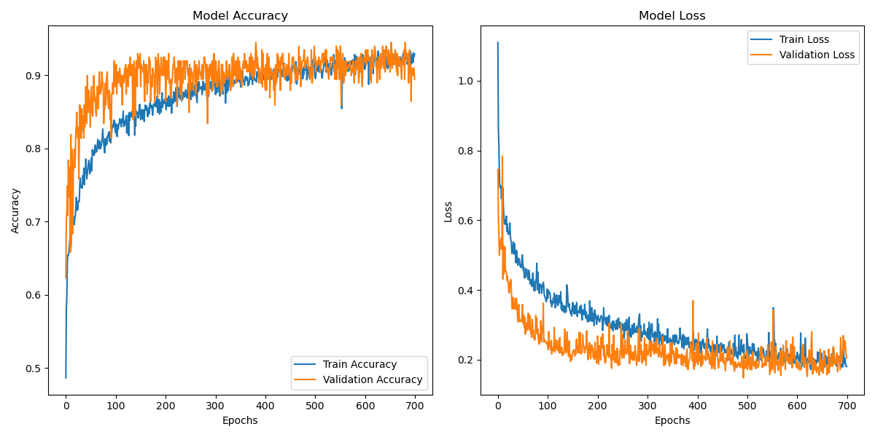
Figure 49. Model Accuracy and Loss of the Computer Vision Model After 700 Epochs

Task 4
Aim: Develop a gripper writing height calibration program to test the machine learning model on the robot manipulator system.
Expected Outcome: By using the output class of the machine learning model, the robot manipulator system can automatically find the boundary height in between the brush touching and not touching the paper
Work Description:
Task 4.1: Develop the gripper writing height calibration program:
By using OpenCV library, the image feed of the USB camera is easily acquired. The image feed then passes through the same preprocessing steps as the dataset in Task 2, which is resizing to 320*240, converting to grayscale, and applying auto-contrast via histogram equalization. The preprocessed image feed is then passed through the machine learning model to predict its class in real time. The real time image class will be used by the gripper writing height calibration program to find the boundary Z-coordinate in between the brush touching and not touching the paper.
The gripper writing height calibration program follows a very simple logic. Initially, it will control the arm to move back to its initial high position by using a simple Hermite curve. The CNN model should output “no_maobi” as the Chinese writing brush should be out of sight above the image. The program will then control the robotic arm to move vertically downwards. At this state, when the brush enters the image from above, the CNN model should output “maobi_off_paper” as it is above the paper. It will then slowly move down until the CNN model outputs “maobi_on_paper”, which means the brush has touched the paper.
Although we can directly use this Z coordinate as the new calibrated value of gripper_writing_height, from my experiment, it is usually too low as the CNN model does not respond as quickly in real time. So, a one second pause is added such that everything can be stabilized before the brush slowly moves up again. We stop when the CNN model outputs “maobi_off_paper” again. We will then use this value of the Z coordinate as the new, calibrated value of gripper_writing_height.
Task 4.2: Test the gripper writing height calibration program:
A few problems are encountered when the gripper writing height calibration program is being tested.
First, the CNN model might have mistaken the shadow of the robotic arm as an ink patch drawn by the brush and identify it as touching the paper when it is not. In Figure 50, the brush is touching the paper with a very slight bent on the tip of the brush, creating a small black dot on the paper. Although the model should have learnt the fact that “the small slight bent = the brush touches the paper”, the model might have learnt the fact that “a patch of black near the tip of the brush = the brush touches paper”. So, when the model sees the patch of shadow on the tip of the brush in Figure 51, or the patch of ink in the background that is on the tip of the brush due to the camera’s perspective in Figure 52, it wrongly labelled the image as “maobi_on_paper” when the brush is not even touching the paper. The only solution here is to add all these images to the dataset to train the model again, hoping it would learn it with the new training. Therefore, the current dataset of 994 images is the third version as the model was trained before with a smaller dataset.
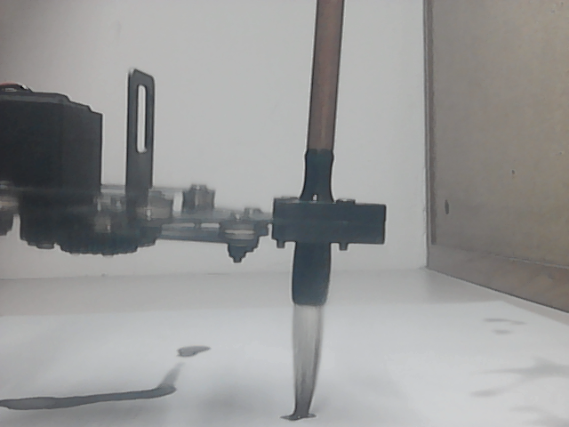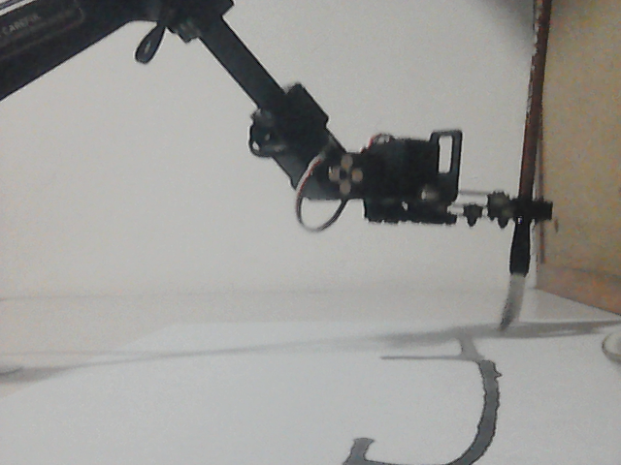
Figure 50. The Brush Touching Paper with a Slight Bend and Writes a Black Ink Dot
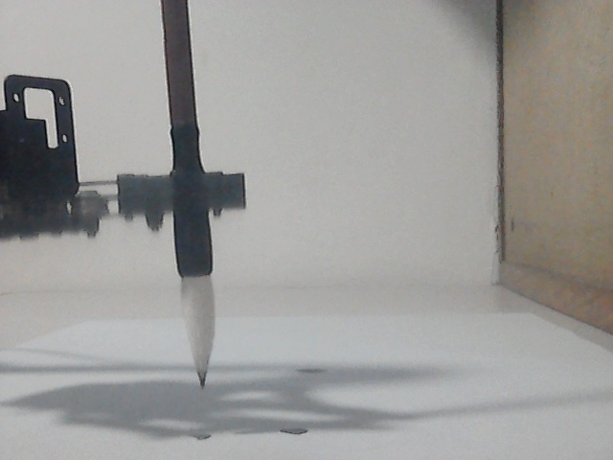
Figure 51. The Brush Hovering Over a Patch of Shadow
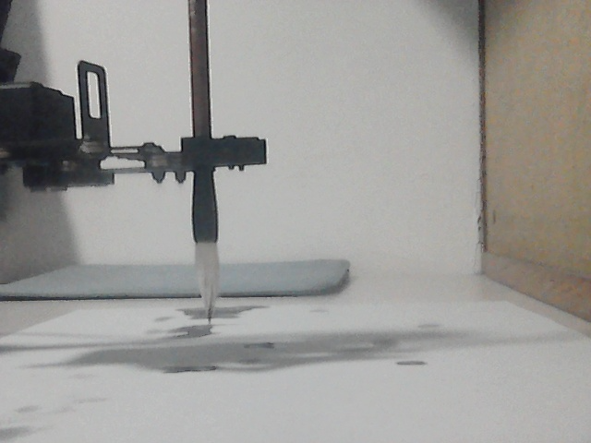
Figure 52. The Brush Hovering Over a Patch of Ink
Secondly, there might be some wrong or noise values in between. There might be a wrong value of “maobi_on_paper” in between a long list of “maobi_off_paper” and there might also be a wrong value of “maobi_off_paper” in between a list of “maobi_on_paper”. This usually leads to wrong calibration result and it has to be re-calibrated again. A function can be added in the future to allow it calibrate multiple times and take the average value and remove the outliers.
Thirdly, the robotic arm might move too fast and overshoots too much. The CNN model might not be able to stop the robotic arm in time and the brush might split like the Figure 53 below. This might potentially break the brush or the robotic arm. So, a lower limit is added to avoid it going too low and make it even slower during calibration.
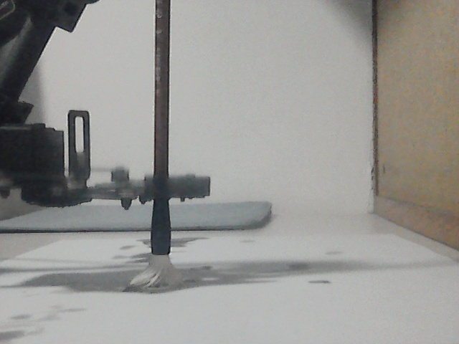
Figure 53. The Brush Going Too Low and Splitting Like a Mop
Although there are many problems to the gripper writing height calibration program, it can successfully calibrate under normal lighting environment. We would continue to train a better CNN model and modify the gripper writing height calibration program such that it can calibrate automatically without error in different lighting and background environment.

Comparing Bézier Curves Path Planning Algorithm with Traditional Methods
Objective: To demonstrate the advantages of using Bézier curves in robotic path planning compared to traditional methods, focusing on improvements in smoothness, speed, and accuracy.
In this objective, we will create a simple benchmark program to write the Chinese calligraphy and use it to compare how well the Bézier curves algorithms we developed in the previous part are. The writing speed, the smoothness of the resulting characters and the accuracy of writing would be evaluated and compared to see how well the Bézier curves algorithms are when comparing to the benchmark algorithm.

Task 1
Aim: Develop a benchmark Fai Chun writing algorithm that does not utilize Bézier curves.
Expected Outcome: Develop a program that can write the same Fai Chun as in objective 2 without utilizing Bézier curves to smoothen the trajectory and the strokes to act as a benchmark to compare the performance
Work Description:
In this task, we would develop a benchmark program that has the same functionality of writing Chinese characters as the algorithm developed in Section 2.2.2 but does not utilize Bézier curves. We will use some simple straight-line trajectories to replace the Hermite curve algorithm to connect the control points together.
The straight-line trajectory is implemented using a lerp function and its mathematical formula is as follow:
$Lerp\left(t\right)= P_{0}+t(P_{1}-P_{0})$, where
- Time t ranges from 0 ~ 1
- P₀ is the Starting Point 3D Position Vector
- P₁ is the Ending Point 3D Position Vector
Similar to Section 2.2.2 Task 3.2, the “medians” points of the brush strokes are used as the control points of the algorithm. The Z coordinates are hardcoded to a fixed value called gripper_writing_height. In this straight-line algorithm, the control points are simply connected by straight lines as shown in the Figure 54 below:
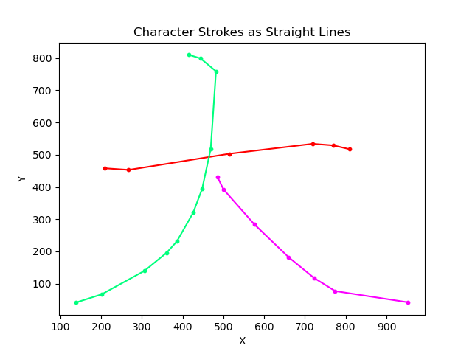
Figure 54. Result of Straight-Line Algorithm on the Chinese Character 大
Similar to the curve length function in Section 2.2.2 Task 3.3, we have the straight-line length function
$$L=\left\|P_{1}-P_{0}\right\|$$
, which is basically the Euclidean distance between the starting point and the ending point.
So, the time variable t increment by PEN_SPEED/ straight line length to maintain the uniform speed along different lengths of straight lines in a character.
The connecting Hermite curve is replaced by 3 segments of straight lines. The first line moves 50 mm vertically up from the end of the previous stroke. Then, a second straight line moves to the top of the first control point of the next stroke. Finally, a third straight line moves vertically down to the paper to start writing. An example is shown in the Figure 55 below:
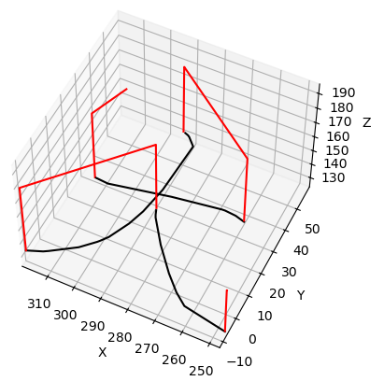
Figure 55. Trajectory of Writing the Chinese Character 大 with the Straight-Line Algorithm
The same logic applies when we want to connect multiple characters together. We move straight vertically up from the last control point of the previous character, then move straight horizontally to the top of the first control point of the next character, then move vertically down towards the paper. An example is shown in the Figure 56 below:
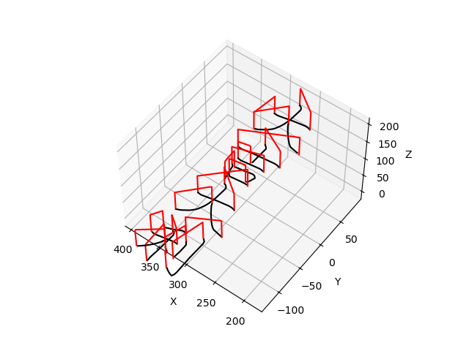
Figure 56. Trajectory of Writing the Chinese Characters 大吉大利 with Straight-Line Algorithm
We then apply this to the physical robotic arm and the result is shown in Figure 57 below:
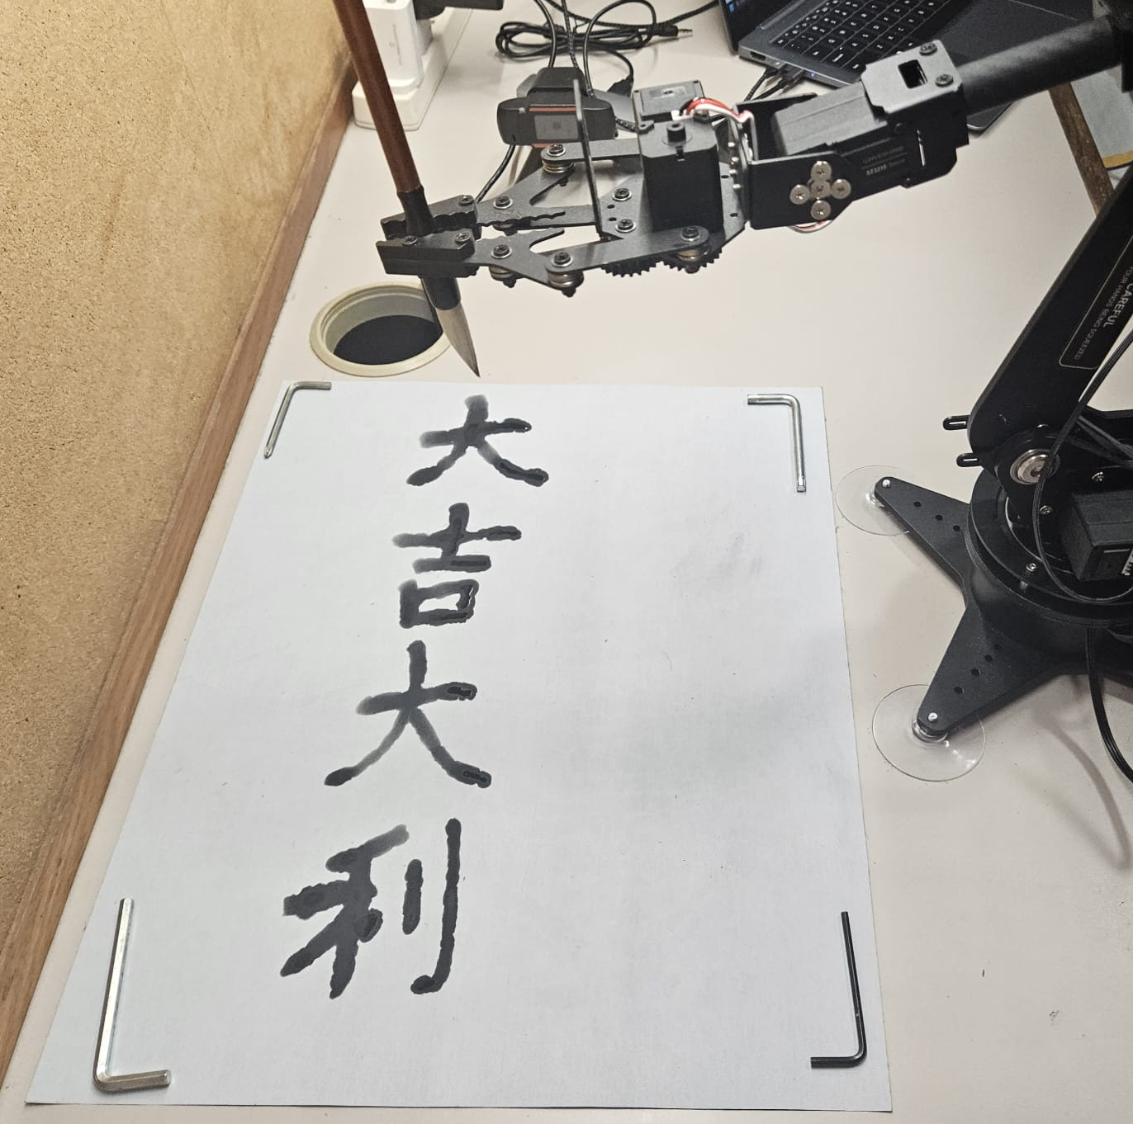
Figure 57. Result of the Fai Chun 大吉大利 Written by the Robotic Arm Using the Straight-Line Algorithm
This algorithm is one of the simplest and primitive way to utilize the graphics.txt dataset to write a Chinese character. Any algorithms that aim to enhance it should have a better result than this algorithm. So, this can act as a benchmark for us to compare how much better the new Bézier curves algorithms is to this basic straight-line implementation.

Task 2
Aim: Compare the performance of the Bézier curves path planning algorithm to traditional methods.
Expected Outcome: Demonstrate that the Bézier curves path planning algorithm is better than the traditional methods in terms of speed, smoothness, and accuracy.
Work Description:
With all algorithms developed, it is time to compare and evaluate the performance of different algorithms. We will compare and evaluate the performance of 3 different algorithms developed. They are
- Straight Line benchmark algorithm developed in Task 1
- 2D Spline algorithm developed in Section 2.2.2 Task 3.5
- 3D Spline algorithm developed in Section 2.2.2 Task 3.7
The algorithms will be tested on
- Writing different characters
- Writing different Fai Chuns
, and their speed, smoothness, and accuracy will be evaluated to compare their performance.
Table 5. Comparison Between Different Algorithms Writing a Single Character
Character | Straight-Line Algorithm | 2D Spline Algorithm | 3D Spline Algorithm
大  3 strokes | 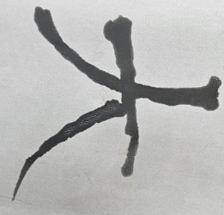  Figure 58. Result of the Chinese Character 大 Using Straight-Line Algorithm | 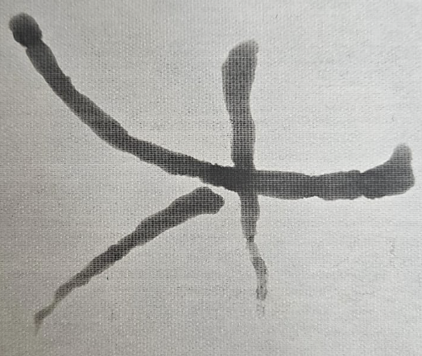  Figure 59. Result of the Chinese Character 大 Using 2D Spline Algorithm | 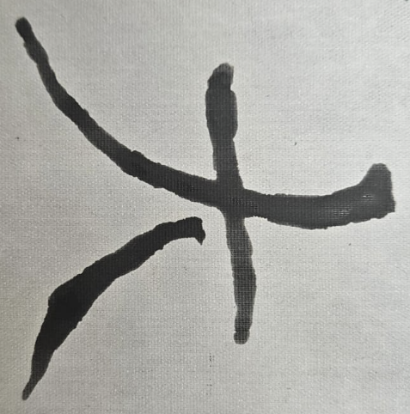  Figure 60. Result of the Chinese Character 大 Using 3D Spline Algorithm
大  3 strokes | Speed: 29.11s  Speed per stroke: 9.70s | Speed: 15.09s  Speed per stroke: 5.03s | Speed: 18.27s  Speed per stroke: 6.09s
我  7 strokes | 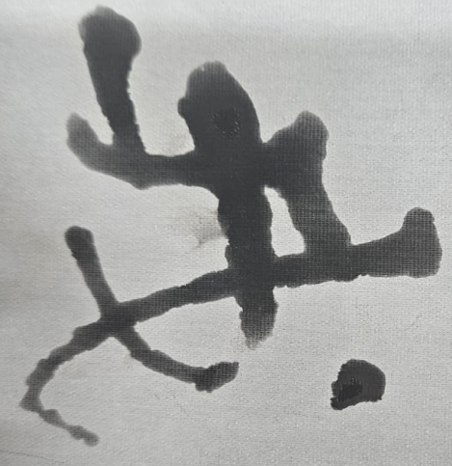  Figure 61. Result of the Chinese Character 我 Using Straight-Line Algorithm | 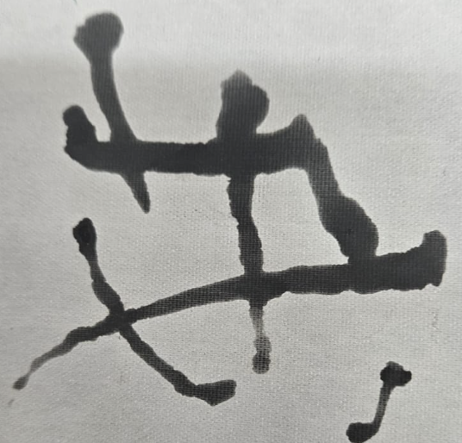  Figure 62. Result of the Chinese Character 我 Using 2D Spline Algorithm | 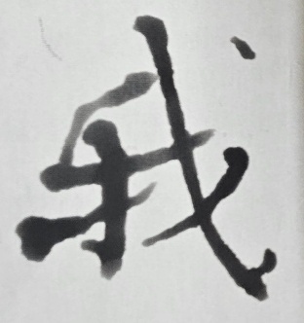  Figure 63. Result of the Chinese Character 我 Using 3D Spline Algorithm
我  7 strokes | Speed: 56.23s  Speed per stroke: 8.04s | Speed 30.04s  Speed per stroke: 4.29s | Speed: 33.07s  Speed per stroke: 4.72s
春  9 strokes | 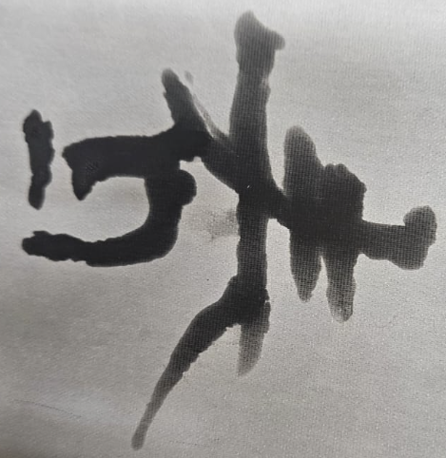  Figure 64. Result of the Chinese Character 春 Using Straight-Line Algorithm | 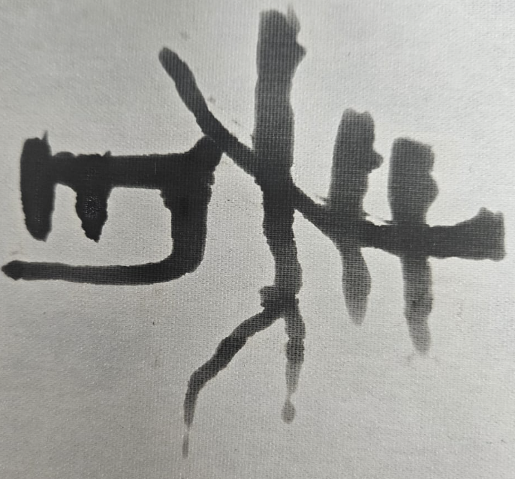  Figure 65. Result of the Chinese Character 春 Using 2D Spline Algorithm | 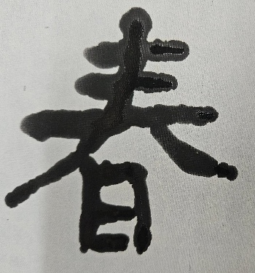  Figure 66. Result of the Chinese Character 春 Using Spline Algorithm
春  9 strokes | Speed: 74.42s  Speed per stroke: 8.27s | Speed: 37.04s  Speed per stroke: 4.11s | Speed: 43.00s  Speed per stroke: 4.78s
入  2 strokes | Speed: 19.71s  Speed per stroke: 9.86s | Speed: 9.94s  Speed per stroke: 4.97s | Speed: 13.55s  Speed per stroke: 6.78s
心  4 strokes | Speed: 29.47s  Speed per stroke: 7.37s | Speed: 15.72s  Speed per stroke: 3.93s | Speed: 19.45s  Speed per stroke: 4.86s
科  8 strokes | Speed: 61.69s  Speed per stroke: 7.71s | Speed: 36.28s  Speed per stroke: 4.54s | Speed: 38.68s  Speed per stroke: 4.84s
學  12 strokes | Speed: 105.66s  Speed per stroke: 8.14s | Speed: 57.38s  Speed per stroke: 4.78s | Speed: 61.54s  Speed per stroke: 5.13s
萬  10 strokes | Speed: 88.80s  Speed per stroke: 8.88s | Speed: 51.33s  Speed per stroke: 5.13s | Speed: 52.24s  Speed per stroke: 5.22s
福  13 strokes | Speed: 86.88s  Speed per stroke: 6.69s | Speed: 47.26s  Speed per stroke: 3.64s | Speed: 53.43s  Speed per stroke: 4.11s
龍  16 strokes | Speed: 106.87s  Speed per stroke: 6.68s | Speed: 56.24s  Speed per stroke: 3.52s | Speed: 63.19s  Speed per stroke: 3.95s
Average: | Speed: 65.884s  Speed per stroke: 8.36s | Speed: 35.632s  Speed per stroke: 4.54s | Speed: 39.642s  Speed per stroke: 5.09s
Percentage Improvement | n/a | 45.92%  per stroke: 45.63% | 39.87%  per stroke: 39.64%

Table 6. Comparison Between Different Algorithms Writing a Fai Chun
Fai Chun | Straight-Line Algorithm | 2D Spline Algorithm | 3D Spline Algorithm
大吉大利  17 strokes  (3+6+3+5) | 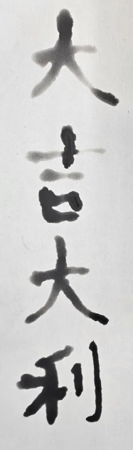  Figure 67. Result of the Chinese Characters大吉大利Using Straight-Line Algorithm | 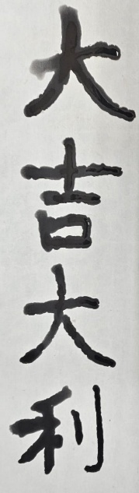  Figure 68. Result of the Chinese Characters大吉大利Using 2D Spline Algorithm | 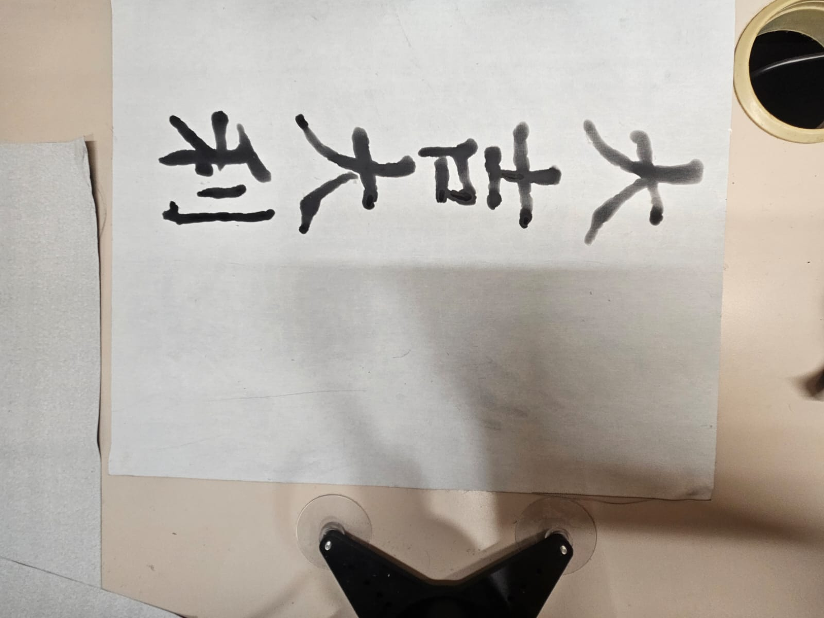  Figure 69. Result of the Chinese Characters大吉大利Using 3D Spline Algorithm
大吉大利  17 strokes  (3+6+3+5) | Speed: 152.50s  Speed per stroke: 8.96s | Speed: 85.91s  Speed per stroke: 5.06s | Speed: 88.51s  Speed per stroke: 5.20s
心想事成  26 strokes  (4+10+6+6) | 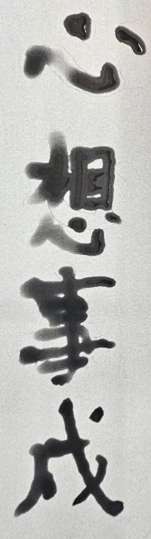  Figure 70. Result of the Chinese Characters心想事成 Using Straight-Line Algorithm | 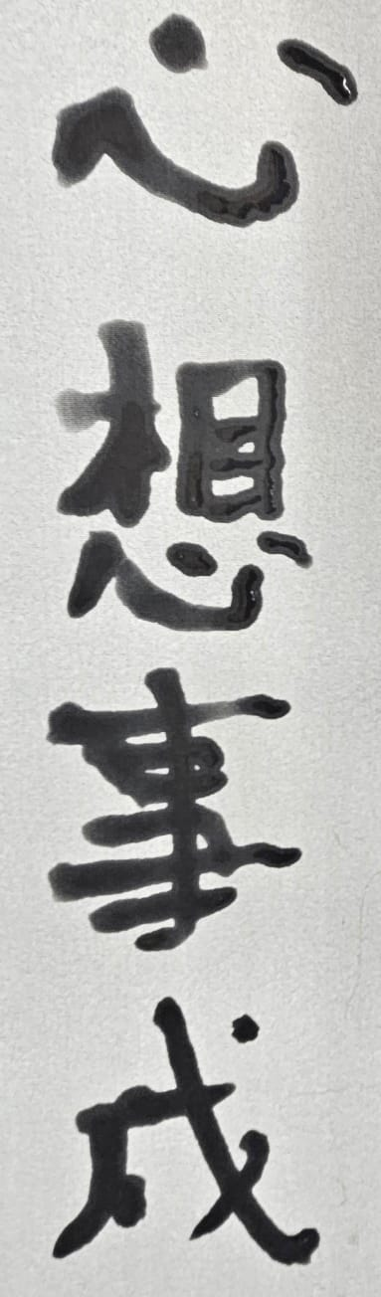  Figure 71. Result of the Chinese Characters心想事成 Using 2D Spline Algorithm | 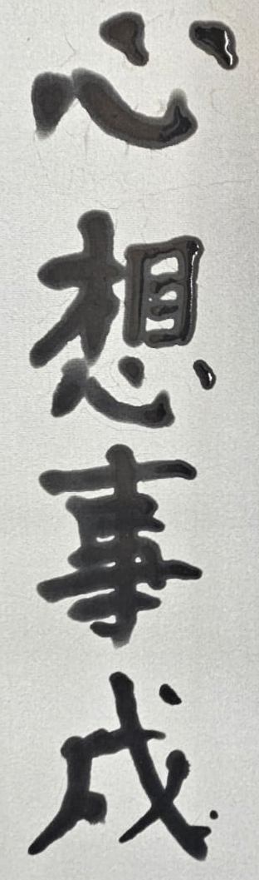  Figure 72. Result of the Chinese Characters心想事成 Using 3D Spline Algorithm
心想事成  26 strokes  (4+10+6+6) | Speed: 238.68s  Speed per stroke: 9.17s | Speed: 127.63s  Speed per stroke: 4.91s | Speed: 132.03s  Speed per stroke: 5.08s
恭喜發財  30 strokes  (6+6+8+10) | 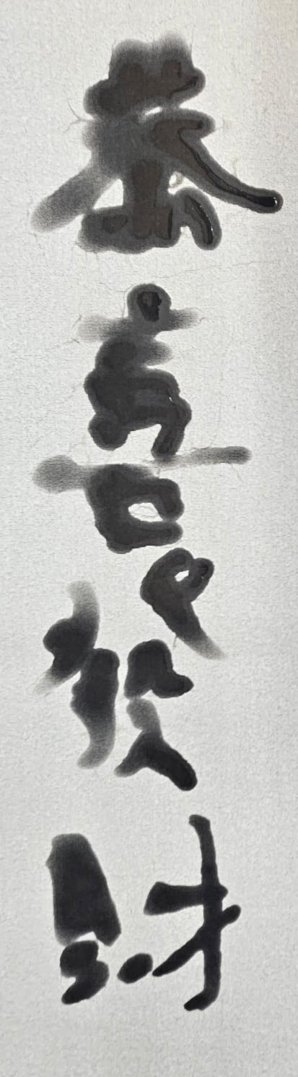  Figure 73. Result of the Chinese Characters恭喜發財Using Straight-Line Algorithm | 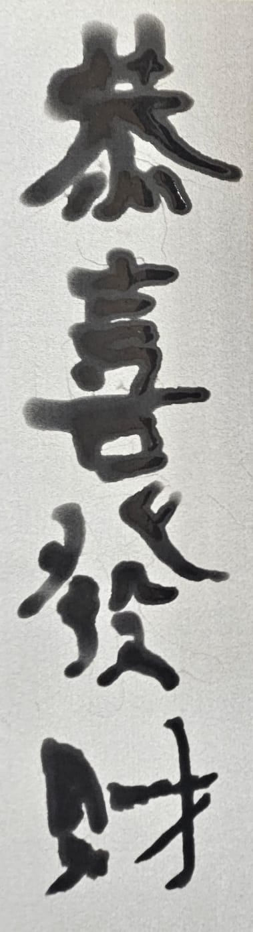  Figure 74. Result of the Chinese Characters恭喜發財Using 2D Spline Algorithm | 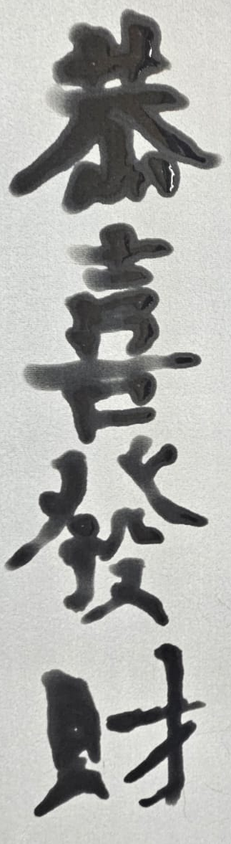  Figure 75. Result of the Chinese Characters恭喜發財Using 3D Spline Algorithm
恭喜發財  30 strokes  (6+6+8+10) | Speed: 327.19s  Speed per stroke: 10.90s | Speed: 172.29s  Speed per stroke: 5.74s | Speed 182.42s  Speed per stroke: 6.08s
出入平安  19 strokes  (6+2+5+6) | Speed: 138.84s  Speed per stroke: 7.31s | Speed: 79.71s  Speed per stroke: 4.19s | Speed: 84.75s  Speed per stroke: 4.46s
萬事如意  31 strokes  (10+6+6+9) | Speed: 283.12s  Speed per stroke: 9.13s | Speed: 165.92s  Speed per stroke: 5.35s | Speed: 176.19s  Speed per stroke: 5.68s
Average: | Speed: 228.07s  Speed per stroke: 9.09s | Speed: 126.29s  Speed per stroke: 5.05s | Speed: 132.78s  Speed per stroke: 5.14s
Percentage Improvement | n/a | 44.53%  per stroke: 44.55% | 41.66%  per stroke: 43.60%
Based on the testing data above, in terms of writing speed, the 2D Spline Algorithm demonstrates a significant advantage, being approximately 45% faster than the Straight-Line Benchmark Algorithm, while the 3D Spline Algorithm is only around 40% faster. This enhanced speed is due to the continuous motion enabled by the Bézier-curved path, which avoids the frequent pauses required by the Straight-Line algorithm during direction changes. Although the 3D Spline Algorithm is slightly slower than the 2D variant, its ability to produce higher-quality strokes justifies its performance.
Due to space constraints in this report, only images of the first three characters and the first three Fai Chuns are displayed. The smoothness of the algorithms is challenging to convey visually, as smoothness is perceived during the robotic arm's movement. The Straight-Line Algorithm exhibits numerous pauses throughout the strokes and between different strokes. In contrast, the 2D Spline Algorithm pauses before and after each stroke but maintains smoothness while writing. The 3D Spline Algorithm involves only a pause before each stroke and after each character, making it the smoothest of the three.
In terms of writing accuracy, all three algorithms perform similarly, as they rely on the same dataset. If the data from graphics.txt is subpar, the resulting characters—such as "我" and Fai Chun like "恭喜發財"—will also be flawed. From the images provided, both the Straight Line and 2D Spline algorithms produce strokes of uniform thickness, which can appear unnatural. In contrast, the 3D Spline Algorithm attempts to create natural variations in stroke thickness. Consequently, the 3D Spline Algorithm demonstrates the highest accuracy, closely resembling both the trajectory and the thickness of the brush strokes in the characters.
In conclusion, the evaluation of the three algorithms—Straight Line, 2D Spline, and 3D Spline—reveals that the Bézier curves path planning algorithm significantly outperforms traditional methods. The 2D Spline Algorithm excels in speed and maintains a smooth writing experience, while the 3D Spline Algorithm offers superior accuracy by mimicking the natural thickness of brush strokes. Both algorithms demonstrate clear advantages over the Straight-Line benchmark, which suffers from frequent pauses and uniform stroke thickness. Overall, the findings support the hypothesis that Bézier curves provide a more efficient and aesthetically pleasing approach to character writing, making them a compelling choice for future applications in robotic writing and other automated tasks.

Main Objective Evaluation & Discussion

Our primary objective was to develop and implement a Bézier curves path planning algorithm for a robot manipulator system, enabling it to write Chinese calligraphy with precision and fluidity. This system is designed to facilitate smooth trajectories without requiring extensive modifications to existing hardware.

The first aspect we evaluated was the trajectory simulation. The initial task involved creating a 3D plot of the robotic arm's movement. As detailed in Subsection 2.2.1, the simulation successfully visualized the trajectories, demonstrating the algorithm's capability to generate smooth paths. This foundational step was crucial in confirming that the manipulator could follow the desired trajectories effectively.

Next, we assessed the development of the 3D Bézier curve algorithm. This algorithm outputs target positions and velocities based on specified control points. In the final task detailed in Subsection 2.2.2, we implemented this algorithm within the system, allowing for accurate control of the robotic arm's movements. This implementation proved essential for achieving the fluidity required in calligraphy.

Following that, we focused on the 3D Bézier spline algorithm, which connects multiple Bézier curves with C² continuity. This enhancement allowed for seamless transitions between brush strokes, a key requirement for producing high-quality calligraphy. The results indicated that the manipulator could execute strokes without noticeable interruptions, fulfilling our objective of maintaining smooth writing motions.

Another critical evaluation centered on the integration of the Bézier curves path planning algorithm within the robotic arm for writing tasks. We first acquired the necessary tools, including the robotic arm and calligraphy instruments. Subsequently, we successfully programmed the manipulator to move to specified 3D coordinates, demonstrating its capability to accurately position itself for writing tasks. The application of the 3D Bézier spline algorithm to write Chinese characters confirmed the system's effectiveness in producing aesthetically pleasing calligraphy.

Additionally, we aimed to utilize a machine learning model to identify the contact of the Chinese writing brush (毛筆) with the paper. We acquired a camera and implemented the necessary code for image capture. Through the processes of annotation, preprocessing, and augmentation, we created a dataset for training our computer vision model. The model achieved an accuracy of 90% or above, as detailed in Subsection 2.2.3, validating its reliability. The development of a brush writing height calibration program further ensured that the model could effectively track the brush's position during operation.

Finally, we set out to demonstrate the advantages of using Bézier curves in robotic path planning compared to traditional methods. In Subsection 2.2.4, we developed a Fai Chun writing algorithm without Bézier curves to establish a baseline for comparison. The evaluation showed that the Bézier curves path planning algorithm significantly outperformed traditional methods in terms of speed, smoothness, and accuracy.

Overall, we successfully achieved our main objective of creating a robotic writing system that not only executes smooth and precise calligraphy but also enhances user interaction through an intuitive interface. While the current implementation may not offer the full range of features found in commercial products, it effectively addresses the need for a reliable and efficient solution for automated calligraphy.

SECTION 3—CONCLUSION

This project aims to demonstrate the smoothness and precision of the 3D Bézier curve path planning algorithm on a robotic arm while incorporating computer vision as sensory input. We developed a robot manipulator system capable of writing Chinese calligraphy, utilizing the Bézier curves algorithm to generate smooth trajectories that enable fluid brush strokes.

The implementation of the 3D Bézier curve algorithm provided target positions and velocities based on specified control points, allowing the manipulator to execute movements with a high degree of accuracy. Additionally, a 3D Bézier spline algorithm connected multiple curves with C² continuity, further enhancing the smoothness of the writing motions.

The robot manipulator system was equipped with a computer vision system powered by a machine learning model that achieved an accuracy of 90% in detecting whether the writing brush was in contact with the paper. This system utilized a camera for image capture and included a brush writing height calibration program to ensure reliable operation.

In the end, the robotic writing system successfully demonstrated its ability to produce aesthetically pleasing calligraphy and provided a user-friendly interface that allows users to select characters for writing. However, there remain several areas for improvement.

For the hardware, three enhancements could be made. First, redesigning the gripper to hold the brush more firmly could improve stability and control during writing. Second, utilizing a robotic arm with higher precision and speed would enhance the quality and efficiency of the strokes. Third, implementing a 6 DOF (Degrees of Freedom) arm instead of the current 5 DOF would allow for greater flexibility in movement.

For the software, three key improvements can be implemented. First, adding functionality to detect whether the brush has ink would help prevent dry brush strokes. Second, developing a system to detect the location of the Fai Chun paper would ensure accurate positioning for writing. Third, incorporating detection of the position of the ink dish would allow for automatic re-inking of the brush as needed.

Overall, while the project successfully achieved its main objectives, there are numerous opportunities for refinement and enhancement. Continued development in both hardware and software will lead to a more robust and versatile robotic writing system, paving the way for future applications in robotics and automated calligraphy.

REFERENCES
[1] A. Medhi, "Optimal Path and Trajectory Planner for HKUST Robocon," GitHub, private repository. Accessed: Sep. 10, 2024.
[2] A. A. Al-Qassara and A. N. Abdulnabib, "Optimal path planning obstacle avoidance of robot manipulator system using Bézier curve," American Scientific Research Journal for Engineering, Technology, and Sciences (ASRJETS), vol. 40, no. 01, pp. 6-17, Jan. 2018.
[3] Y. Wu, J. Feng, W. Chen, and Y. Guan, "Application of Stroke Extraction and Trajectory Planning in Robotic Calligraphy," in Intelligent Robotics and Applications, X. Lan, X. Mei, C. Jiang, F. Zhao, and Z. Tian, Eds. Singapore: Springer, 2025, vol. 15202. DOI: 10.1007/978-981-96-0774-7_23.
[4] M. Lind, "Real-time quintic Hermite interpolation for robot trajectory execution," PeerJ Comput. Sci., vol. 6, p. e304, 2020. DOI: 10.7717/peerj-cs.304.
[5] S. Kishore, "Make Me a Hanzi: Free, open-source Chinese character data," GitHub, 2025. [Online]. Available: https://github.com/skishore/Make Me a Hanzi . [Accessed: Feb. 4, 2025].
[6] Waveshare, "RoArm-M2-S Robotic Arm Control," Waveshare Wiki, 2025. [Online]. Available: https://www.waveshare.com/wiki/RoArm-M2-S . [Accessed: Oct. 15, 2024].
[7] Waveshare, "RoArm-M1 Robotic Arm Control," Waveshare Wiki, 2025. [Online]. Available: https://www.waveshare.com/wiki/RoArm-M1 . [Accessed: Oct. 28, 2024].
[8] Roboflow, "Roboflow: Computer vision tools for developers and enterprises," [Online]. Available: https://universe.roboflow.com . [Accessed: Nov. 4, 2024].
[9] Roboflow, "Final Database," [Online]. Available: https://universe.roboflow.com/essamhaider/final_database . [Accessed: Mar. 28, 2025].

APPENDICES

Appendix A – Final Project Schedule
Table 7. Project Schedule
Objective Statements | Task | Wk1 16 Sep | Wk2 23 Sep | WK3 30 Sep | WK4 7 Oct | WK5 14 Oct | WK6 21 Oct | WK7 28 Oct | WK8 4 Nov | WK9 11 Nov | WK10 18 Nov | WK11 25 Nov | WK12 2 Dec | WK13 9 Dec | WK14 16 Dec | Wk15 23 Dec | Wk16 30 Dec | Wk17 6 Jan | Wk18 13 Jan
Bézier Curves Path Planning
 | 3D Trajectory Plotter
 | 3D Bézier Curve Algorithm
 | 3D Bézier Spline Algorithm
Chinese Calligraphy Robot
 | Acquire Robotic Arm and Tools
 | Manual Control to 3D Coordinates
 | Draw Chinese Characters
 | Draw Fai Chun
Computer Vision System
 | Acquire Camera and take images
 | Annotate and Prepare Dataset
 | Train Computer Vision Model
 | Writing Height Calibration Program
Compare Traditional Method
 | Implement Traditional Algorithm
 | Compare Performance
Table 2. Project Schedule (Continued)
Objective Statements | Task | WK19 20 Jan | WK20 27 Jan | WK21 3 Feb | WK22 10 Feb | WK23 17 Feb | WK24 24 Feb | WK25 3 Mar | WK26 10 Mar | WK27 17 Mar | WK28 24 Mar | WK29 31 Mar | WK30 7 Apr
Bézier Curves Path Planning
 | 3D Trajectory Plotter
 | 3D Bézier Curve Algorithm
 | 3D Bézier Spline Algorithm
Chinese Calligraphy Robot
 | Acquire Robotic Arm and Tools
 | Manual Control to 3D Coordinates
 | Draw Chinese Characters
 | Draw Fai Chun
Computer Vision System
 | Acquire Camera and take images
 | Annotate and Prepare Dataset
 | Train Computer Vision Model
 | Writing Height Calibration Program
Compare Traditional Method
 | Implement Traditional Algorithm
 | Compare Performance
Table Key:
Yellow: worked on that item, Blue: worked on that objective, Gray: worked on similar item but got discarded due to change of topic

Appendix B — Budget
Table 8. Budget
Items | Cost
Waveshare RoArm-M1 | RMB 1904.8
Waveshare ST3215 Servo Motor | RMB 110
480p HD USB Camera | RMB 12.9
Chinese calligraphy beginner set | RMB 18.5
Red Fai Chun Paper | RMB 23.8
Chinese calligraphy ink | RMB 5.9
Total | RMB 2075.9

Appendix C — Deviation(s) from the Proposal and Progress Report and Supporting Reason(s)
Initially, the intent was to implement a Bézier curved path planning algorithm for a robotic arm using computer vision. However, challenges arose in finding a suitable application that could effectively visualize the trajectory and demonstrate its smoothness.

The proposal report suggested using the robot manipulator system for shooting and dribbling basketballs. Difficulties were encountered in acquiring a sufficiently large and powerful robotic arm capable of performing these tasks. Discussions with supervisors highlighted that the shooting trajectory lacked variety and that dribbling was too repetitive, making this application unsuitable for showcasing the Bézier curved path planning algorithm.

In the progress report, a new application was proposed: sorting different colored markers from a table to a stationary shelf. This would involve detecting the locations of the markers and the shelf using a depth camera and planning a Bézier curved path to navigate around obstacles. However, the costs of the necessary equipment significantly exceeded the project budget. The Intel® RealSense™ Depth Camera D435i is approximately $4000, and the Jetson Nano costs around $2500, both surpassing the total budget of $2500 for this final year project. Additionally, experimentation with the Waveshare RoArm-M1 robotic arm, which costs about $1900, revealed that its 5 Degrees of Freedom (DOF) design limited its ability to grasp markers oriented differently. A 6 DOF robotic arm is required to effectively grab the markers without constraints.

During the Chinese New Year, inspiration was drawn from Fai Chun decorations, which presented an excellent opportunity to demonstrate the 3D Bézier curved path planning algorithm. Further experimentation revealed that the quality of Chinese calligraphy is highly sensitive to the distance between the brush and the paper. Consequently, the decision was made to incorporate a simple, inexpensive USB camera to ensure consistent distance calibration during tests of the robot manipulator system.

Appendix D — Monthly Reports
Monthly Report for ECE FYP
Project Code: | WKT06 | Supervisor(s): | Professor Woo Tim
Project Title: | Computer Vision-based Path Planning for Robot Manipulator Using Bézier Curves
Group Member(s): | - CHEUNG, Dick Ho 2) / 3) /
Reporting Period: | Report #1 ☒ Oct (Fall)  Report #2 ☐ Nov (Fall)  Report #3 ☐ Feb (Spring)  (please attach Reports #1-2 to the Progress Report to be submitted in Jan)  (please attach Reports #3 to the Final Report to be submitted in Apr)
Progress Report:  - List the work completed in this reporting period.  - Identify the major difficulties encountered.  - Comment on the overall progress. | The work completed:  - Write a ROS2 node that can plot a 3D Hermite Spline with user-defined number of control points. (Each control point requires a 3D position vector and 3D velocity vector)  - Plot the 1st, 2nd, 3rd derivative and curvature graph of the Hermite Spline to prove its smoothness  - Acquired a half functional 4 DOF robotic arm (RoArm-M2-S). (The bottom 2 servos are functional, the top 2 are not functional due to broken wires)  - Able to control the robotic arm through ROS2 nodes  - Able to simulate the movement of the robotic arm in ROS2 using Rviz2.  Major difficulties:  - The original application written in the proposal report – shoot and dribble a basketball, could not demonstrate the difference between Bézier Curved Path Planning and normal robotic arm control methods. So, I decided to change the application and did not start the part about computer vision.  - The original robotic arm written in the proposal report – JetArm, has relatively short arm length, has smaller ranges of the movable angles of joints, and are more expensive than the RoArm-M2-S I acquired.  - The mini-computer written in the proposal report, JETSON NANO, does not have official support for Ubuntu 22.04 and ROS2 Humble that I am using. Maybe it would be easier and cheaper to run Ubuntu 22.04 and ROS2 Humble in the VirtualBox or in WSL (Windows simulated Linux) in my laptop computer.  Comment on overall progress:  - Although many changes are made on the proposal report, the objective on Bézier Curves path planning is mostly finished. So, I can focus on the objective of computer vision and the objective of applying the Bézier Curves path planning algorithm on some
Future Plan:  - Write down the working plan for the next reporting period. | - Fix the current robotic arm or buy a new one  - Think of a new application of the path planning algorithm (instead of the basketball written in the proposal report) such that it can better demonstrate the advantages of using Bézier Curves  - Start training a Yolo model on the objects of the new application
Group  Representative’s  Signature: | CHEUNG Dick Ho
(Version 2020-10)

Monthly Report for ECE FYP/FYT
Project Code: | WKT06 | Supervisor(s): | Professor Woo Tim
Project Title: | Computer Vision-based Path Planning for Robot Manipulator Using Bézier Curves
Group Member(s): | 1) CHEUNG, Dick Ho 2) / 3) /
Reporting Period: | Report #1 ☐ Oct (Fall)  Report #2 ☒ Nov (Fall)  Report #3 ☐ Feb (Spring)  (please attach Reports #1-2 to the Progress Report to be submitted in Jan)  (please attach Reports #3 to the Final Report to be submitted in Apr)
Progress Report:  - List the work completed in this reporting period.  - Identify the major difficulties encountered.  - Comment on the overall progress. | The work completed:  - Bought a new 5 DOF robotic arm (RoArm-M1)  - Able to control the robotic arm to follow a generated 3D Hermite Spline  - Able to draw a 2D Hermite Spline on a paper with the robotic arm holding a marker  - Able to move a marker using the robotic arm from the ground to a shelf using a hard coded 3D Hermite Spline  - Found a dataset of wax sticks with 728 images on Roboflow. (As wax sticks look the most similar to the markers I used)  - Started training a YOLOv8 model to detect the position of wax sticks/markers  Major difficulties:  - The robotic arm does not hold the markers firmly when moving or drawing.  - I could not find a dataset with markers online that look the same as the ones I am using.  - When I train the YOLOv8 model with the dataset of wax sticks, it becomes overfit to the wax sticks and will not detect markers anymore.  - I need to make my own dataset of markers and label them myself, which will take me a lot of time  Comment on overall progress:  - I finished most of the Bézier Curves path planning part as scheduled in the proposal report but need more tuning and testing  - I started computer vision part but I am a bit behind schedule as I am still not sure about my application. Since the computer vision model depends on the objects of the applications.  - I am still doubting if “sorting marker in a small stationary shelf” is a good way to showcase the advantage of using Bézier Curves  - Overall, I think I am a bit slow due to Robotics Team duties this month but I think I will have more time during December and January to chase back the schedule.
Future Plan:  - Write down the working plan for the next reporting period. | - Acquire a depth camera (Intel® RealSense™ Depth Camera D435i) to get the RGB image and depth image of the surrounding of the robotic arm  - Continue to train a yolo object detection model to identify the location of markers  - identify the 3D location of the markers using depth image  - identify the color of the marker  - identify the 3d location of the obstacles around the robotic arm  - Find a way to clamp the markers firmly  - Find a 3D Bézier Curves path to go around the obstacles to move the markers from 1 location to another
Group  Representative’s  Signature: | CHEUNG Dick Ho
(Version 2020-10)

Monthly Report for ECE FYP/FYT
Project Code: | WKT06 | Supervisor(s): | Professor Woo Tim
Project Title: | Computer Vision-based Path Planning for Robot Manipulator Using Bézier Curves
Group Member(s): | 1) CHEUNG, Dick Ho 2) / 3) /
Reporting Period: | Report #1 ☐ Oct (Fall)  Report #2 ☐ Nov (Fall)  Report #3 ☒ Feb (Spring)  (please attach Reports #1-2 to the Progress Report to be submitted in Jan)  (please attach Reports #3 to the Final Report to be submitted in Apr)
Progress Report:  - List the work completed in this reporting period.  - Identify the major difficulties encountered.  - Comment on the overall progress. | The work completed:  - Migrated all code from Linux Ubuntu and ROS2 environment back to a normal Windows Python environment for easier development and execution  - The robotic arm can hold a Chinese brush(毛筆) firmly and write with it.  - It can fetch brush stroke data from a free, open-source Chinese character dataset called, Make Me a Hanzi  - It can plan a Hermite spline for each stroke of the Chinese character by using the brush stroke coordinates data from the Make Me a Hanzi dataset.  - It can hold a Chinese brush(毛筆) and followed its planned Hermite splines paths to write a Fai Chun(揮春) on a piece of paper.  - Started labelling my own images on Roboflow to prepare to train my own computer vision object detection YOLO model.  Major difficulties:  - It is hard to setup YOLO Ultralytics in the Linux Ubuntu environment inside a WSL (Windows Simulated Linux)  - Depth Camera is expensive to buy and difficult to setup in WSL (Windows Simulated Linux)  - The robotic arm is not holding the brush firmly and might shake midway  Comment on overall progress:  - The progress previously is a little bit stuck but I overcome it by basically redo everything by migrating everything back to a simple environment while maintaining the original functionality
Future Plan:  - Write down the working plan for the next reporting period. | - Make a UI for user to choose which Fai Chun they want to write  - Fix the distance between the robotic arm and the laptop camera  - Train a YOLO object detection model with my own labelled images  - Convert the perspective view image coordinates to back to a 2D coordinates on the table in order to locate the object for the robotic arm to interact with
Group  Representative’s  Signature: | CHEUNG Dick Ho
(Version 2020-10)

